

**Division of Finance and Business Operations**

**Request for Proposal  
  
and Specifications for**

**Preferred Vendor Relationships for Land Survey, Geotechnical Survey, Commissioning, Material Testing and Environmental Site Assessments, Air and Water Balancing, Hazmat Testing and Air Monitoring, 3-Dimensional Laser Scanning**

No part of this publication may be reproduced, transmitted, transcribed, stored in a retrieval system, or translated into any language in any form by any means without the written permission of Wayne State University

**Wayne State University**

**Procurement & Strategic Sourcing**

**April 01, 2024**

Table of Contents

1. RFP Overview and Schedule 3

2. Scope of Work 4

3. Cost of the Work 11

4. Proposal Requirements 12

5. Evaluation and Other Criteria 14

**Schedules**

Schedule A - Proposal Certification, Non-Collusion Affidavit, Vendor Acknowledgement

Schedule B - Insurance Requirements

Schedule C - Fee Schedule

Schedule C.1 - Material Testing Unit Pricing

Schedule C.2 - Hazmat Testing Unit Pricing

Schedule D - Summary Questionnaire

**Appendices**

Appendix A - Campus map

Appendix B – Sample Contract

Appendix C – (Reserved)

# About Wayne State

**Wayne State University**, founded in 1868, is committed to preparing its students to excel in a fast-paced and interconnected global society. It combines the academic excellence of a major research university with the practical experiences of an institution whose history, location and diversity make it a microcosm of the world students will enter when they graduate. The University holds the Highest Carnegie Foundation classification for research activity. It has 13 colleges and schools and offers more than 350 academic programs including bachelor’s, master’s and doctoral degrees; post-baccalaureate, graduate and specialist certificates; and three professional programs (<http://wayne.edu/about/facts/>).

# RFP Overview and Schedule

Wayne State University (WSU) requests proposals from interested consultants who would like to provide professional consultant services for: land survey, geotechnical survey, commissioning, material testing and environmental site assessments, air balancing, Hazmat testing and air monitoring, 3-Dimensional laser scanning, and cost estimating. Interested firms are not required to provide all services. Respondents will be required to indicate the specific areas of service for which they are qualified and would like to work for the University.

It is the University’s intent to establish a list of preferred vendors to be awarded professional service work for individual projects and reduce the University’s need for individual competitive proposals and lengthy negotiations for the numerous small to large size projects developed through Facilities, Planning and Management (FP&M). Successful vendors will be granted a three-year contract with two optional one-year extensions. The University will execute master contracts with each successful vendor and assign projects with individual work orders.

|  |  |
| --- | --- |
| **RFP Schedule** | |
| Bid Date: | April 01, 2024 |
| Optional Pre-Bid Meeting: | Optional  Date: April 11, 2024  Time: 03:00 pm  Location: Facilities Planning and Management  5454 Cass Avenue  Conference Room 3  Detroit, MI 48202 |
| Questions: | Due: April 18, 2024  Submit to: Robert Kuhn, Senior Buyer at [rfpteam3@wayne.edu](mailto:ac6243@wayne.edu) |
| Bid Due Date: | April 25, 2024  Electronic Submittal |
| Interviews: | Week of May 06, 2024 |
| Final Selection: | Week of May 13, 2024 |
| Start of Services: | Week of ASAP after contract award |
| **Note:** | These dates may be adjusted, at the discretion of the University. |
| Contract Term: | 3 years from date of Award with 2 optional 1-year extensions |

1. **Registration**

Please use our online registration form at <https://forms.wayne.edu/6604586202c0f/> to indicate your attendance at the optional pre-proposal meeting to be held on April 11, 2024 at 10:00 AM and your intent to submit a proposal for the services listed.

1. **Questions and Addenda**

All questions must be directed to Robert Kuhn, Senior Buyer at [rfpteam3@wayne.edu](mailto:rfpteam3@wayne.edu) prior to the question deadline. It is the consultant’s responsibility to check for any additional addenda. Only written addenda shall be revisions to this solicitation.

1. **Submission**

Proposals will be received by electronic submission until April 25, 2024 at 2:00 p.m. (local time – Detroit Michigan). The link for bid submission will be posted with the bid details at <http://go.wayne.edu/bids> beginning April 01, 2024, and can be accessed direct at <https://forms.wayne.edu/6604594658699>. Schedule C, Schedule C.1, and Schedule C.2 must be provided in Excel format. Vendors are strongly encouraged to combine any other documents into one PDF for the ease of distribution within the University and to ensure no portion of your response is inadvertently omitted in transmission to the University or internally to the end user department.

**Please Note, the submission form has approximately 40 fields. Allow at least 15 minutes to complete this, when approaching the bid submission deadline. For any discrepancy between the submission form and the actual proposal, the responses in the proposal will prevail.**

1. **Withdrawal**

After the submission deadline has passed, no modification of any proposal will be accepted. All proposals become the property of the University.

1. **Consultant Interviews**

The proposals will be used to develop a short-list of qualified firms to attend interviews with the project selection committee. The selection of vendors will be based on the response to this RFP and interviews.

# Scope of Work

1. **Background**

The University’s Design and Construction Services (D&CS) Department is responsible for managing design and construction of all minor and major projects on campus. Projects managed by this group vary in type and complexity. Projects may include new or existing facilities. The types of projects generally include, but are not limited to: office, classroom, laboratory, residential, site development, on-grade parking, demolition, and roofing. This RFP is intended to enter into agreements with consultant services to support these projects. The University plans to procure 1 or 2 firms for each category of work.

Services will be requested on an as-needed basis and work will be assigned on a discretionary basis. The existence of a contract does not obligate the University in any way relative to the quantity of work assigned to each vendor.

1. **Scope Summary**

The consultants procured under this RFP will be responsible for providing professional consultant services in the disciplines defined below. Potential consultants may respond to any or all of the categories.

1. Land Survey
2. Geotechnical Survey
3. Commissioning (MEP and building envelope)
4. Material Testing and Environmental Site Assessments
5. Air and water Balancing
6. Hazmat Testing and Air Monitoring
7. 3-Dimensional Laser Scanning
8. **Scope Details**

Consultants who are successful in this procurement will be assigned work on an as-needed basis by the University. The scope will be relayed at that time. The University will also give the consultant applicable historical documents for their review and verification to support the assigned tasks. The details provided below for each of the categories of work are intended to provide enough basis for hourly pricing by the prospective consultants. All work done under this procurement shall be completed in accordance with industry standards and meet the applicable requirements, laws, and codes. Unless a lump sum proposal is requested, or unit prices are established, as detailed below, the consultants will be reimbursed based on negotiated rates per the consultant’s submitted and agreed upon fee structure.

For scope that is clearly defined in advance, the University may solicit lump sum bids from multiple consultants that are under contract with the University. The successful consultant will be paid the agreed upon lump sum price as full payment for the work, unless a negotiated and approved change order is issued to modify the contract amount.

For material testing, unit pricing categories are shown in Schedule C.1. For Hazmat testing, unit pricing categories are shown in Schedule C.2. If you are proposing for either material testing or Hazmat testing, fill out the labor rates in Schedule C as well as the unit prices in Schedule C.1 or C.2.

The awarded vendors will be required to provide adequate personnel in a timely fashion to perform the assigned projects. Services provided under this contract shall include all meetings, coordination, and correspondence to support the project. The vendor shall work with the University to maximize the efficiency of their work. This may include providing options on means and methods, coordinating with other impacted parties, and providing opinions on ways to minimize project costs.

Consultants must visit the site and ensure that the proposed work is feasible. Archive drawings provided by the University should be verified against existing conditions to ensure that provided documentation represents actual conditions.

The consultants will be required to meet the University Design and Communication Infrastructure Standards. The design standards are at: <http://www.forms.procurement.wayne.edu/Adv_bid/DC-Standards-Nov-2018.pdf> and the Communication Infrastructure Standards are available here: <https://tech.wayne.edu/docs/wsu-communications-standards.pdf>.

The University may choose to hire additional consultants during a project. The consultant is expected to coordinate with other professionals and provide appropriate project information to others, as necessary.

The University reserves the right to assign work based on previous performance by each consultant under this RFP. Project distribution will be based on workload, past experience, and success to date.

1. **Land Survey**

The land surveyor will be required to survey areas of campus and prepare reports and maps, as specified by the University. The surveys must be completed by a surveyor licensed in the State of Michigan.

The scope of work includes but is not limited to: establish ground control and property boundaries, perform right of way mapping, determine the location of utilities, stake the locations of construction design points, prepare topographic maps, research land records, and prepare plots, maps, and reports. The surveyor will be required to provide all equipment to perform the assigned tasks.

The consultant will be required to review and understand existing surveys and maps of the site prior to performing their work. Sources of information about the existing area may include previous maps, plots, titles, meetings with University staff, and land records. The consultant shall perform field investigations to confirm that field conditions match the existing site documentation.

The consultant shall attend project meetings with the University and other consultants, as applicable. The consultant shall coordinate their efforts with other impacted entities so as to maximize the efficiency of the work.

The consultant will furnish the specified number of written reports, field records, and supporting documents for each task performed. Deliverables will be submitted in a format consistent with University standards and requirements. This may include hardcopy, the native electronic files, or both.

1. **Geotechnical Survey**

The geotechnical surveyor will be asked to provide geotechnical analysis services for various projects, as specified by the University. The work shall be prepared by a Professional Engineer licensed in the State of Michigan.

The scope of work includes but is not limited to: earth retention design for excavation, groundwater monitoring and dewatering design, geotechnical site exploration, soil borings, building movement monitoring, foundation review and analysis, slope stability analysis, and pavement investigation. Additional areas of geotechnical engineering may be included in the work.

The consultant will be required to review and understand existing condition documents prior to performing their work. Sources of information about the existing area may include previous design, geotechnical reports, meetings with University staff, and site observations. The consultant shall perform field investigations to confirm that field conditions match the existing site documentation.

The consultant shall attend project meetings with the University and other consultants, as applicable. The consultant shall coordinate their efforts with other impacted entities so as to maximize the efficiency of the work.

The consultant will furnish the specified number of written reports, field records, and supporting documents for each task performed. Deliverables will be submitted in a format consistent with University standards and requirements. This may include hardcopy, the native electronic files, or both.

1. **Commissioning (MEP and building envelope)**

The commissioning consultant will be asked to provide commissioning services for various projects, at various stages of each project, as specified by the University. Commissioning may occur for new systems or for previously installed systems. Building envelope commissioning may be included in some projects. The work shall be prepared by a Professional Engineer licensed in the State of Michigan and ASHRAE BCxP certified.

The scope of work includes but is not limited to: review and finalize list of systems to be commissioned, review and comment on the design of systems to be commissioned, develop and submit for approval a proposed Commissioning Plan and revise as directed, develop commissioning specifications for the equipment in all systems to be commissioned, coordinate these specifications with the designer and contractors, request any information needed from contractors or equipment manufacturers to perform commissioning tasks (including O&M materials and start-up and checkout procedures), ensure appropriate construction checklists for commissioned equipment have been developed, write functional performance test procedures for equipment and systems to be commissioned, maintain a master issues log and a separate record of functional testing, report all issues as they occur directly to the University, coordinate and observe functional performance tests done by contractors, oversee and review training of operating personnel including a review of final O&M manuals, and list all non-compliance issues and recommendations for improvement to equipment or operations, future actions, and commissioning process changes.

The consultant will be required to review and understand existing MEP systems and building envelope systems as well as components of the systems. Sources of information about the system may include O&M manuals, design drawings, meetings with University staff, and other supporting documents provided by University staff. The consultant shall also perform field investigations to identify current performance characteristics.

The consultant shall attend project meetings with the University and other consultants, as applicable. The consultant shall coordinate their efforts with other impacted entities so as to maximize the efficiency of the work.

The consultant will furnish the specified number of written reports, field records, and supporting documents for each task performed. Deliverables will be submitted in a format consistent with University standards and requirements. This may include hardcopy, the native electronic files, or both.

1. **Material Testing and Environmental Site Assessments**

The consultant will provide laboratory and field tests, inspections, observations, other quality control checks, environmental site assessments, and reports necessary to fulfill the independent testing and inspection requirements for the projects, as specified by the University. The work shall be prepared under the management of a Professional Engineer licensed in the State of Michigan with experience in sampling, inspection, and testing of construction materials. The materials testing lab must have a current certificate of accreditation from American Association of State Highway and Transportation Officials indicating compliance with AASHTO R 18 “Recommended Practice for Establishing and Implementing a Quality System for Construction Materials Testing Laboratories”. Include the accreditation with the proposal.

The scope of work includes but is not limited to: environmental site assessments, ground penetrating radar, cast-in-place concrete testing, soil and aggregate testing, and weld testing. Cast-in-place testing will include field testing of fresh concrete including slump, air content, and temperature, and casting and testing a set of cylinders for compressive strength testing of each class of concrete. The intervals of testing will be as defined by the University. The soil and aggregate testing includes field and laboratory testing of soils and aggregates, such as soil classification, aggregate gradation, moisture density relationship, and the compacted density of engineered fill. The weld testing includes review and approval of welding quality control plans and shop drawings, performing quality assurance inspection and lab verification testing, reviewing mill certifications for structural steel, and reviewing quality control welding reports. The consultant will be required to confirm that actual test results meet contractual specifications. In cases where they do not, re-work and re-testing may be required.

The consultant will be required to review and understand existing condition documents prior to performing their work. Sources of information about the existing area may include previous design, specifications, meetings with University staff, and site observations. The consultant shall perform field investigations to confirm that field conditions match the existing site documentation.

The consultant shall attend project meetings with the University and other consultants, as applicable. The consultant shall coordinate their efforts with other impacted entities so as to maximize the efficiency of the work.

The consultant will furnish the specified number of written reports, field records, and supporting documents for each task performed. Deliverables will be submitted in a format consistent with University standards and requirements. This may include hardcopy, the native electronic files, or both.

1. **Air and water Balancing**

The testing and balancing consultant will provide on-site HVAC services to optimize the operation of existing HVAC systems within University facilities, as specified by the University. The consultant shall be certified for testing, adjusting, and balancing, with a certification from TABB or NEBB.

The scope of work includes but is not limited to: test, adjust, and balance existing HVAC systems. This may include both air and water balancing. All instruments shall be provided by the consultant and shall be calibrated. The consultant shall note deficiencies in the system construction or design that will not be correctable by testing and balancing. Upon testing and balancing the system, the consultant shall mark final settings and issue a report showing: initial system testing results, testing results after balancing, final settings, deficiencies not correctable by balancing, and system recommendations.

The consultant will be required to review and understand existing MEP systems as well as components of the systems. Sources of information about the system may include O&M manuals, design drawings, meetings with University staff, and other supporting documents provided by University staff. The consultant shall also perform field investigations to identify current performance characteristics.

The consultant shall attend project meetings with the University and other consultants, as applicable. The consultant shall coordinate their efforts with other impacted entities so as to maximize the efficiency of the work.

The consultant will furnish the specified number of written reports, field records, and supporting documents for each task performed. Deliverables will be submitted in a format consistent with University standards and requirements. This may include hardcopy, the native electronic files, or both.

1. **Hazmat Testing and Air Monitoring**

The consultant will provide Hazmat testing and air monitoring services to evaluate existing materials, track the air quality at the University, identify issues, and recommend remediation plans, as specified by the University. The consultant shall be certified for Hazmat testing and air monitoring. Hazmat inspections shall be completed by a Michigan-accredited asbestos building inspector or a Certified Industrial Hygienist. The consultants must be experienced professionals with expertise in: asbestos sampling, lead material building inspections, abatement monitoring, interpretation of lab analysis, indoor air quality assessments, hazard evaluations, remedial investigations, feasibility studies, and risk based corrective action plans.

The scope of work includes but is not limited to: inspect and test potentially hazardous materials, perform daily background air sampling, prepare sampling logs, monitor regulatory compliance, and prepare and implement remediation plans. The consultant shall provide their own calibrated equipment for the work. If the testing and monitoring results do not meet requirements, the consultant shall immediately notify the University and prepare a remediation plan.

The consultant will be required to review and understand existing condition documents prior to performing their work. Sources of information about the existing area may include previous design, meetings with University staff, and site observations. The consultant shall perform field investigations to confirm that field conditions match the existing site documentation.

The consultant shall attend project meetings with the University and other consultants, as applicable. The consultant shall coordinate their efforts with other impacted entities so as to maximize the efficiency of the work.

The consultant will furnish the specified number of written reports, field records, and supporting documents for each task performed. Deliverables will be submitted in a format consistent with University standards and requirements. This may include hardcopy, the native electronic files, or both.

1. **3-Dimensional Laser Scanning**

The laser scanning consultant may be asked to provide 3-D laser scanning of existing conditions at any of the University facilities. Scan locations may be indoors or outdoors and will vary in size. The 3-D files may be used by the University to inform design teams on construction projects, for O&M work, or any other need. Locations and details for each scan will be provided by the University.

The scope of work includes but is not limited to: work with the University and the designer to determine the appropriate resolution and technical requirements so that the scan can be used by the designer in their CAD system to provide existing conditions for design, performing the 3-D scan, checking the file to find and resolve errors, ensuring the scan can be used by the designer, and then issuing a report.

The consultant will be required to review and understand existing condition documents prior to performing their work. Sources of information about the existing area may include previous design, meetings with University staff, and site observations.

The consultant shall attend project meetings with the University and other consultants, as applicable. The consultant shall coordinate their efforts with other impacted entities so as to maximize the efficiency of the work.

The consultant will furnish the electronic data files of the scan, written and field reports (as necessary), and supporting documents for each task performed. Deliverables will be submitted in a format consistent with University standards and requirements. This may include hardcopy, the native electronic files, or both.

In your RFP response, indicate the scanning hardware and software you propose to use. Designate the accuracy, resolution, resultant file type, and other technical information that is relevant in your response.

# Cost of the Work

1. **Payment to Consultant**

Work may be assigned as time and material, not-to-exceed time and material, unit price, or lump sum (or, in some cases, as a combination of these methods). For time and material work, payment will be made to the vendor using the agreed upon all-inclusive labor rates (the rates include all overhead and profit), actual costs for materials, and the agreed upon equipment rates. If equipment is used that is not in Schedule C, either actual rental invoices or a mutually agreed upon rental rate for consultant-owned equipment will be used, without markup. Fill out Schedule C (one sheet for each category of work for which you wish to propose) with the labor rates and equipment rates for your work. The labor and equipment rates will remain the same for the duration of the contract. Timesheets signed by University site representation are required for all time and material work. Regular work hours for straight time rates is from 7:00 am to 5:30 pm on weekdays. Overtime rates may apply for the hours in excess of 10 hours per day or 40 hours per week. However, overtime must be pre-approved by the University. Travel time to the University is not eligible for payment.

Indirect office work (such as project management, administrative work, project scheduling, and report review) shall not exceed 15% of the field labor and lab work by the consultant. It shall, however, be billed on an hourly basis for time and material work. If it exceeds 15% of the direct work, the number shall be reduced to meet the maximum threshold. For lump sum work, the indirect office work shall be included in the lump sum price.

If you are proposing for construction material testing or Hazmat testing, also fill out Schedule C.1 or C.2 (in addition to Schedule C) with proposed testing unit prices. Add additional tests that you can provide. For Schedules C.1 and C.2, the unit prices apply to the lab portion of the testing. The labor portion for the field oversight will be paid as per the rates in Schedule C.

1. **Potentially Acceptable Reimbursables**

The hourly rates, unit prices, or lump sum amounts include all costs associated with the project, unless pre-approved by the University. The University has established limits on acceptable reimbursables from professional service consultants. Without regard to the consultant’s policies and practices, the University will accept as reimbursable costs only items pre-approved by the University. Approved reimbursables will be paid at actual costs, with no markup or multiplier. Respondents should consider these restrictions in preparing their responses.

1. **Unacceptable Reimbursables**

Costs beyond those identified above as potentially acceptable reimbursables (pending pre-approval) are prohibited for reimbursement and are included in the labor or unit price rates. Examples of unacceptable reimbursable costs include, but are not limited to:

* Vehicle charges, vehicle rentals, or per diem rates
* Transportation to or from the consultant’s office and the University
* Parking at the University
* Telephone, computer, printing, software, license fees, and internet service
* Shipping or handling fees

# Proposal Requirements

All consultants responding to this RFP must submit complete information requested in this section and clearly note any exceptions to any information contained in the RFP. Responses are limited to 20 pages total, one-sided, with 11-point font. This is inclusive of all required documents and attachments, as well as any optional material included at the discretion of the respondent. Tab sheets and the cover pages do not count. Responses will be evaluated based upon selection criteria as outlined within the RFP. Each proposal shall include the following items:

1. **Executive Summary**

Provide a summary describing your understanding of the RFP requirements and what unique qualities differentiate your company from others responding to this RFP.

1. **Company Contact Information and Company Overview**

Clearly identify the contact information of the company representative designated to receive all RFP information, addenda, or any other official correspondence relating to the project. Provide a profile of the local office presence and capabilities of the local office to support the University. Businesses within 50 miles of the University will be awarded additional points during evaluation of the proposals.

1. **Similar Experience**

Provide detailed information on previous similar experience as it may relate to the scope, size, and complexity of University work. Provide a detailed list of projects of similar size and nature. References should be available, upon request.

1. **Project Team**

Identify your company’s proposed project team. Include staff qualifications, resumes, roles, an organizational chart, and responsibilities. Provide the name and contact information of the point person for the work. Identify what portions of the work will be done in-house and what portions (if any) will be done by subconsultants. For testing, is the laboratory work to be done in-house or with a subconsultant? Identify, by name and role, all potential subconsultants. Personnel and subconsultants identified in the proposal shall not be replaced without approval from the University.

1. **Approach**

Describe your team’s approach to delivering the work, interacting with the customers, and the challenges anticipated in performing the services. What makes your team best qualified to perform projects for the University? How will you ensure you meet our staffing requirements and schedule to perform the assigned projects in a timely fashion?

1. **Regulatory Agencies and Licenses**

Identify regulatory agencies which have oversight of your work. Detail the requirements that your work must meet. Explain how you will meet these requirements. Explain the licenses and certifications that are required for your work and document your plan to meet these requirements.

1. **Communication Plan**

Open and clear channels of communication with the University and other vendors is important. Please outline your communication plan. How quickly can you respond to requests for new work and questions on existing work? How will you ensure that the University is an important priority?

1. **Innovation**

What innovations does your company bring, if hired? Any and all ideas of how to optimize the work will be encouraged.

1. **Contract**

Sample contract documents are attached to this RFP. The terms are non-negotiable. Please confirm your willingness to accept these terms. The consultant is required to meet all requirements in the contract.

1. **Cost of Proposal Preparation**

Expenses for developing and presenting proposals are marketing expenses and shall be the responsibility of the consultants. They will not be reimbursed by the University. All supporting documentation submitted with this proposal will become the property of the University and may be subject to Freedom of Information Act disclosures.

1. **Schedules to Return with the Proposal**

Complete the schedules and include them with your proposal. Include Excel versions of Schedules C, C.1, and C.2.

# Evaluation and Other Criteria

1. **Evaluation Criteria**

The selection committee will consider all aspects of the RFP responses. We may short list the firms and then hold interviews of the shortlisted firms. The final award will be based on the following criteria:

|  |  |
| --- | --- |
| Evaluation Criteria | Weight |
| Cost Proposal | 25% |
| Interviews | 20% |
| Relevant Company Experience and Qualifications | 15% |
| Relevant Project Team Experience and Qualifications | 15% |
| Understanding of the RFP and Quality of Proposal | 15% |
| Communication Plan | 5% |
| Innovation | 5% |

1. **W/MBE participation**

The University is committed to the development and utilization of WBE and MBE enterprises. Implicit in this RFP is a desire to receive proposals from WBE and MBE enterprises. WBE and MBE participation may factor in the selection of consultants and all consultants are expected to support the University’s WBE and MBE initiatives.

**Schedule A**

**Response to Wayne State University**

**Request for Proposal**

**RFP: Preferred Vendor Relationships for**

**Architecture and Engineering Services**

**DATED: April 01, 2024**

**PROPOSAL CERTIFICATION, ACKNOWLEDGEMENTS,  
and NON_COLLUSION AFFIDAVIT**

VENDOR is to certify its proposal as to its compliance with the Request for Proposal specifications using the language as stated hereon.

**ACKNOWLEDGEMENTS**

By virtue of submittal of a Proposal, VENDOR acknowledges and agrees that:

* All of the requirements in the Scope of Work of this RFP have been read, understood and accepted.
* The University’s General Requirements and Guidelines have been read, understood and accepted.
* Compliance with the Requirements and/or Specifications, General Requirements and Guidelines, and any applicable Supplemental Terms and Conditions will be assumed acceptable to the VENDOR if not otherwise noted in the submittal in an Exhibit I, Restricted Services.
* The Supplier is presently not debarred, suspended, proposed for debarment, declared ineligible, nor voluntarily excluded from covered transactions by any Federal or State of Michigan department or agency.
* Wayne State University is a constitutionally autonomous public university within Michigan's system of public colleges and universities, and as such, is subject to the State of Michigan Freedom of Information Act 442 of 1976. Any Responses Proposals, materials, correspondence, or documents provided to the University are subject to the State of Michigan Freedom of Information Act, and may be released to third parties in compliance with that Act, regardless of notations in the VENDOR's Proposal to the contrary.
* All of the Terms and Conditions of this RFP and Vendor’s Response Proposal become part of any ensuing agreement.
* The individual signing below has authority to make these commitments on behalf of Supplier.
* This proposal remains in effect for **[120]** days.

VENDOR, through the signature of its agent below, hereby offers to provide the requested products/services at the prices specified, and under the terms and conditions stated and incorporated into this RFP.

**PROPOSAL CERTIFICATION**

The undersigned, duly authorized to represent the persons, firms and corporations joining and participating in the submission of this Proposal states that the Proposal contained herein is complete and is in strict compliance with the requirements of the subject Request for Proposal***,*** except as noted in Exhibit 1, the "**Restricted Services/Exceptions to RFP**" section of the Proposal. If there are no modifications, deviations or exceptions, indicate “None” in the box below:

|  |  |
| --- | --- |
|  | **NONE** – There are no exceptions to the University’s requirements or terms |

|  |  |
| --- | --- |
|  | **YES** – Exceptions exist as shown in Exhibit 1, Restricted Services. |

**NON-COLLUSION AFFIDAVIT**

The undersigned, duly authorized to represent the persons, firms and corporations joining and participating in the submission of the foregoing Proposal, states that to the best of his or her belief and knowledge no person, firm or corporation, nor any person duly representing the same joining and participating in the submission of the foregoing

Proposal, has directly or indirectly entered into any agreement or arrangement with any other VENDORS, or with any official of the UNIVERSITY or any employee thereof, or any person, firm or corporation under contract with the UNIVERSITY whereby the VENDOR, in order to induce acceptance of the foregoing Proposal by said UNIVERSITY, has paid or given or is to pay or give to any other VENDOR or to any of the aforementioned persons anything of value whatever, and that the VENDOR has not, directly or indirectly entered into any arrangement or agreement with any other VENDOR or VENDORS which tends to or does lessen or destroy free competition in the letting of the contract sought for by the foregoing Proposal.

The VENDOR hereby certifies that neither it, its officers, partners, owners, providers, representatives, employees and parties in interest, including the affiant, have in any way colluded, conspired, connived or agreed, directly or indirectly, with any other proposer, potential proposer, firm or person, in connection with this solicitation, to submit a collusive or sham bid, to refrain from bidding, to manipulate or ascertain the price(s) of other proposers or potential proposers, or to obtain through any unlawful act an advantage over other proposers or the college.

The prices submitted herein have been arrived at in an entirely independent and lawful manner by the proposer without consultation with other proposers or potential proposers or foreknowledge of the prices to be submitted in response to this solicitation by other proposers or potential proposers on the part of the proposer, its officers, partners, owners, providers, representatives, employees or parties in interest, including the affiant.

**CONFLICT OF INTEREST**

The undersigned proposer and each person signing on behalf of the proposer certifies, and in the case of a sole proprietorship, partnership or corporation, each party thereto certifies as to its own organization, under penalty of perjury, that to the best of their knowledge and belief, no member of the UNIVERSITY, nor any employee, or person, whose salary is payable in whole or in part by the UNIVERSITY, has a direct or indirect financial interest in the award of this Proposal, or in the services to which this Proposal relates, or in any of the profits, real or potential, thereof, except as noted otherwise herein.

Any notice required under the Agreement shall be personally delivered or mailed by first class or certified mail, with proper postage, prepaid, to the Subject VENDOR at the following address:

Company Name: _________________________________________________________

Address: _________________________________________________________

_________________________________________________________

Telephone: (________________)_______________________________________

Fax: (________________)_______________________________________

Tax Payer ID: _________________________________________________________

Signature _________________________________________________________

Typed Name _________________________________________________________

____________________________________ ___________________

(Title) (Date)

The Internal Revenue Code requires recipients of payments which must be reported on Form 1099 to provide their taxpayer identification number (TIN).

T.I.N. (Taxpayer Identification Number, Federal Identification Number, or Social Security Number)*.*

**Schedule B - INSURANCE REQUIREMENTS**

____________________________________________, at its sole expense, shall cause to be issued and maintained in full effect for the term of this agreement, insurance as set forth hereunder:

|  |  |  |  |  |  |  |  |  |  |  |  |  |  |  |  |  |  |  |  |  |  |  |  |  |
| --- | --- | --- | --- | --- | --- | --- | --- | --- | --- | --- | --- | --- | --- | --- | --- | --- | --- | --- | --- | --- | --- | --- | --- | --- |
| |  |  |  | | --- | --- | --- | | **General Contractors/Construction Managers** |  | | | **Projects < $5,000,000** | Workers' Compensation with Employers' Liability & Alternate Employers Endorsement | Statutory Limits & EL $1,000,000 | |  | Commercial General Liability | $1,000,000 per occurrence & $2,000,000 aggregate | |  | Contractors' Pollution Liability with E&O | $5,000,000 per claim | |  | Professional Liability | $2,000,000 per claim & $4,000,000 aggregate * | |  | Auto Liability with Pollution & Legal Liability | $1,000,000 | |  | Excess Liability (umbrella) | $2,000,000 | |  | University Added as Additional Insured on CGL & Auto | * If we require them to have higher PL limits and we PAY for them, then the limits need to be part of an endorsement that says they're for the University | |

**General WSU Requirements, When Not in Conflict with the Above**

**Type of Insurance Minimum Requirement**

1. Comprehensive General Liability $1,000,000 per occurrence

or

$2,000,000 Aggregate

2. Comprehensive Automobile Liability $1,000,000 Combined Single Limit (CSL)

3. Workers' Compensation Statutory-Michigan $ 100,000

(Employers' Liability)

**Maximum Acceptable Deductibles**

**Type of Insurance** **Deductible**

Comprehensive General Liability $ 100,000

Comprehensive Automobile Liability 0

Workers' Compensation 0

**Coverage**

1. All liability policies must be written on an occurrence form of coverage.

2. Commercial General Liability (CGL) includes, but is not limited to: consumption or use of products, existence of equipment or machines on location, and contractual obligations to customers.

3. The Board of Governors of Wayne State University shall be named as an additional insured for CGL and Auto Liability, but only with respect to accidents arising out of said contract.

4. The additional insured provision shall contain a cross liability clause as follows: “The insurance afforded applies separately to each insured against whose claim is made or suit is brought, except with respects to the limits of the company’s liability.”

5. The insurance company for each line of insurance coverage will be reviewed and checked per the A.M. Best’s Key Rating Guide. **A rating of not less than “A-” is required**

**Certificates of Insurance**

1. Certificates of Insurance naming Wayne State University / Office of Enterprise Risk Management & Insurance Programs (ERM) as the certificate holder and stating the minimum required coverage must be forwarded to the Office of Risk Management to be verified and authenticated with the agent and/or insurance company.

2. Certificates shall contain a statement from the insurer that, for this contract, the care, and custody or control exclusion is waived.

3. Certificates shall be issued on a ACORD form or one containing the equivalent wording, and require giving WSU a thirty (30) day written notice of cancellation or material change prior to the normal expiration of coverage.

4. Revised certificates must be forwarded to the Office of ERM thirty (30) days prior to the expiration of any insurance coverage listed on the original certificate, as follows:

Wayne State University

Office of Enterprise Risk Management & Insurance Programs (ERM)

5700 Cass Avenue, Suite 4622 AAB

Detroit, MI 48202

**Specific Requirements-** Individual contracts may require coverage in addition to the minimum general requirement such as, business interruption, higher limits and or blanket fidelity insurance.

**Exception to the insurance requirements** is to be approved, in writing, by the Office of Enterprise Risk Management & Insurance Programs (ERM). Exceptions are determined by the type and nature of the contract and the individual contractor

|  |
| --- |
|  |

**Schedule C, Schedule C.1, and Schedule C.2**

**Fee Schedule,**

**Material Testing Unit Pricing, and**

**Hazmat Testing Unit Pricing**

(download separately from the Website)

[**http://go.wayne.edu/bids**](http://go.wayne.edu/bids)

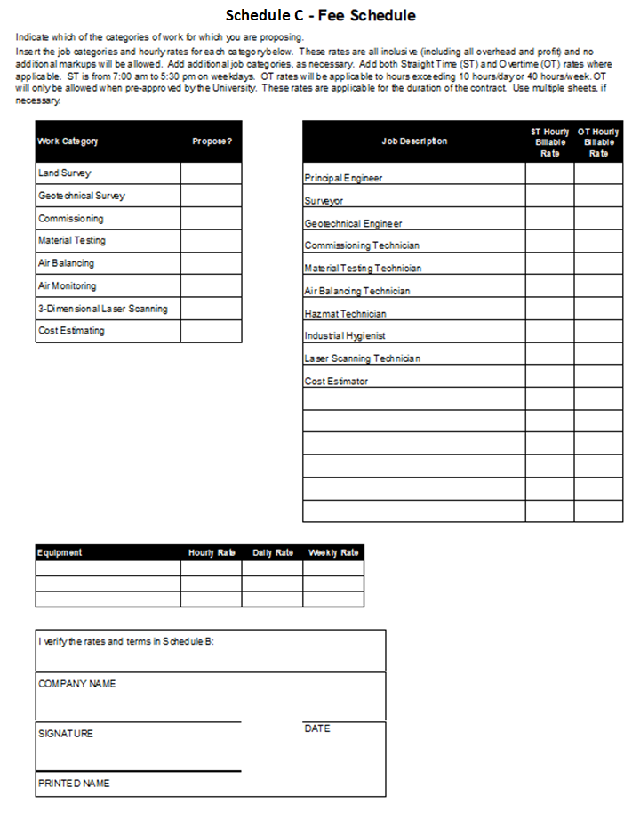

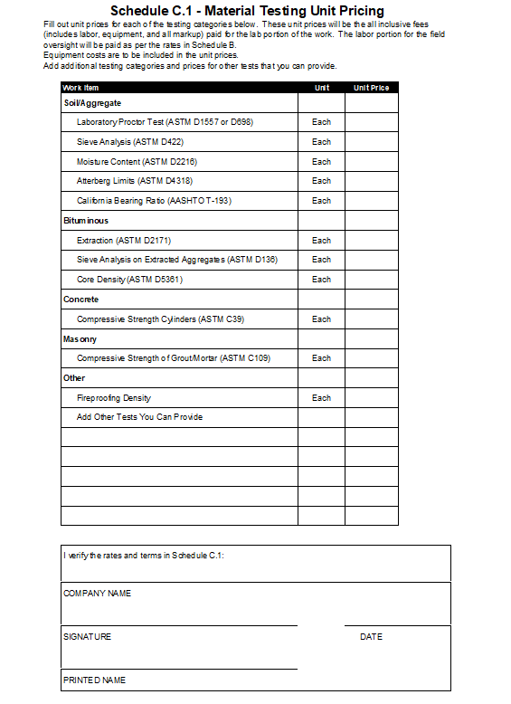

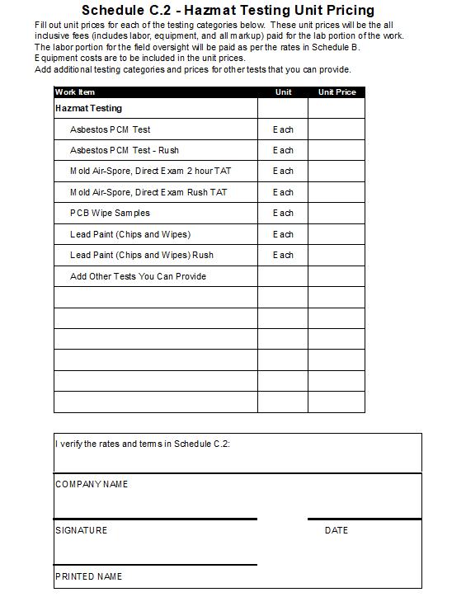

Schedule D - Summary Questionnaire

|  |  |  |  |
| --- | --- | --- | --- |
| 1. Does your company agree to provide a minimum of **3 references** to the University **upon request**, with specific contact names and phone numbers? |  | **YES**  _______ | **ALTERNATIVE**  ______________ |
| 1. Did you attend **the Optional Pre-Proposal** meeting**?** |  | **_______** | **______________** |
| 1. If awarded a contract, will your company provide a certificate of insurance to meet or exceed all our minimum requirements? |  | **_______** | **_______________** |
| 1. Did your company provide the required Proposal Certification, Non- Collusion Affidavit and Vendor Acknowledgement**, Schedule A?** |  | **_______** | **_______________** |
| 1. Did your company complete and provide the Summary **Price Schedules C, C.1 and/or C.2**, and submit them electronically? |  | **_______** | **_______________** |
| 1. Did your company agree to guarantee to maintain a top priority for the UNIVERSITY? |  | **_______** | **______________** |
| 1. Please complete the following questions:   Total number of employees in your company  Total years in business with this company name |  | **______**  **______** |  |
| 1. Are there any conflicts of interest in doing business with the University? |  | **___ Yes**  **___ No** |  |
| 1. Did your company provide a “Restricted Services” exhibit, EXHIBIT 1? |  | **___ Yes**  **___ No** |  |
| 1. Did your company quote services at **prevailing wage rates** where applicable and clearly indicate such in your proposal? |  | **_N / A_** | **______________** |
| 1. Does your company agree to comply with the University Smoke and Tobacco Free Policies? |  | **_______** | **______________** |

1. ADDENDA:

The undersigned affirms that the cost of all work covered by the following Addenda are included in the lump sum price of this proposal.

Addendum No. Date Addendum No. Date

Addendum No. Date Addendum No. Date

Addendum No. Date Addendum No. Date

Addendum No. Date Addendum No. Date

Addendum No. Date Addendum No. Date

Company Name: _________________________________________________________

Signature _________________________________________________________

Typed Name _________________________________________________________

____________________________________ ___________________

(Title) (Date)

**APPENDIX A**

**(Wayne State University Campus Map)**

**See web site:**

[**http://campusmap.wayne.edu/**](http://campusmap.wayne.edu/)

**A detailed list of Paid Parking Options can be viewed at**

**https://parking.wayne.edu/news/approved-2023-24-parking-rates-and-fall-permit-sales-46614**

**Appendix C - (Reserved)**