  Division of Finance and Business Operations |  | Procurement & Strategic Sourcing  5700 Cass Avenue, suite 4200  Detroit, Michigan 48202  (313) 577-3734  FAX (313) 577-3747

July 30, 2015

Dear Vendors:

Wayne State University invites you to submit your Best Educational Pricing on the purchase of a Metabolic Measurement System for the University’s Physical Therapy Department per the specifications and requirements contained in this Request for Quotation, entitled: Medical Equipment. Instructions to Bidders are as follows:

- Responses are to be on this request for quotation for only.
- Additional documents may be submitted: However, this form must be completed in full.
- Bidders that are unable to supply a specific item are encouraged to write “NO BID” on that line.
- Substitutions are not allowed.
- Bidders are to note expected time of delivery for each line if the order is to ship as a partial.
- All prices will be considered FOB Destination unless otherwise indicated.
- If prices are Shipping Point please indicate total transportation charges.
- This order will be awarded as a total package and not on a line item basis.
- Your reply must be received in the WSU Purchasing Office by e-mail no later than 4:00 PM on August 4, 2015.
- LATE BIDS WILL NOT BE ACCEPTED

Bidding documents may be obtained by vendors from the University Purchasing Web Site at http://www.forms.procurement.wayne.edu/Adv_bid/Adv_bid.html beginning July 31, 2015. When visiting the Web Site, click on the "Research" link in green. If you are interested in participating in this process, you must submit your quotation to Procurement & Strategic Sourcing by e-mail no later than August 4, 2015 as follows:
Wayne State University
Academic/Administration Building (AAB)
5700 Cass Avenue
Procurement & Strategic Sourcing, suite 4200
Detroit, MI 48202
e-mail: ag5343@wayne.edu

Enclosed are our requirements and bid sheet for the purchase of Metabolic Measurement System.

You must bid using the format shown in Schedule A. Vendors Quotation should include the following:

- Price Summary, signed by authorized agent of Vendors Company/Firm – please see Schedule A and Specification Sheet
- Vendor Profile (including at least 3 references)
- Exceptions/Restrictions (if any)

The electronic submission should be limited to no more than one of each of the following file types: 1 Word Document and/or 1 Excel Workbook and/or 1 PDF document, with a total file size less than 20 megabytes.

We look forward to receiving your quotation on or before August 4, 2015. Should you have any questions or concerns about this invitation, please contact me at (313) 577-3739 or by e-mail at ag5343@wayne.edu (copy to Cynthia Branch, Email: ab3577@wayne.edu). Thank you for your interest in doing business with Wayne State University.

Sincerely,

Robin Watkins
Buyer

Information for Vendors

The Calendar of Events is as follows:

Activity____________  Formal Release of RFQ | Responsibility ___  Purchasing (PD) | Date____  July 31, 2015
Questions due to Procurement & Strategic Sourcing | VENDORS | August 3, 2015, no later than 12:00 (noon)
Delivery of Quotations by e-mail to: ag5343@wayne.edu | VENDORS | August 4, 2015  by 4:00 p. m.
Announcement of Selected VENDOR | PD | Week of August 10, 2015
Readiness for Service/Contract  Commencement | VENDORS | Week of August 10, 2015
Delivery and Acceptance | VENDORS/ET | August 17, 2015

The University will make every effort to adhere to the above schedule. It is subject however, to time extensions. This would be in the event that further clarification of responses or terms of contract are in the best interest of the University and in the event the University requires more time to assure that the selection of the Vendor is in accordance with its policies, rules and regulations as well as actual timing needs.

Wayne State University (hereafter referred to as UNIVERSITY) is a national research university with an urban teaching and service mission. It is a constitutionally autonomous public university with 13 schools and colleges, has an enrollment of approximately 31,000 students, and has an alumni roster of over 235,000. It is rated among the top 4 percent of all colleges and universities nationwide as classified by the Carnegie Commission.

Expenses for developing and presenting quotes shall be the entire responsibility of the Vendor and shall not be chargeable to the University. All supporting documentation and manuals submitted with this quotation will become the property of the University unless otherwise requested by the Vendor, in writing, at the time of submission, and agreed to, in writing, by the University.

Upon request, VENDOR must agree to provide a minimum of three (3) qualified references. Requests for references will come from Robin Watkins, Buyer, and will be treated as confidential and not added to the publicly permanent RFP file.

References are to be from organizations that have successfully utilized the products and services. The references supplied should include the name and address of the organization, and the contact name(s), titles, e-mail, and the telephone numbers.

Failure to agree to this will result in disqualification of your bid

Vendor selected shall have an excellent track record for providing services for the size and scope of our project as outlined and shall provide WAYNE STATE UNIVERSITY with a top priority commitment. Quotations are to remain in effect a minimum of 120 days from the date of submission. A statement to this effect should be contained in the VENDOR'S cover letter.

Quotation Evaluation

- Quotations will be evaluated and award will be based on the VENDOR'S ability to offer the best value (technical quality, past performance and price), and on anticipated quality of service for the following principal elements:

• Ability to meet all mandatory requirements and specifications of this RFP;
• Cost of Services; Compensation and Fees; (Schedule A);
• Financial Strength of the VENDOR;
• Quotation Documentation / Presentation;
• VENDOR'S Experience (Exhibit 2);
• VENDOR Profiles/References; (Exhibit 2);
• VENDOR Service Plan; (Exhibit 3);

NOTE: Evaluation Criteria are in alphabetical order and are not stated in order of preference.

VENDOR quotations will be evaluated by an evaluation team consisting of members of the UNIVERSITY'S Purchasing and the Physical Therapy. A preliminary screening will be used to identify competitive VENDORS who have met the mandatory requirements. Procurement & Strategic Sourcing may subsequently request selected VENDORS to make a presentation at a set time and date, to clarify information provided in the quotations. Final consideration, evaluation, and recommendation may be made at this point. However, the UNIVERSITY reserves the right to take additional time for reference review, site visits and/or quotation negotiations.

2. To qualify for evaluation, a VENDOR'S quotation must be responsive, must have been submitted on time and must materially satisfy all mandatory requirements identified throughout the RFP. To be considered responsive, a quotation must be reasonable and substantially conform in the judgment of the UNIVERSITY to all of the specified requirements in the RFP. Any deviation from requirements indicated herein must be stated in the quotation specifically under the category "Restricted Services", and clearly identified as Exhibit 1. Otherwise it will be considered that quotations are in strict compliance with all requirements, and any successful VENDOR will be held responsible therefor.

3. If there are portions of any quotation the UNIVERSITY finds unacceptable or otherwise in need of clarification or revision, the UNIVERSITY reserves the right to negotiate with any or all VENDORS. Should the outcome of evaluations result in a recommendation, any resultant contract shall be subject to the approval of the UNIVERSITY'S General Counsel and be approved and signed by the appropriate UNIVERSITY representative.

The UNIVERSITY reserves the rights to accept, reject, modify, and/or negotiate any and all quotations received in conjunction with the Request for Quotation. It reserves the right to waive any defect or informality in the Quotations on the basis of what it considers to be in its best interests. Any quotation which the UNIVERSITY determines to be incomplete, conditional, obscure, or has irregularities of any kind, may be rejected.

This Request for Quotation (RFQ) in no manner obligates the UNIVERSITY to the eventual purchase of any products or services described, implied, or which may be proposed, until confirmed by written agreement, and may be terminated by the UNIVERSITY without penalty or obligation at any time prior to the signing of an Agreement or Purchase Order.

Vendors must refrain from giving any reference to this program, whether in the form of press releases, brochures, photographic coverage, or verbal announcements, without specific written approval from the University.

Quotations are subject to public review after the contracts have been awarded. VENDORS responding to this RFQ are cautioned not to include any proprietary information as part of their Quotation unless such proprietary information is carefully identified as such in writing, and the UNIVERSITY accepts, in writing, the information as proprietary.

You must email your responses to my attention at ag5343@wayne.edu . Remember, your bids must be in the format provided and be received in the Procurement & Strategic Sourcing by August 4, 2015 by 4:00 p.m. Please submit your bids in the format provided on the quote sheet. Include any supplemental information that will illustrate the features of the vehicles proposed.

If you have any questions regarding this bid, please contact Robin Watkins by email at ag5343@wayne.edu copy to Cynthia Branch, Email: ab3577@wayne.edu .

Sincerely,

Robin Watkins, Buyer

Attachment: Insurance Requirements –

- Cost Schedule A
- Insurance Requirements Schedule B

SCHEDULE A - PRICE SCHEDULE

Purchase of Metabolic Measurement System.

Email your responses to Robin Watkins, at ag5343@wayne.edu (copy to Cynthia Branch, Email: ab3577@wayne.edu)). Remember, your bids must be in the format provided and be received in the Procurement & Strategic Sourcing by August 4, 2015 by 4:00 p.m.

Qty. | Item | Description | Price Quote
1 | Metabolic Measurement System for VO2 Max Testing | See Below Specifications
1 | Treadmill | See Below Specifications
1 | Bike Ergometer | See Below Specifications
 | Shipping
 | Warranty | Please provide any warranty information
Other item included
i.e. Training

Company Name: _________________________________________________________

Address: _________________________________________________________

_________________________________________________________

Telephone: (________________)_______________________________________

Fax: (________________)_______________________________________

Email address: _________________________________________________________

Submitted by: _________________________________________________________

Signature _________________________________________________________

____________________________________ ___________________
(Title) (Date)

Specifications for Equipment

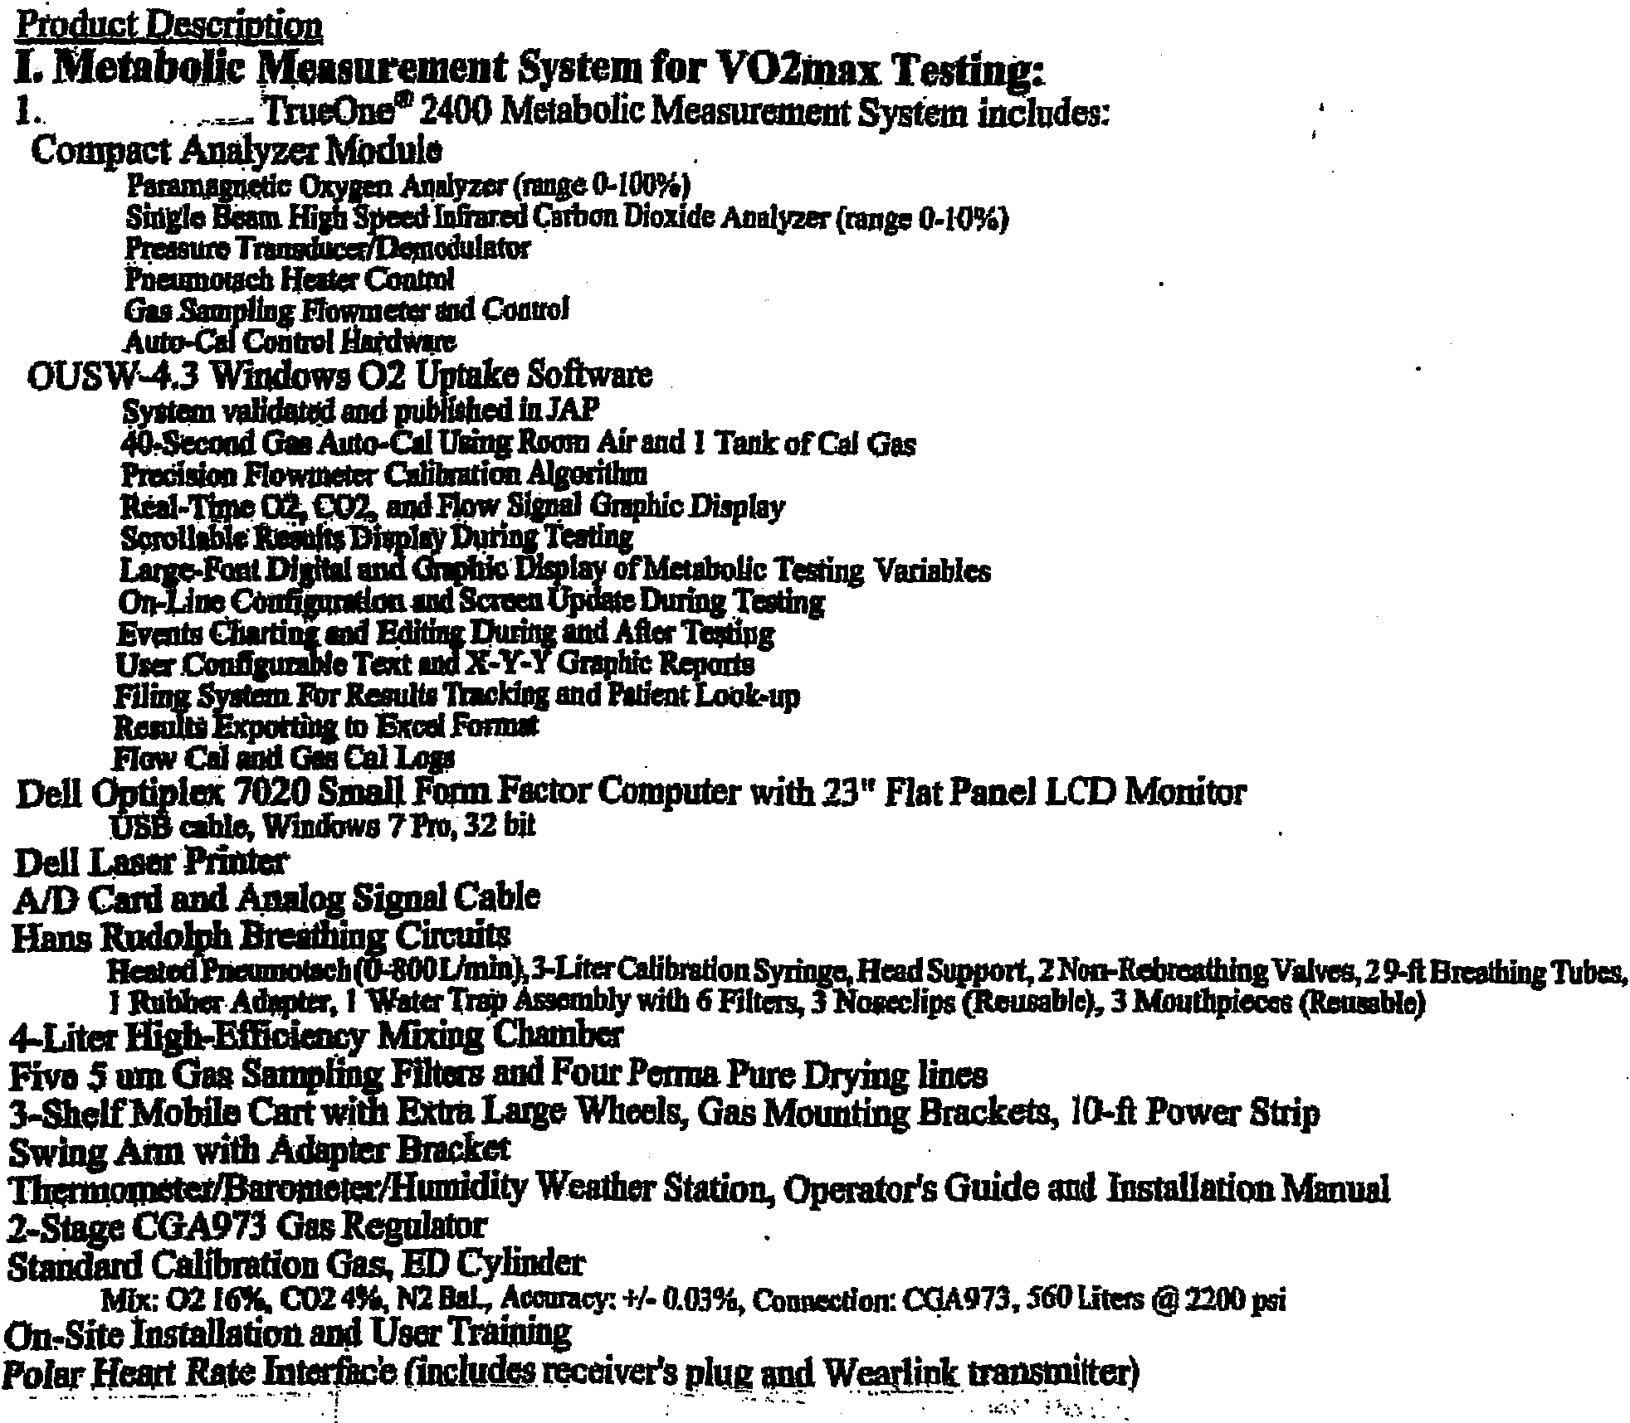
....· ··- ··-·.
- -.
II. Treadmill:
1. TrackMaster TMX428CP Treadmill with Programmable Controller
Elevation: 0- 25%
Speed Range: 0.1 ... 15 mph (220 volts) User Weight Capacity: 500 lbs. Emergency Stop Button
RS232 Computer Interface
Track Master RS232 Interface Cable to True One® Computer
Warranty: 2-YearParts and 1-YearLabor ·
2. Shipping: Dock to Receiving Dock (extra for lift gate or inside delivery)
Subtotal TrackMaster TMX428CP Treadmill with TrueOne® Interface and Dock Delivery
* Special Power Requirement for Treadmill: It requires a dedicated circuit and 220 volts. •
"
*
III. Bike Erometer:
1. Lode Corival Bike Ergometer with TrueOne® Interface
Workload Range of 7 to 750 Watt . Workload (User-Definable Staged or Ramp Protocol) Controllable with TrueOne® TrueOne Interface Cable
Warranty: 1-Year Parts and Labor
··. 3. Shipping (Dock to Dock), Extra for Lift Gate or Inside Delivery
Subtotal Lode Corival (750 Watts) with TrueOne® Interface and Dock Delivery
Schedule B - INSURANCE REQUIREMENTS (Rev 2-2015)

____________________________________________, at its sole expense, shall cause to be issued and maintained in full effect for the term of this agreement, insurance as set forth hereunder:

General Requirements
Type of Insurance | Minimum Requirement
1. Commercial General Liability (CGL)  CGL insurance should be written on ISO  form CG 00 01 (or equivalent substitute)  Contracts valued at $100,000 per year or more | $1,000,000 combined single limit  $2,000,000 annual aggregate  Umbrella Liability per occurrence and in the annual aggregate of $5,000,000.
2. Commercial Automobile Liability  (including hired and non-owned vehicles) | $1,000,000 combined single limit per accident for bodily injury and property damage, without annual aggregate.
3. Workers' Compensation  (Employers' Liability) | Required by the State of Michigan and Employer’s Liability in the amount of  $500,000 per accident for bodily injury or disease.

Maximum Acceptable Deductibles

Type of Insurance Deductible

Commercial General Liability $5,000
Commercial Automobile Liability 0
Workers' Compensation 0
Property - All Risk $1,000

Coverage

1. All liability policies must be written on an occurrence form of coverage.
2. Commercial General Liability (CGL) includes, but is not limited to: consumption or use of products, existence of equipment or machines on location, and contractual obligations to customers.
3. The Board of Governors of Wayne State University shall be named as an additional insured, but only with respect to accidents arising out of said contract.
4. The additional insured provision shall contain a cross liability clause as follows: “The insurance afforded applies separately to each insured against whose claim is made or suit is brought, except with respects to the limits of the company’s liability.”
5. The insurance company for each line of insurance coverage will be reviewed and checked per the A.M. Best’s Key Rating Guide. A rating of not less than “A-” is required

Certificates of Insurance

1. Certificates of Insurance naming Wayne State University / Office of Risk Management as the certificate holder and stating the minimum required coverage must be forwarded to the Office of Risk Management to be verified and authenticated with the agent and/or insurance company.
2. Certificates shall contain a statement from the insurer that, for this contract, the care, custody or control exclusion is waived.
3. Certificates shall be issued on a ACORD form or one containing the equivalent wording, and require giving WSU a thirty (30) day written notice of cancellation or material change prior to the normal expiration of coverage.

4. Revised certificates must be forwarded to the Office of Risk Management thirty (30) days prior to the expiration of any insurance coverage listed on the original certificate, as follows:

Wayne State University
Office of Risk Management
5700 Cass Avenue, Suite 4622 AAB
Detroit, MI 48202

Specific Requirements- Individual contracts may require coverage in addition to the minimum general requirement
such as, business interruption, higher limits and or blanket fidelity insurance.
Exception to the insurance requirements is to be approved, in writing, by the Office of Risk Management. Exceptions are determined by the type and nature of the contract and the individual contractor.

Below for Purchasing Use Only

