

Division of Finance and Business Operations

Request for Proposal
and Specifications for

Summer Cleaning Services for Housing 2016

No part of this publication may be reproduced, transmitted, transcribed, stored in a retrieval system, or translated into any language in any form by any means without the written permission of Wayne State University

Wayne State University
Procurement & Strategic Sourcing

March 10, 2016

  Division of Finance and Business Operations |  | Procurement & Strategic Sourcing  5700 Cass Avenue, suite 4200  Detroit, Michigan 48202  (313) 577-3734  FAX (313) 577-3747

March 10, 2016

Dear Vendors:

Wayne State University invites you to participate in its Request for Proposal process to provide Summer Cleaning Services for Housing 2016, for the University Housing, per the specifications contained herein the Request for Proposal. This service is expected to commence on May 2, 2016.

We have a bid information package complete with the Request for Proposal and complete specifications available for downloading from the University Purchasing Web Site at http://www.forms.procurement.wayne.edu/Adv_bid/Adv_bid.html (include capitalization and underscores) as of March 10, 2016. When visiting the Web Site, click on the “Services” link in green. Copies of the RFP will not be available at the pre-proposal meeting. If you are interested in participating in this process, you and/or responsible representatives of your organization must attend our mandatory pre-proposal meeting to be held on:

March 18, 2016, 2:00 p.m. (EST)
Student Center Building
5221 Gullen Mall,
470 Student Center Building
Detroit, MI 48202

For your convenience a map of the University and appropriate parking lots can be downloaded and printed from: http://campusmap.wayne.edu. Guest parking in any of the University student and guest lots is $7.00. A detailed list of Cash & Credit Card operated lots can be viewed at http://purchasing.wayne.edu/cash_and_credit_card_lots.php. Cash lots dispense change in quarters. Due to time constraints, Vendors are encouraged to avoid parking at meters on the street (especially blue “handicapped” meters). Please confirm your participation and/or attendance at the mandatory pre-proposal meeting by emailing your intent to participate (or not to participate) by sending Appendix 2 to Kimberly Tomaszewski at ac9934@wayne.edu no later than 12:00 noon on March 17, 2016.

We hope to see you at the mandatory pre-bid meeting. Please bring a copy of this Request for Proposal for your reference during the meeting. Should you have any questions or concerns about this invitation, please contact me at (313) 577–3757, or email: ac9934@wayne.edu. Thank you for your interest in doing business with Wayne State University.

Sincerely,

Kimberly Tomaszewski
Senior Buyer

Enclosure
Cc: Leiann Day

RFP: Summer Cleaning Services for Housing 2016
for the University Housing

Page No.(s)
Note ii

I. Introduction 1

II. Information for VENDOR 1
A. General 1, 2
B. Calendar of Events 2
C. Mandatory Pre-Proposal Meeting 2, 3
D. Examination of the Request for Proposal 3
E. Delivery of Proposals 3
F. Proposal Format 3, 4
G. Proposal Evaluation 4, 5
H. VENDOR Profile, Experience, References and Lost Accounts 5, 6
I. VENDOR Service Plan 6

III. Scope of Work and Technical Requirements 13-16

IV. General Requirements and Guidelines 6

SCHEDULES

Schedule A Proposal Certification, Non-Collusion Affidavit, VENDOR Acknowledgements
Schedule B, Insurance Requirements
Schedule C, Cost Schedule
Schedule D, Summary Questionnaire

EXHIBITS TO BE SUBMITTED WITH VENDOR PROPOSAL(S)

VENDOR Exhibit 1, Exceptions / Restricted Services
VENDOR Exhibit 2, Profile/Experience/References
VENDOR Exhibit 3, Service Plan
VENDOR Exhibit 4, Sample Management Reports

APPENDICES

Appendix 1, Wayne State University Map – (see website: http://campusmap.wayne.edu )
Appendix 2, Registration/Intent Form
Appendix 3, Prevailing Wage Rate Schedules
Appendix 4, Drawings

I. INTRODUCTION

A. Wayne State University, founded in 1868, is committed to preparing its students to excel in a fast-paced and interconnected global society. It combines the academic excellence of a major research university with the practical experiences of an institution whose history, location and diversity make it a microcosm of the world students will enter when they graduate. The University is classified by the Carnegie Foundation for the Advancement of Teaching as RU/VH (Research University, Very High research activity), a distinction held by only 2.3 percent of institutions of higher education in the United States. It has 13 colleges and schools and offers more than 380 academic programs including bachelor’s, master’s and doctoral degrees; post-baccalaureate, graduate and specialist certificates; and three professional programs (http://wayne.edu/about/facts/).

B. Procurement & Strategic Sourcing is soliciting proposals from qualified professional organizations, hereafter referred to as VENDOR(s), who specialize in providing Cleaning Services of superior quality, at competitive pricing, as described in the Statement of Work section of the Request for Proposal (RFP). Project must commence on or before May 2, 2016 and be completed by September 30, 2018.

This RFP outlines basic requirements as specified in the Scope of Work section of the RFP (Section III). Proposals submitted are to be in accordance with the outline and specifications contained in and are to remain in effect a minimum of 120 days from the date of submission, and may be subject to further extensions as negotiated.

C. The UNIVERSITY reserves the right to accept, reject, modify, and/or negotiate any and all proposals received in conjunction with the RFP. It reserves the right to waive any defect or informality in the Proposals on the basis of what it considers to be in its best interests. Any proposal may be rejected which the UNIVERSITY determines to be incomplete, conditional, obscure, or has irregularities of any kind. The UNIVERSITY reserves the right to award to the firm, or firms, which in its sole judgment, will best serve its long-term interest.

This RFP in no manner obligates the UNIVERSITY to the eventual purchase of any products or services described, implied, or which may be proposed, until confirmed by written agreement, and may be terminated by the UNIVERSITY without penalty or obligation at any time prior to the signing of an Agreement or Purchase Order.

D. Expenses for developing and presenting proposals shall be the entire responsibility of the VENDOR and shall not be chargeable to the UNIVERSITY. All supporting documentation and manuals submitted with this proposal will become the property of the UNIVERSITY.

E. All questions concerning this Request for Proposal are to be directed to Kimberly Tomaszewski, Senior Buyer, Email; ac9934@wayne.edu and to Leiann Day, Procurement Analyst, Email; leiann.day@wayne.edu. Copy both Kimberly Tomaszewski and Leiann Day on all E-Mail questions. The deadline for questions is March 23, 2016, 12:00 noon. Under no circumstances may a VENDOR contact other individuals at the UNIVERSITY, or its consultants to discuss any aspect of this RFP, unless expressly authorized by Procurement & Strategic Sourcing to do so.

II. INFORMATION FOR VENDOR

A. General

This RFP contains requests for information. VENDORS, however, in responding to this RFP, are encouraged to provide any additional information they believe relevant. VENDORS are encouraged to examine all sections of this RFP carefully, in that the degree of interrelationship between sections is high.

B. Calendar of Events

Activity____________  Formal Release of RFP | Responsibility ___  Purchasing (PD) | Date____  March 10, 2016
Mandatory Pre-bid meeting at the Student Center Building, 5221 Gullen Mall, 470 Student Center Building, Detroit, MI 48202 | PD/Evaluation Team  (ET)/VENDORS | March 18, 2016  2:00 p.m.
Questions due to Procurement & Strategic Sourcing | VENDORS | March 23, 2016 - 12 Noon
Delivery of Proposals to the Academic/ Administration Bldg., Purchasing Dept., 5700 Cass Avenue, 4th Floor – Suite 4200, Detroit, MI | VENDORS | April 4, 2016 by 4:00 p.m.
Evaluation of Proposals  (clarifications & negotiations) | PD/ET | Week of April 4, 2016
Announcement of Selected VENDOR | PD | Week of April 11, 2016
Readiness for Service/Contract  Commencement | VENDORS | Week of May 2, 2016
Project Completion | VENDORS/ET | September 30, 2018

The UNIVERSITY will make every effort to adhere to the above schedule. It is subject however, to time extensions at the University’s discretion.

C. Mandatory Pre-Proposal Meeting

You must attend a mandatory Pre-Proposal Meeting on March 18, 2016 at 2:00 p.m. (EST) at the Student Center Building, 5221 Gullen Mall, 470 Student Center Building, Detroit, MI 48202, as a condition for submitting a proposal.

Pre-registration for the meeting is to be made on or before Noon on, March 17, 2016. Please email Appendix 2 to attention of Kimberly Tomaszewski at ac9934@wayne.edu to confirm your attendance.

During this meeting, we will answer any questions you may have to clarify any ambiguities in this Request for Proposal. Answers to questions that cannot be answered during this meeting will be emailed to all VENDORS and posted to the University website as soon as they are obtained.

D. Examination of the Request for Proposal

Before submitting proposals, each VENDOR will be held to have examined the UNIVERSITY requirements outlined in the Scope of Work and Technical Information sections, and satisfied itself as to the existing conditions under which it will be obligated to perform in accordance with specifications of this RFP.

No claim for additional compensation will be allowed due to unfamiliarity with the specifications and/or existing conditions. It shall be understood that the VENDOR has full knowledge of all of the existing conditions, and accepts them "as is."

E. Delivery of Proposals (10-30-2009)

An original (clearly marked as such) plus one copy (2 total) of concise proposals in booklet or notebook form with supporting documentation shall be delivered in a sealed envelope or container to UNIVERSITY Procurement & Strategic Sourcing.

In addition, an electronic version is required, which should be submitted to our secure mailbox at rfp@wayne.edu and be sure your subject line reads “(company name) RFP Summer Cleaning Services for Housing 2016 Response”. The electronic submission should be limited to no more than one of each of the following file types: 1 Word Document and/or 1 Excel Workbook and/or 1 PDF document, with a total file size less than 20 megabytes. ZIP Files containing separate sections of a proposal are not acceptable, drop box submissions are not accepted either. If your submission was sent correctly, you will receive an auto-reply message acknowledging receipt of your Proposal. If you do not receive an auto-reply message, check the address you used and resubmit your Proposal. However, in the event a discrepancy exists between the electronic submission and the original copy of the Vendor’s Response Proposal, the original copy will prevail.

Please note – Your RFP submission is not valid unless we receive both the hard copy and the electronic copy on or before the due date and time.

The specific format for responses is detailed in Section II F (below). Proposals and Schedule C, Cost Schedule must be signed and the authority of the individual signing must be stated thereon. All responses are to be addressed to:

ATTN.: Kimberly Tomaszewski, Senior Buyer
Wayne State University

RFP: Summer Cleaning Services for Housing 2016
5700 Cass Avenue, 4th Floor - Suite 4200 AAB
Detroit, MI 48202

And: E-mail a copy to RFP@wayne.edu /
Subject line: “(company name) RFP Summer Cleaning Services for Housing 2016 Response”.

Deadline for receipt of proposals by Procurement & Strategic Sourcing is, April 4, 2016 by 4:00 p.m. (local time). Date and time will be stamped on the proposals by Procurement & Strategic Sourcing. Proposals received after that time will not be accepted. No details of the proposal will be divulged at the time of opening.

F. Proposal Format

Proposals are limited to 50 pages total, one sided, and eleven (11) point font. (This is inclusive of all required documents and schedules and any optional material included at the discretion of the respondent, but tab sheets and the cover pages do not count in the overall document count.)

Proposals are to be submitted in notebook form with appropriate indices. Each proposal should provide a straightforward concise description of the VENDOR'S service, approach and ability to meet the UNIVERSITY'S needs as stated in this RFP. Schedules and Exhibits listed below must be included in your proposal:

Schedules (provided in this package)
Schedule A - Proposal Certification, Non Collusion Affidavit, VENDOR Acknowledgements
Schedule B - Insurance Requirements
Schedule C - Cost Schedule, Summary of Quoted Rates
Schedule D - Summary Questionnaire

Exhibits (created by Vendors as needed)
Exhibit 1 - Exceptions/Restrictions; if any (Section II G)
Exhibit 2 - Profile / Experience / References (Section II H)
Exhibit 3 - VENDOR Service Plan (Section III)

Care should be exercised in preparation of the proposals since it is the UNIVERSITY'S intent to have the final contract documentation to consist of a University Standard Service Provider Agreement (Appendix 5) that incorporates the RFP, VENDOR Proposal, any letters of clarification, and will require the issuance of a Purchase Order for invoicing purposes.

Unnecessarily elaborate brochures or other presentations beyond those sufficient to present a complete and effective quotation are not desired.

G. Proposal Evaluation

- Proposals will be evaluated and award will be based on the VENDOR'S ability to offer the best value (quality, past performance and price), and on anticipated quality of service. Items considered include but are not limited to:

• Ability to meet all mandatory requirements and specifications of this RFP;
• Cost of Services; Compensation and Fees; (Schedule C);
• Financial Strength of the VENDOR;
• Proposal Documentation / Presentation;
• VENDOR'S Experience (Exhibit 2);
• VENDOR Profiles/References; (Exhibit 2);
• VENDOR Service Plan; (Exhibit 3);

NOTE: Evaluation Criteria are in alphabetical order and are not stated in order of preference.

VENDOR proposals will be evaluated by a team consisting of members of the UNIVERSITY'S Purchasing and University Housing. A preliminary screening will be used to identify competitive VENDORS who have met the mandatory requirements. Procurement & Strategic Sourcing may subsequently request selected VENDORS to make a presentation at a set time and date, to clarify information provided in the proposals. Final consideration, evaluation, and recommendation may be made at this point. However, the UNIVERSITY reserves the right to take additional time for reference review, site visits and/or proposal negotiations.

2. To qualify for evaluation, a VENDOR'S proposal must be responsive, must have been submitted on time and must materially satisfy all mandatory requirements identified throughout the RFP, in the judgment of the UNIVERSITY. Any deviation from requirements indicated herein must be stated in the proposal specifically under the category "Restricted Services", and clearly identified as Exhibit 1. Otherwise it will be considered that proposals are in strict compliance with all requirements. Check the box indicating "None" for Restricted Services on the Proposal Certification Schedule A. In those cases where mandatory requirements are stated, material failure to meet those requirements may result in disqualification of the VENDOR'S response

3. If there are portions of any proposal the UNIVERSITY finds unacceptable or otherwise in need of clarification or revision, the UNIVERSITY reserves the right to clarify or negotiate with any or all VENDORS. Should the outcome of evaluations result in a recommendation, any resulting contract will be subject to the approval of the UNIVERSITY'S General Counsel and must be approved and signed by the appropriate UNIVERSITY representative.

- After notification of acceptance of proposal and the signing of a resulting agreement and/or Purchase Order, the successful VENDOR will be expected to establish and be in a position to commence work or services on or before May 2, 2016.

H. VENDOR Profile, Experience, References, and Lost Accounts

1. VENDOR Profile should include:

VENDOR is required to provide organizational data that demonstrates the size, scope and capability of the Company to handle the UNIVERSITY'S specific requirements specified in this RFP. Explain any company relationships that could be construed to be a conflict of interest in doing business with the UNIVERSITY now or in the future.

Upon University request, VENDOR must agree to provide publicly distributed annual reports and/or independently audited financial statements including its statement of financial position, statement of operations, and statement of cash flows for at least the past three years. Vendor must further agree to permit the UNIVERSITY, upon request, to audit VENDOR's books as related to the Wayne State University account.

Failure to agree to this will result in disqualification of your bid (see Schedule D).

Financial Information will be treated as confidential and not added to the publicly permanent RFP file. Requested Financials must be sent to:

ATTN.: Kenneth Doherty, Assistant Vice President
Procurement & Strategic Sourcing
Wayne State University

RFP: Summer Cleaning Services for Housing 2016
Procurement & Strategic Sourcing
5700 Cass Avenue, 4th Floor - Suite 4200 AAB
Detroit, MI 48202

VENDORS must include a self-addressed envelope marked "Confidential" with their financial statement. Statements will be returned upon completion of any University review.

2. Experience

VENDORS are to state in their proposals their qualifications to meet the RFP specifications in terms of past and current consulting experience with the same or similar requirements. This information should be provided in the VENDOR’S Exhibit 2 of their proposal. VENDORS are to focus on experiences with organizations having needs similar to that of the UNIVERSITY.

3. References

Upon request, VENDOR must agree to provide a minimum of three (3) qualified references. Requests for references will come from Kimberly Tomaszewski, Senior Buyer, and will be treated as confidential and not added to the publicly permanent RFP file.

References are to be from organizations that have successfully utilized the products and services. The references supplied should include the name and address of the organization, and the contact name(s), titles, e-mail, and the telephone numbers.

Failure to agree to this will result in disqualification of your bid (see Schedule D).

4. Lost Accounts and Legal Actions

Upon request, VENDOR must agree to provide a list of significant accounts that the VENDOR has lost during the past three (3) years. "Significant" for this purpose shall be construed to mean accounts representing billings by the VENDOR in the range of $25,000.00 or more each year. A lost account can be defined when the vendor has been terminated on a job because of performance or default. Contact names and telephone numbers of affected Companies must be provided.

Indicate any significant past or pending lawsuits or malpractice claims against the VENDOR.

I. VENDOR Service Plan

Vendors should include a complete description of the products and services offered in their Proposal. The Service Plan should include, but not be limit to:

- A summary of the products or services to be provided.
- When applicable, a timeline showing how the Vendor plans to deliver products and/or services to fulfill any contract issued as a result of this RFP.
- Key staff members at the Vendors organization that will be assigned to the University account or will otherwise be part of an implementation team.
- Any resource requirements on the part of the University necessary in order for the Vendor to meet its obligations under an agreement resulting from this RFP.
- Any hardware, software, or other technology the University must have in order to use the Vendors products or services.
- Any alternative ideas or proposals that should be considered by the University in addition to the base proposal.

III. SCOPE OF WORK AND TECHNICAL REQUIREMENTS

- Project Requirements and Specifications:

Procurement & Strategic Sourcing (PASS) of the UNIVERSITY is soliciting proposals from qualified professional organizations, hereafter referred to as VENDOR(s), who possess significant experience in providing the UNIVERSITY’S requirements for Housing Summer Cleaning, Painting and/or Carpeting as described in the Scope of Work section of the RFP. Work must be complete no later than August 22, 2013.

Our intent is to award contracts to multiple VENDORS for cleaning, painting and/or carpeting, so that the UNIVERSITY has the discretion to assign work individually among the VENDORS. The University intends to award contracts for a 12 month period, with the option to renew for two (2) possible one-year extensions. The initial period will be for this 2016 season ending September 30, 2013. The UNIVERSITY may, at its option, extend the contract for up to two additional one year periods of service, through September 30, 2018.

All pricing is to be based on a “Per Room” basis. No unit price bids are allowed as part of your base proposal. Vendors may, at their option, provide alternate pricing on a unit cost basis provided they have complied with base bid requirements.

CLEANING

Residence Hall

As discussed, all general student rooms, including living rooms, bathroom and hallway. Cleaning includes but is not limited to floors swept, mopped and/or vacuumed; all walls washed (hallways and rooms); windows and sills cleaned; blinds dusted and cleaned; shelves and drawers cleaned throughout; doors cleaned both sides; receptacles and light switches cleaned; cabinets cleaned (interior and exterior); countertops cleaned; appliances cleaned (interior and exterior); all to be pulled out and cleaned underneath; sinks and fixtures cleaned and polished; all mirrors cleaned; cleaned (interior and exterior); vanity cleaned (interior and exterior); bathroom shelves; shower/bathtub and tiles cleaned; toilet bowl ~': (interior and exterior); toilet tank (exterior); all vents to be cleaned and walls washed throughout and all furniture cleaned (interior and exterior); proper hauling and disposal of trash in the receptacles, located on the first floor of each building.
No trash or debris is into swept into the hallway at any time.

The total number of units and general cleaning areas will be given. The total costs include supplies and materials. Any variation of this total must be approved by both you and a signed representative of this office.

Payment will be rendered monthly. The completion must be confirmed by the Associate Director or designee.

Apartment

General apartment cleaning includes but is not limited to the following: floors swept, mopped, scrubbed and/or vacuumed as needed; all walls are to be washed; windows (remove screens where there are awning windows) and sills and mullions are to be cleaned; blinds dusted and cleaned; shelves and drawers cleaned throughout; doors and door hardware cleaned (both sides of the door); receptacles and light switches cleaned; cabinets cleaned (interior and exterior); countertops cleaned; stove and refrigerator cleaned (interior and exterior); both stove and refrigerator to be pulled out and cleaned underneath, back walls & sides and underneath of the cabinets; hood range cleaned (above and underneath); sinks and fixtures cleaned and polished; all mirrors cleaned; medicine cabinet cleaned (interior and exterior); vanity cleaned (interior and exterior); bathroom shelves; shower/bathtub and tiles cleaned; toilet bowl (interior and exterior); toilet tank (exterior); all vents cleaned and walls washed throughout; proper hauling and disposal of trash.

This cleaning project should commence on May 1, 2015 and be completed by August 30, 2015.
There are periods where the window of turning over a number of units is much smaller.

No trash or debris is to be swept into the hallway at any time.

General Installation Requirements:

Vendor will be required to perform delivery/installations per the following:

Coordinate all work with the Housing Management Office and Associate Director of
Housing Operations.

Work is to be performed during normal business hours unless permission is expressly granted by the Housing Management Office.

Vendors are to remove all rubbish, trash, and refuse from each job site upon the end of the days work. Use of University Dumpsters must be coordinated with the Housing Management Office.

As buildings are occupied with tenants, vendors are to exercise their utmost care in the execution of all installations, including blocking of hallways, excessive noise, excessive dust and refuse, and all other activities which may prove to be an impediment and disturbance to the building’s tenants.

B. Payment

Payments will be generated for complete units on a monthly basis. The completion of a unit requires signed confirmation by the Associate Director or designee. All payments will be rendered within thirty (30) days of signed invoice submissions.
Apartment / Residence Hall Unit Listing for this contract

Apartments:

DeRoy Apartments
Efficiency (56 units)
1 bedroom (112 units)
2 bedroom (84 units)
University Tower (Apartments)
1 bedroom (60 units)
2 bedroom (180 units)
3 bedroom (84 units)

Residence Halls:

Ghafari Hall (Residence Hall)
1 room suite

IV. GENERAL REQUIREMENTS AND GUIDELINES

- Terms and Conditions (2-23-2009)

Any contract between the UNIVERSITY and VENDOR resulting from this RFP will be made using the University’s Standard Service Provider Agreement (Exhibit V). The Agreement will incorporate this RFP and its terms and conditions by reference. Should the Vendor have additional terms to incorporate into the Agreement, the Vendor’s Proposal response must include a formal copy of any VENDOR'S terms and conditions applicable to this transaction. Evaluation and acceptance and/or modification of these terms and conditions by the University's General Counsel is essential prior to the award of the contract. If supplied, this should be included in Exhibit 1 of the Vendor’s proposal. In the event the VENDOR does not supply terms and conditions with their proposal, the University's terms and conditions will govern this transaction.

- Governing Law (Michigan)

VENDOR agrees that, in the event of a dispute, laws of the State of Michigan will prevail.

- Non-Discrimination

The parties agree that in the performance of any contract they shall not discriminate in any manner on the basis of race, creed, color, national origin, age, religion, sex, sexual orientation, marital status or handicap protected by law. Such action shall include, but is not limited to the following: employment, upgrading, demotion, transfer, recruitment or recruitment advertising; layoff or termination; rates of pay or other forms of compensation. By submitting a proposal, VENDORS certify that they will conform to the provisions of the Federal Civil Rights Action of 1964, as amended. Information on the Civil Rights Act can be found at http://www.eeoc.gov/laws/statutes/titlevii.cfm

- Civil Rights Requirements

All VENDORS must be in compliance with the directives of the Michigan Department of Civil Rights. The Department of Civil Rights web address is
http://www.michigan.gov/mdcs/0,1607,7-147-6881---,00.html

- Immigration Reform and Control Act of 1986

By submitting a proposal, the VENDORS certify that they do not and will not during the performance of this contract employ illegal alien workers or otherwise violate the provisions of the federal Immigration Reform and Control Act of 1986.

- Debarment Status (6-12-2009)

By submitting a proposal, VENDORS certify that they are not currently debarred from submitting bids on contracts nor are they an agent of any person or entity that is currently debarred from submitting bids on contracts. The University’s Department Policy can be found at http://purchasing.wayne.edu/vendors/debarred.php. State of Michigan information on Debarment can be found at
http://www.michigan.gov/buymichiganfirst/0,1607,7-225-48677-20042--,00.html. The Federal Debarred Vendor List (Excluded Parties List System) and related links can be found at http://www.epls.gov/

- Indemnification and Hold Harmless

The VENDOR shall defend, indemnify and hold harmless the UNIVERSITY, its officers, employees and agents, against any and all liability of whatever nature which may arise directly or indirectly by reason of the VENDOR'S performance under this Agreement.

- VENDOR Liability

The VENDOR will be liable for any associated costs of repairs for damage to buildings or other UNIVERSITY property caused by the negligence of the VENDOR'S employees.

- Early Termination by the University

The UNIVERSITY shall have the right to terminate the contract with the VENDOR without penalty after the UNIVERSITY'S thirty (30) days written notice of termination to the VENDOR under the following circumstances:

1. Default of VENDOR

It shall be considered a default whenever the VENDOR shall:

a. Disregard or violate material provisions of the contract documents or UNIVERSITY instructions, or fail to execute the work according to the agreed upon schedule of completion and/or time of completion specified, including extensions thereof, or fail to reach agreed upon performance results.

- Declare bankruptcy, become insolvent, or assign company assets for the benefit of creditors.

2. Convenience of the UNIVERSITY

When termination of the contract is determined to be in the best interest of the University for serving it’s community, and its students, faculty, and staff.

Note: Any contract cancellation notice shall not relieve the VENDOR of the obligation to deliver and/or perform prior to the effective date of cancellation.

- Cancellation of Contract by VENDOR

VENDOR must provide a minimum of ninety (90) days written notice of cancellation of contract to the UNIVERSITY regardless of the reason for said termination. Such notification must be sent to:

Kenneth Doherty, Assistant Vice President

Procurement & Strategic Sourcing
Wayne State University

RFP: Summer Cleaning Services for Housing 2016
5700 Cass Avenue, Suite 4200, AAB
Detroit, MI 48202

- Joint or Partnering Bids/Proposals

A joint bid/proposal by two or more Vendors proposing to participate jointly in performance of proposed work may be submitted. A single Vendor must be clearly identified as the “Primary Vendor” who will assume responsibility for performance of all other Vendors and all subcontractors. The Primary Vendor must identify itself as such and submit the proposal under its company name and signature. If a contract is awarded in response to a joint bid/proposal, the Primary Vendor must execute the contract and all Partner Vendors must verify in writing that the Primary Vendor is authorized to represent them in all matters relating to the contract. At least one of the Vendors must have attended any and all mandatory Pre-Proposal or other meetings.

- Non-Assignment

The agreement shall be between the UNIVERSITY and the VENDOR and the VENDOR shall neither assign nor delegate the agreement, its rights or obligations, or any of its terms without the express written permission of the UNIVERSITY.

- Price Schedules

VENDOR is to quote the products and services in accordance with specifications set forth in this Request for Proposal. Prices and other requested data must be stated on or in the exact format of Cost Schedule C. Vendors must not modify the format of any Price Schedule or to alter its functionality.

Please Note: You must respond using Schedule C. Failure to do so may result in disqualification of your Proposal. VENDOR shall be responsible for all errors and omissions.

A copy of Cost Schedule C is to be provided in Excel format with your electronic submission. The paper copy will govern if any discrepancies exist between the paper copy and electronic version.

- Pricing Variances

No changes shall be made, nor invoices paid for extra changes, alterations, modifications, deviations, and extra orders except upon a written change order from the UNIVERSITY. The UNIVERSITY will not authorize payment for changes, alterations, modifications, deviations, etc. that are a result of VENDOR error.

- Certification, Affidavit, and Acknowledgements (11-01-11)

The Proposal Certification, Non-Collusion Affidavit, and Vendor Acknowledgements, Schedule A, must be executed as a part of the VENDOR'S proposal.

- VENDOR Payment/Billing Terms

Payments of invoices will be made thirty (30) days after receipt and approval of invoice, by the UNIVERSITY, for each month completed.

ACH payments are both faster and less costly for Vendors and the University. As a result, this is the University’s preferred payment method. To enroll in the University’s ACH program, visit http://fisops.wayne.edu/disbursements/tax-forms.php and download the ACH payment agreement form. The completed form should be signed and sent to vendorach@wayne.edu.

- Entire Agreement

An agreement, when fully executed, shall incorporate by reference this RFP and the Vendor’s response Proposal, and will contain all the covenants and agreements between the parties with respect to the subject matter of this agreement. Any amendment or modification to this agreement must be in writing and signed by all parties.

- Severability

It is understood and agreed that if any part, term, or provision of this agreement is held to be illegal or in conflict with any law of the State of Michigan, the validity of the remaining portions or provisions shall be construed and enforced as if the Agreement did not contain the particular part, term, or provision held to be invalid.

- Modification of Service

The UNIVERSITY reserves the right to modify the services during the course of the contract, with concurrence of the VENDOR. Any changes in pricing and rates proposed by the VENDOR resulting from such changes are subject to acceptance by the UNIVERSITY.

In the event prices and rates cannot be negotiated to the satisfaction of both parties, the contract may be subject to cancellation and competitive bidding based upon the new specifications.

- Publicity

VENDORS must refrain from giving any reference to this project, whether in the form of press releases, brochures, photographic coverage, or verbal announcements, without written approval from the UNIVERSITY.

- Independent Contractor

The VENDOR agrees that in all respects its relationship with the UNIVERSITY will be that of an independent contractor. Vendor will not act or represent that it is acting as an agent of the UNIVERSITY or incur any obligation on the part of the UNIVERSITY without written authority of the UNIVERSITY.

- Confidentiality

Proposals could be subject to public review after the contracts have been awarded. VENDORS responding to this proposal are cautioned not to include any proprietary information as part of their proposal unless such proprietary information is carefully identified as such in writing, and the UNIVERSITY accepts, in writing, the information as proprietary.

- Credit References

From time to time, the University is asked to provide credit and business references to potential new Vendors. In the event your company is awarded a contract as a result of your response to this RFP, the University would like the option to include your company as a future reference.

- Insurance Requirements (10-5-2009)

VENDORS must provide Certificates of Insurance or other evidence that insurance is in place. If awarded a contract, VENDOR must then provide a Certificate of Insurance naming Wayne State University / Office of Risk Management as a certificate holder and the Board of Governors as an additional insured. During the life of the contract, the VENDOR must maintain insurance as stated in Insurance Provisions (Schedule B) and any additional requirements as specified by the UNIVERSITY Office of Risk Management.

- Minority, Woman and Disabled Veteran Owned Business Enterprises (M/W/DBEs)

Specify in your proposal whether ownership of your company is a certified M/W/DVBE. The University, in accordance with guidelines from the MMSDC and WBENC, considers a M/W/DVBE as one that is at least 51% owned, operated, and controlled by a M/W/DVBE, or in case of a publicly-owned business, at least 51% of the stock must be owned by a M/W/DVBE.

If the firm is not a M/W/DVBE, describe the firm’s partnering relationships (if any) with M/W/DBE and how it plans to support the UNIVERSITY’S goal to award UNIVERSITY business to M/W/DVBEs.

1. Reporting
The selected firm will identify and fairly consider M/W/DVBE for subcontracting opportunities when qualified firms are available to perform a given task in performing for the UNIVERSITY under the resulting agreement. The selected VENDOR must submit a quarterly M/W/DVBE business report to the UNIVERSITY Procurement & Strategic Sourcing by the 15th of the month following each calendar quarter; specifically the months of April, July, October, and January. Such reports should be sent directly to:

Kenneth Doherty, Assistant Vice President

Procurement & Strategic Sourcing
Wayne State University
RFP: Summer Cleaning Services for Housing 2016
5700 Cass Avenue, Suite 4200, AAB
Detroit, MI 48202

2. Report Detail
M/W/DVBE business reports must contain, but are not limited to the following:
- Firm’s name, address, and phone number with which the VENDOR has contracted over the specified quarterly period
- Contact person at the minority firm who has knowledge of the specified information
- Type of goods and/or services provided over the specified period of time
- Total amount paid to the minority firm as it relates to the UNIVERSITY account.

Specify in your proposal whether your company is a certified 8(A) firm.

A complete set of the University's Supplier Diversity Program, which includes complete definitions of each of the above, can be downloaded from our web site at
http://purchasing.wayne.edu/docs/university_policy_2004_02.doc.

- Ownership of Documents

All documents prepared by the VENDOR, including but not limited to: tracings, drawings, estimates, specifications, field notes, investigations, studies and reports, shall become the property of the UNIVERSITY. At the UNIVERSITY’S option, such documents will be delivered to UNIVERSITY Procurement & Strategic Sourcing. Prior to completion of the contracted services, the UNIVERSITY shall have a recognized proprietary interest in the work product of the VENDOR.

- Prevailing Wage Rates (4-25-2010)

Wayne State University requires all project contractors, including subcontractors, who provide labor on University projects to compensate at a rate no less than prevailing wage rates.

The rates of wages and fringe benefits to be paid to each class of laborers and mechanics by each VENDOR and subcontractor(s) (if any) shall be not less than the wage and fringe benefit rates prevailing in Wayne County, Michigan, as determined by the United States Secretary of Labor. Individually contracted labor commonly referred to as “1099 Workers” are not acceptable for work related to this project.

Installers of furniture or equipment responsible for onsite assembly must be classified minimally as carpenters, and those responsible for electrical connections must be classified minimally as electricians.

Additional information can be found on University Procurement & Strategic Sourcing’s web site at purchasing.wayne.edu under Information for Vendors.

If you have any questions, or require rates for additional classifications, please contact:

Michigan Department of Consumer & Industry Services,
Bureau of Safety and Regulation, Wage and Hour Division,
7150 Harris Drive,
P.O. Box 30476,
Lansing, Michigan 48909-7976

http://www.michigan.gov/dleg/0,1607,7-154-27673_27706-39650--,00.html

Wayne State University's Prevailing Wage Requirements:
When compensation will be paid under prevailing wage requirements, the University shall require the following:

- The contractor shall obtain and keep posted on the work site, in a conspicuous place, a copy of all current prevailing wage and fringe benefit rates.

- The contractor shall obtain and keep an accurate record showing the name and occupation of and the actual wages and benefits paid to each laborer and mechanic employed in connection with this contract.

- The contractor shall submit a completed certified payroll document [U.S. Department of Labor Form WH 347] verifying and confirming the prevailing wage and benefits rates for all employees and subcontractors for each payroll period for work performed on this project. The contractor shall include copies of pay stubs for all employee or contract labor payments related to Wayne State University work. The certified payroll form can be downloaded from the Department of Labor website at http://www.dol.gov/whd/forms/wh347.pdf. NOTE: Invoices WILL NOT be processed until certified payrolls are received.

If the VENDOR or subcontractor fails to pay the prevailing rates of wages and fringe benefits and does not cure such failure within 10 days after notice to do so by the UNIVERSITY, the UNIVERSITY shall have the right, at its option, to do any or all of the following:

1. Withhold all or any portion of payments due the VENDOR as may be considered necessary by the UNIVERSITY to pay laborers and mechanics the difference between the rates of wages and fringe benefits required by this contract and the actual wages and fringe benefits paid;

2. Terminate this contract and proceed to complete the contract by separate agreement with another vendor or otherwise, in which case the VENDOR and its sureties shall be liable to the UNIVERSITY for any excess costs incurred by the UNIVERSITY.

3. Propose to the Assistant Vice President that the Vendor be considered for Debarment in accordance with the University’s Debarment Policy, found on our website at
http://purchasing.wayne.edu/docs/appm28.pdf

Terms identical or substantially similar to this section of this RFP shall be included in any contract or subcontract pertaining to this project.

The current applicable prevailing wage rates as identified by the State of Michigan Department of Consumer & Industry Services, Bureau of Safety and Regulation, Wage and Hour Division are listed below for reference. Refer to item C above if additional information is required.

If a project specific Prevailing Wage Rate Schedule has been issued, it will be posted to the website as Appendix 3 at
http://www.forms.procurement.wayne.edu/Adv_bid/Adv_bid.html

For more information and a general prevailing wage rate schedule, see Purchasing Website at:
http://purchasing.wayne.edu/vendors/wage-rates.php.

- Buy American

Wayne State University intends to purchase products in the United States of America whenever an American made* product is available that meets or exceeds the specifications requested and the price is equal to or lower than a foreign made product. Vendors are required to bid American made products whenever available. Vendors may bid foreign made products when:

1) They are specified
2) As an alternate as long as they are technically equal to the product specified.

* (More than 50% of the product is manufactured or assembled in the U.S.A.)

- Smoke and Tobacco-Free Policies (9-2015

On August 19, 2015, Wayne State joined hundreds of colleges and universities across the country that have adopted smoke- and tobacco-free policies for indoor and outdoor spaces. Contractors are responsible to ensure that all employees and all subcontractors’ employees are in compliance anytime they are on WSU’s main, medical, or extension center campuses. The complete policy can be found at http://wayne.edu/smoke-free/policy/.

Schedule A
RESPONSE TO WAYNE STATE UNIVERSITY
REQUEST FOR PROPOSAL

RFP: Summer Cleaning Services for Housing 2016
AND TO ANY AMENDMENTS, THERETO
DATED: March 10, 2016

PROPOSAL CERTIFICATION, ACKNOWLEDGEMENTS,
and NON_COLLUSION AFFIDAVIT

VENDOR is to certify its proposal as to its compliance with the Request for Proposal specifications using the language as stated hereon.

ACKNOWLEDGEMENTS

By virtue of submittal of a Proposal, VENDOR acknowledges and agrees that:

- All of the requirements in the Scope of Work of this RFP have been read, understood and accepted.
- The University’s General Requirements and Guidelines have been read, understood and accepted.
- Compliance with the Requirements and/or Specifications, General Requirements and Guidelines, and any applicable Supplemental Terms and Conditions will be assumed acceptable to the VENDOR if not otherwise noted in the submittal in an Exhibit I, Restricted Services.
- The Supplier is presently not debarred, suspended, proposed for debarment, declared ineligible, nor voluntarily excluded from covered transactions by any Federal or State of Michigan department or agency.
- Wayne State University is a constitutionally autonomous public university within Michigan's system of public colleges and universities, and as such, is subject to the State of Michigan Freedom of Information Act 442 of 1976. Any Responses Proposals, materials, correspondence, or documents provided to the University are subject to the State of Michigan Freedom of Information Act, and may be released to third parties in compliance with that Act, regardless of notations in the VENDOR's Proposal to the contrary.
- Any contract between the UNIVERSITY and VENDOR resulting from the RFP will be made using the University’s Standard Service Provider Agreement. The Agreement will incorporate this RFP and its terms and conditions and Vendor’s Response Proposal by reference. Should the Vendor have additional terms to incorporate into the Agreement, they will be incorporated into the Agreement as an Appendix.
- All of the Terms and Conditions of this RFP and Vendor’s Response Proposal become part of any ensuing agreement, regardless of whether the ensuing agreement specifically references the RFP and Vendor’s Response Proposal.
- The individual signing below has authority to make these commitments on behalf of Supplier.
- This proposal remains in effect for [120] days.

VENDOR, through the signature of its agent below, hereby offers to provide the requested products/services at the prices specified, and under the terms and conditions stated and incorporated into this RFP.

PROPOSAL CERTIFICATION

The undersigned, duly authorized to represent the persons, firms and corporations joining and participating in the submission of this Proposal states that the Proposal contained herein is complete and is in strict compliance with the requirements of the subject Request for Proposal dated March 10, 2016, except as noted in Exhibit 1, the "Restricted Services/Exceptions to RFP" section of the Proposal. If there are no modifications, deviations or exceptions, indicate “None” in the box below:

NONE – There are no exceptions to the University’s requirements or terms

YES – Exceptions exist as shown in Exhibit 1, Restricted Services.

NON-COLLUSION AFFIDAVIT

The undersigned, duly authorized to represent the persons, firms and corporations joining and participating in the submission of the foregoing Proposal, states that to the best of his or her belief and knowledge no person, firm or corporation, nor any person duly representing the same joining and participating in the submission of the foregoing Proposal, has directly or indirectly entered into any agreement or arrangement with any other VENDORS, or with any official of the UNIVERSITY or any employee thereof, or any person, firm or corporation under contract with the UNIVERSITY whereby the VENDOR, in order to induce acceptance of the foregoing Proposal by said UNIVERSITY, has paid or given or is to pay or give to any other VENDOR or to any of the aforementioned persons anything of value whatever, and that the VENDOR has not, directly or indirectly entered into any arrangement or agreement with any other VENDOR or VENDORS which tends to or does lessen or destroy free competition in the letting of the contract sought for by the foregoing Proposal.

The VENDOR hereby certifies that neither it, its officers, partners, owners, providers, representatives, employees and parties in interest, including the affiant, have in any way colluded, conspired, connived or agreed, directly or indirectly, with any other proposer, potential proposer, firm or person, in connection with this solicitation, to submit a collusive or sham bid, to refrain from bidding, to manipulate or ascertain the price(s) of other proposers or potential proposers, or to obtain through any unlawful act an advantage over other proposers or the college.

The prices submitted herein have been arrived at in an entirely independent and lawful manner by the proposer without consultation with other proposers or potential proposers or foreknowledge of the prices to be submitted in response to this solicitation by other proposers or potential proposers on the part of the proposer, its officers, partners, owners, providers, representatives, employees or parties in interest, including the affiant.

CONFLICT OF INTEREST

The undersigned proposer and each person signing on behalf of the proposer certifies, and in the case of a sole proprietorship, partnership or corporation, each party thereto certifies as to its own organization, under penalty of perjury, that to the best of their knowledge and belief, no member of the UNIVERSITY, nor any employee, or person, whose salary is payable in whole or in part by the UNIVERSITY, has a direct or indirect financial interest in the award of this Proposal, or in the services to which this Proposal relates, or in any of the profits, real or potential, thereof, except as noted otherwise herein.

Any notice required under the Agreement shall be personally delivered or mailed by first class or certified mail, with proper postage, prepaid, to the Subject VENDOR at the following address:

Company Name: _________________________________________________________

Address: _________________________________________________________

_________________________________________________________

Telephone: (________________) ___________________________________

Fax: (________________) ___________________________________

Email address: _________________________________________________________

Submitted by: _________________________________________________________

Signature _________________________________________________________

____________________________________ ___________________
(Title) (Date)

Schedule B - INSURANCE REQUIREMENTS (Rev 2-2015)

____________________________________________, at its sole expense, shall cause to be issued and maintained in full effect for the term of this agreement, insurance as set forth hereunder:

General Requirements
Type of Insurance | Minimum Requirement
1. Commercial General Liability (CGL)  CGL insurance should be written on ISO  form CG 00 01 (or equivalent substitute)  Contracts valued at $100,000 per year or more | $1,000,000 combined single limit  $2,000,000 annual aggregate  Umbrella Liability per occurrence and in the annual aggregate of $5,000,000.
2. Commercial Automobile Liability  (including hired and non-owned vehicles) | $1,000,000 combined single limit per accident for bodily injury and property damage, without annual aggregate.
3. Workers' Compensation  (Employers' Liability) | Required by the State of Michigan and Employer’s Liability in the amount of  $500,000 per accident for bodily injury or disease.

Maximum Acceptable Deductibles

Type of Insurance Deductible

Commercial General Liability $5,000
Commercial Automobile Liability 0
Workers' Compensation 0
Property - All Risk $1,000

Coverage

1. All liability policies must be written on an occurrence form of coverage.
2. Commercial General Liability (CGL) includes, but is not limited to: consumption or use of products, existence of equipment or machines on location, and contractual obligations to customers.
3. The Board of Governors of Wayne State University shall be named as an additional insured, but only with respect to accidents arising out of said contract.
4. The additional insured provision shall contain a cross liability clause as follows: “The insurance afforded applies separately to each insured against whose claim is made or suit is brought, except with respects to the limits of the company’s liability.”
5. The insurance company for each line of insurance coverage will be reviewed and checked per the A.M. Best’s Key Rating Guide. A rating of not less than “A-” is required

Certificates of Insurance

1. Certificates of Insurance naming Wayne State University / Office of Risk Management as the certificate holder and stating the minimum required coverage must be forwarded to the Office of Risk Management to be verified and authenticated with the agent and/or insurance company.
2. Certificates shall contain a statement from the insurer that, for this contract, the care, and custody or control exclusion is waived.
3. Certificates shall be issued on a ACORD form or one containing the equivalent wording, and require giving WSU a thirty (30) day written notice of cancellation or material change prior to the normal expiration of coverage.
4. Revised certificates must be forwarded to the Office of Risk Management thirty (30) days prior to the expiration of any insurance coverage listed on the original certificate, as follows:

Wayne State University
Office of Risk Management
5700 Cass Avenue, Suite 4622 AAB
Detroit, MI 48202

Specific Requirements- Individual contracts may require coverage in addition to the minimum general requirement
such as, business interruption, higher limits and or blanket fidelity insurance.
Exception to the insurance requirements is to be approved, in writing, by the Office of Risk Management. Exceptions are determined by the type and nature of the contract and the individual contractor

Schedule C

(Cost Schedule; Compensation and Fees)

See web site:

http://www.forms.procurement.wayne.edu/Adv_bid/Adv_bid.html

SCHEDULE C
Cost Schedule
RFP- Summer Cleaning Services for Housing 2016
All pricing is to be to be based on a “Per Room” basis. No unit price bids are allowed as part of your base proposal.
Vendors may, at their option, provide alternate pricing on a unit cost basis provided they have complied with base bid requirements.

DeRoy Apartments
Efficiency (56 Units) |  | $______________
1 bedroom (112 Units) |  | $______________
2 bedroom (84 Units) |  | $______________
University Tower (Apartments)
1 bedroom (60 Units) |  | $______________
2 bedroom (180 Units) |  | $______________
3 bedroom (84 Units) |  | $______________
Ghafari Hall (Residence Hall)
1 room suite |  | $______________

Maximum Annual Increases (Vendors are to indicate the Maximum PERCENTAGE Increases or any Decreases for each year)
 | Year 2 – (2017) |  |  |  | Year 3 – (2018)
 | No Increase | Maximum Increase % |  |  | No Increase | Maximum Increase %
 |  |  | % |  |  |  | %

*(The University reserves the right to request and inspect vendor’s paid invoices and/or bill of materials to verify the mark-up being charged to the University)

The proposal rate must be guaranteed to remain in effect for one year from the contract award date.

Company Name:_____________________________________________________________________________
Submitted by:_______________________________________________________________________________
Signature:__________________________________________________________________________________
Typed Name:_______________________________________________________________________________
 | (Title) |  |  | (Date)
Phone:______________________________________________FAX:___________________________________

Schedule D - Summary Questionnaire
- Can your company commence on or before May 2, 2016 and be completed by September 30, 2018? |  | YES  _______ | ALTERNATIVE  ______________
- Does your company agree to provide a minimum of 3 references to the University upon request, with specific contact names and phone numbers? |  | _______ | ______________
- Did you attend the mandatory Pre-Proposal meeting on March 18, 2016? |  | _______ | ______________
- If awarded a contract, will your company provide a certificate of insurance to meet or exceed all our minimum requirements? |  | _______ | _______________
- Did your company provide the required Proposal Certification, Non- Collusion Affidavit and Vendor Acknowledgement, Schedule A? |  | _______ | _______________
- Did your company complete and provide the Summary Price Schedule C, and submit it electronically to rfp@wayne.edu? (Zip Files and Drop Box submissions are not acceptable) |  | _______ | _______________
- Does your company agree to enroll in our ACH payment program? |  | _______ | ______________
- Did your company agree to guarantee to maintain a top priority for the UNIVERSITY? |  | _______ | ______________
- Please complete the following questions:  Total number of employees in your company  Total years in business with this company name |  | ______  ______
- Does your company agree to provide financial reports to the University upon request? |  | _______ | ______________
- Does your company agree to allow the UNIVERSITY to audit your books pertaining to the UNIVERSITY account? |  | _______ | ______________
- Are there any conflicts of interest in doing business with the University? |  | ___ Yes  ___ No
- Did your company provide a “Restricted Services” exhibit, EXHIBIT 1? |  | ___ Yes  ___ No
- Does your company agree to provide a list of lost accounts in excess of $25,000? |  | _______ | ______________
- Did your company quote services at prevailing wage rates where applicable and clearly indicate such in your proposal? |  | _______ | ______________
- If awarded an agreement as a result of this RFP, is your company willing to serve as a future credit reference for the University? |  | _______ | ______________
- Does your company agree to comply with the University Smoke and Tobacco Free Policies? |  | _______ | ______________

- ADDENDA:
The undersigned affirms that the cost of all work covered by the following Addenda are included in the lump sum price of this proposal.

Addendum No. Date Addendum No. Date

Addendum No. Date Addendum No. Date

Addendum No. Date Addendum No. Date

Addendum No. Date Addendum No. Date

Addendum No. Date Addendum No. Date

Company Name: _________________________________________________________

Signature _________________________________________________________

Typed Name _________________________________________________________

____________________________________ ___________________
(Title) (Date)

APPENDIX 1

(Wayne State University Campus Map)

See web site:

http://campusmap.wayne.edu/

A detailed list of Cash & Coin operated lots can be viewed at http://purchasing.wayne.edu/cash_and_credit_card_lots.php

APPENDIX 2

REGISTRATION/INTENT FORM

RFP: Summer Cleaning Services for Housing 2016 / Kimberly Tomaszewski

Please use this form to indicate your attendance at our mandatory Pre-proposal meeting to be held on, March 18, 2016 at 2:00 p.m. and your intent to submit a proposal for the services listed. Please type or print the information requested below, then email to attention of Kimberly Tomaszewski at ac9934@wayne.edu by, March 17, 2016, 12:00 noon.

VENDOR Name:

VENDOR Address:

Contact Person:

Telephone: ( )

Fax: ( )

E-mail

YES ________ I will be attending the mandatory Pre-proposal meeting on March 18, 2016

Location: Student Center Building
5221 Gullen Mall,
470 Student Center Building
Detroit, MI 48202

Time: 2:00 p.m. (EST)

NO _________ I will not participate in the Request for Proposal and will not be
present at the meeting.

I understand that this will not affect our status as a potential supplier to Wayne State University.

Thank you for interest shown in working with Wayne State University.

Kimberly Tomaszewski
Senior Buyer

APPENDIX 3

Appendix 3
Prevailing Wage Rates

(Posted Separately)
See web site:

http://www.forms.procurement.wayne.edu/Adv_bid/Adv_bid.html

APPENDIX 4

Drawings

See web site:

http://www.forms.procurement.wayne.edu/Adv_bid/Adv_bid.html
Drawings:

Studio Apartment - DeRoy

1-Bedroom Apartment - DeRoy

2-Bedroom End Apartment - DeRoy

University Towers One, Two and Three Bedroom Units

Ghafari Hall/ South Hall Foot Print

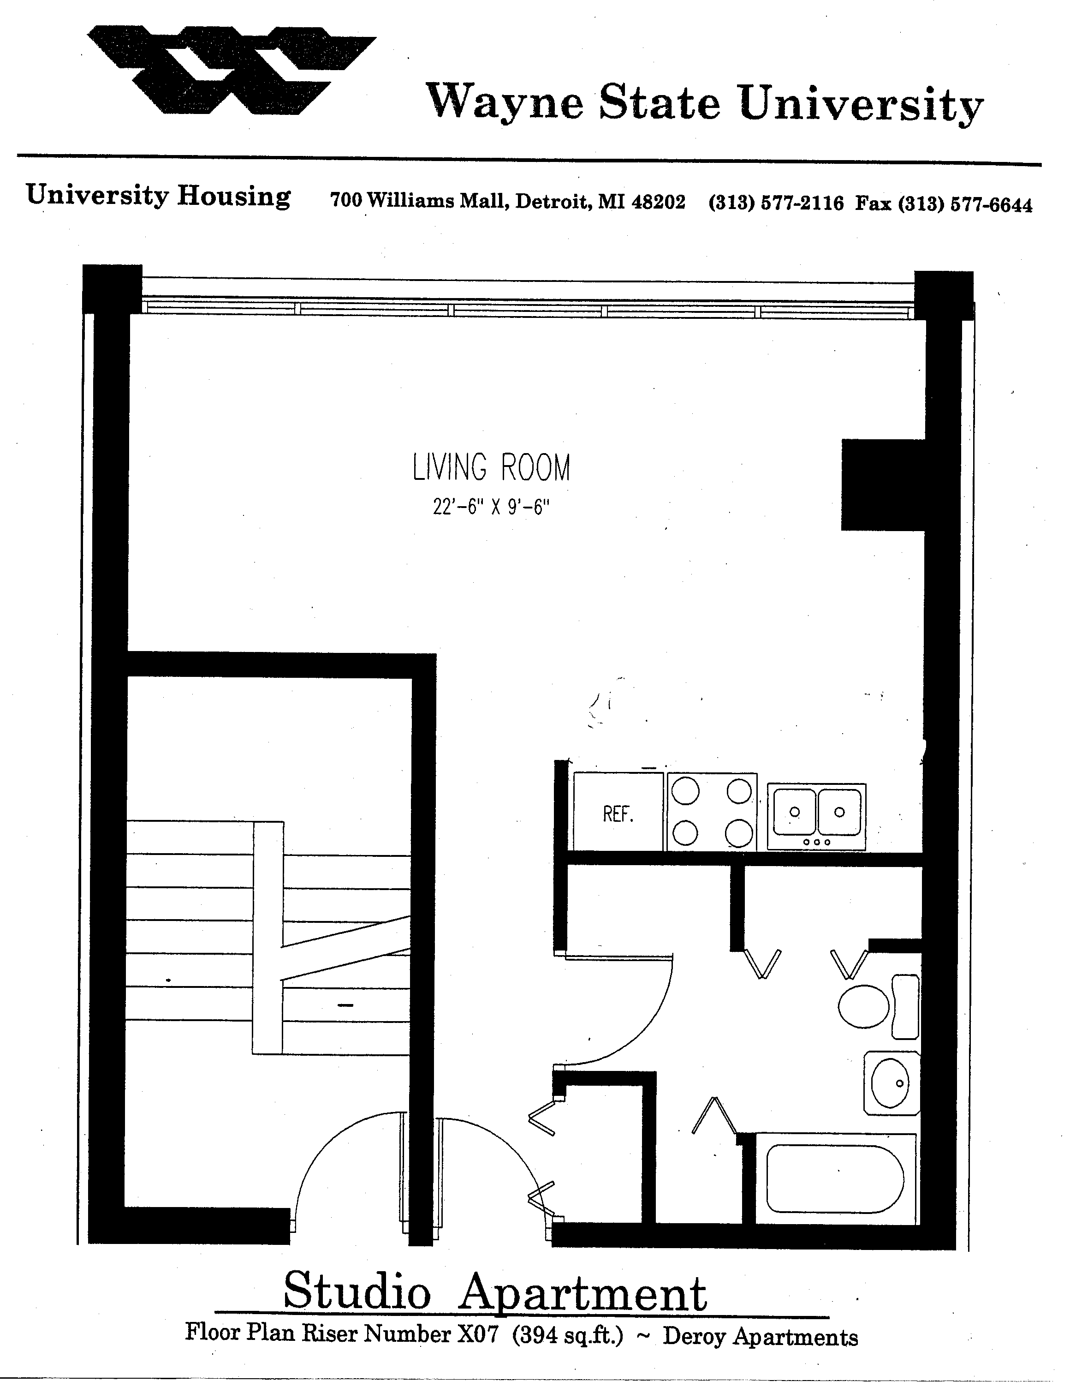
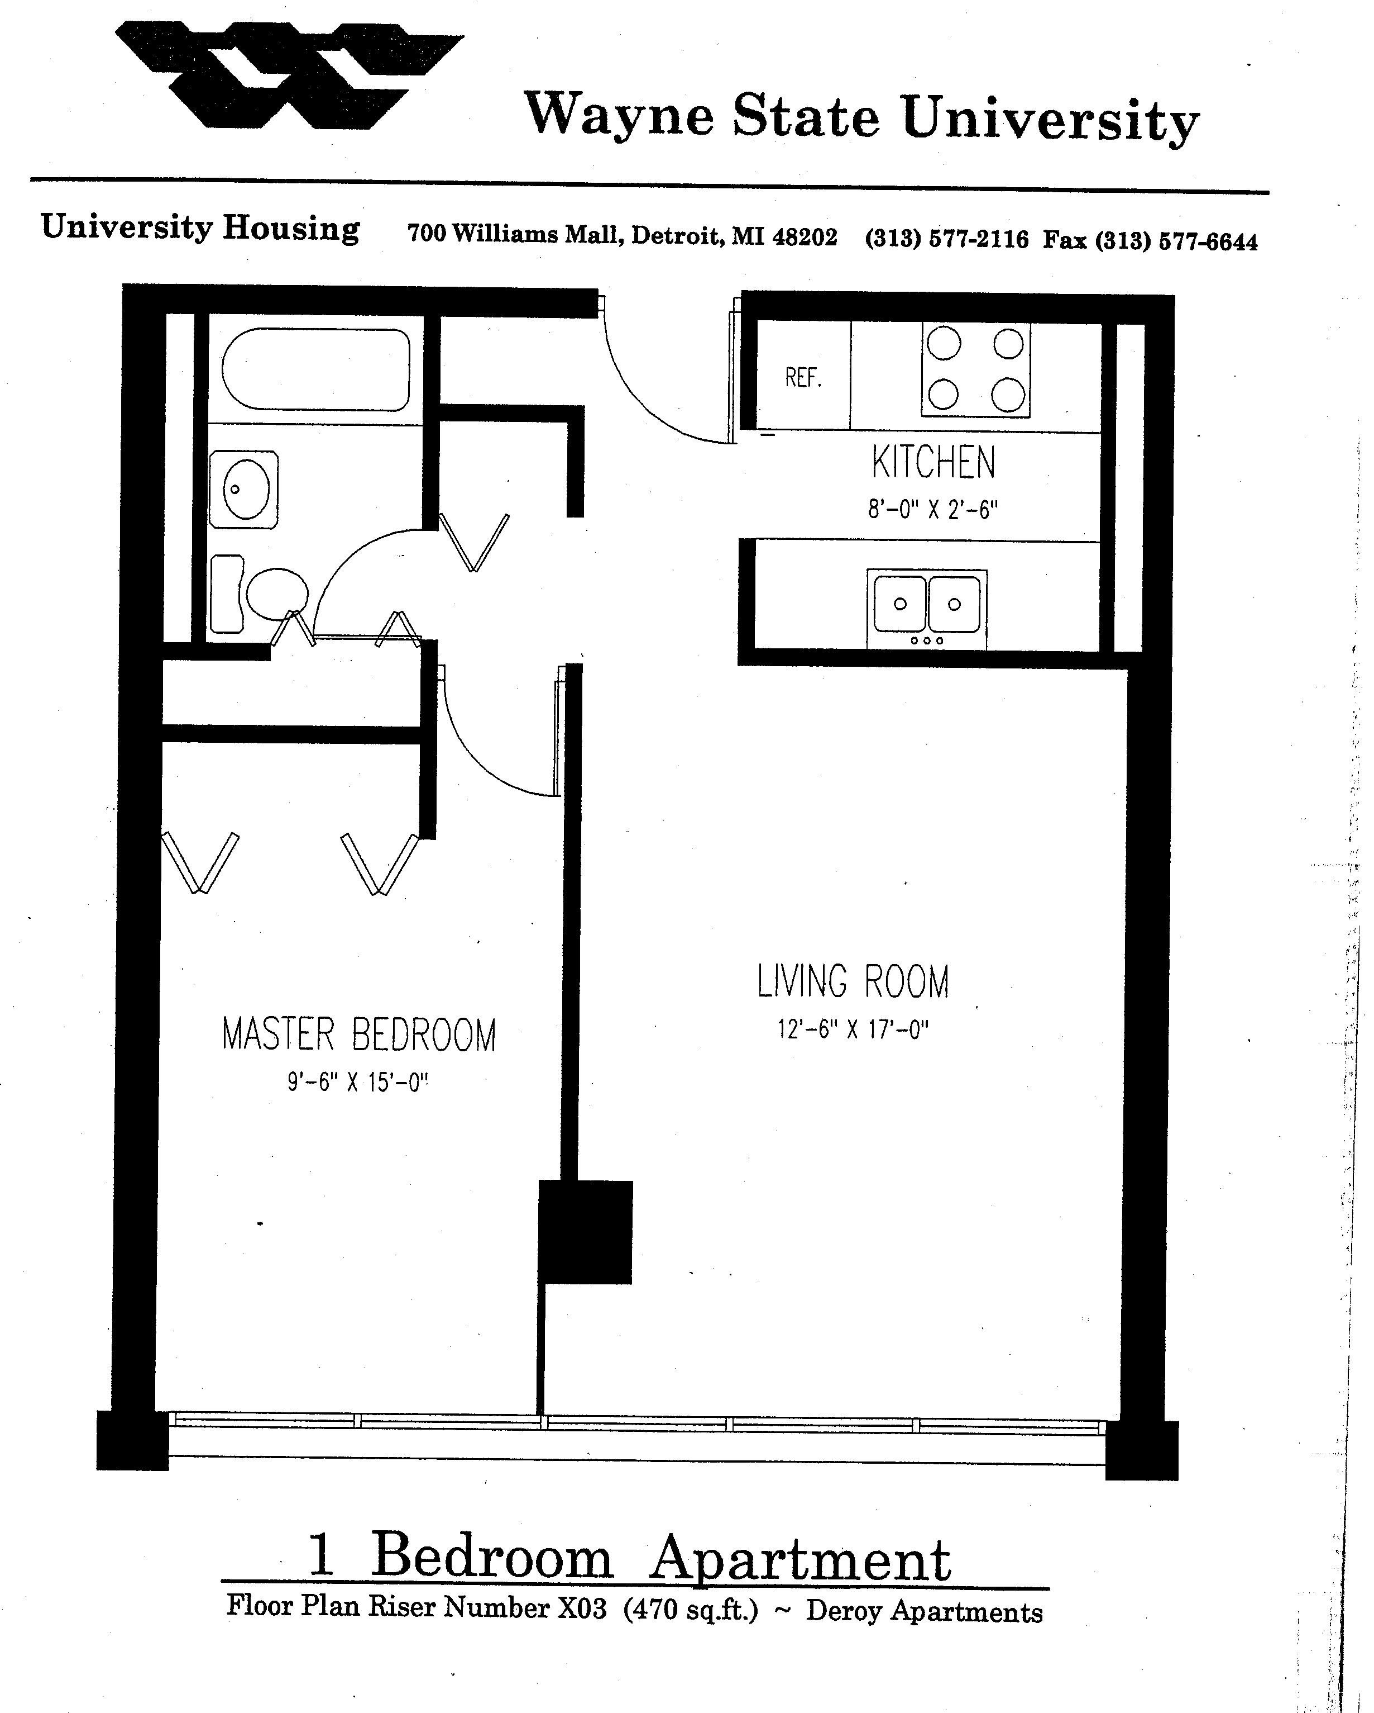
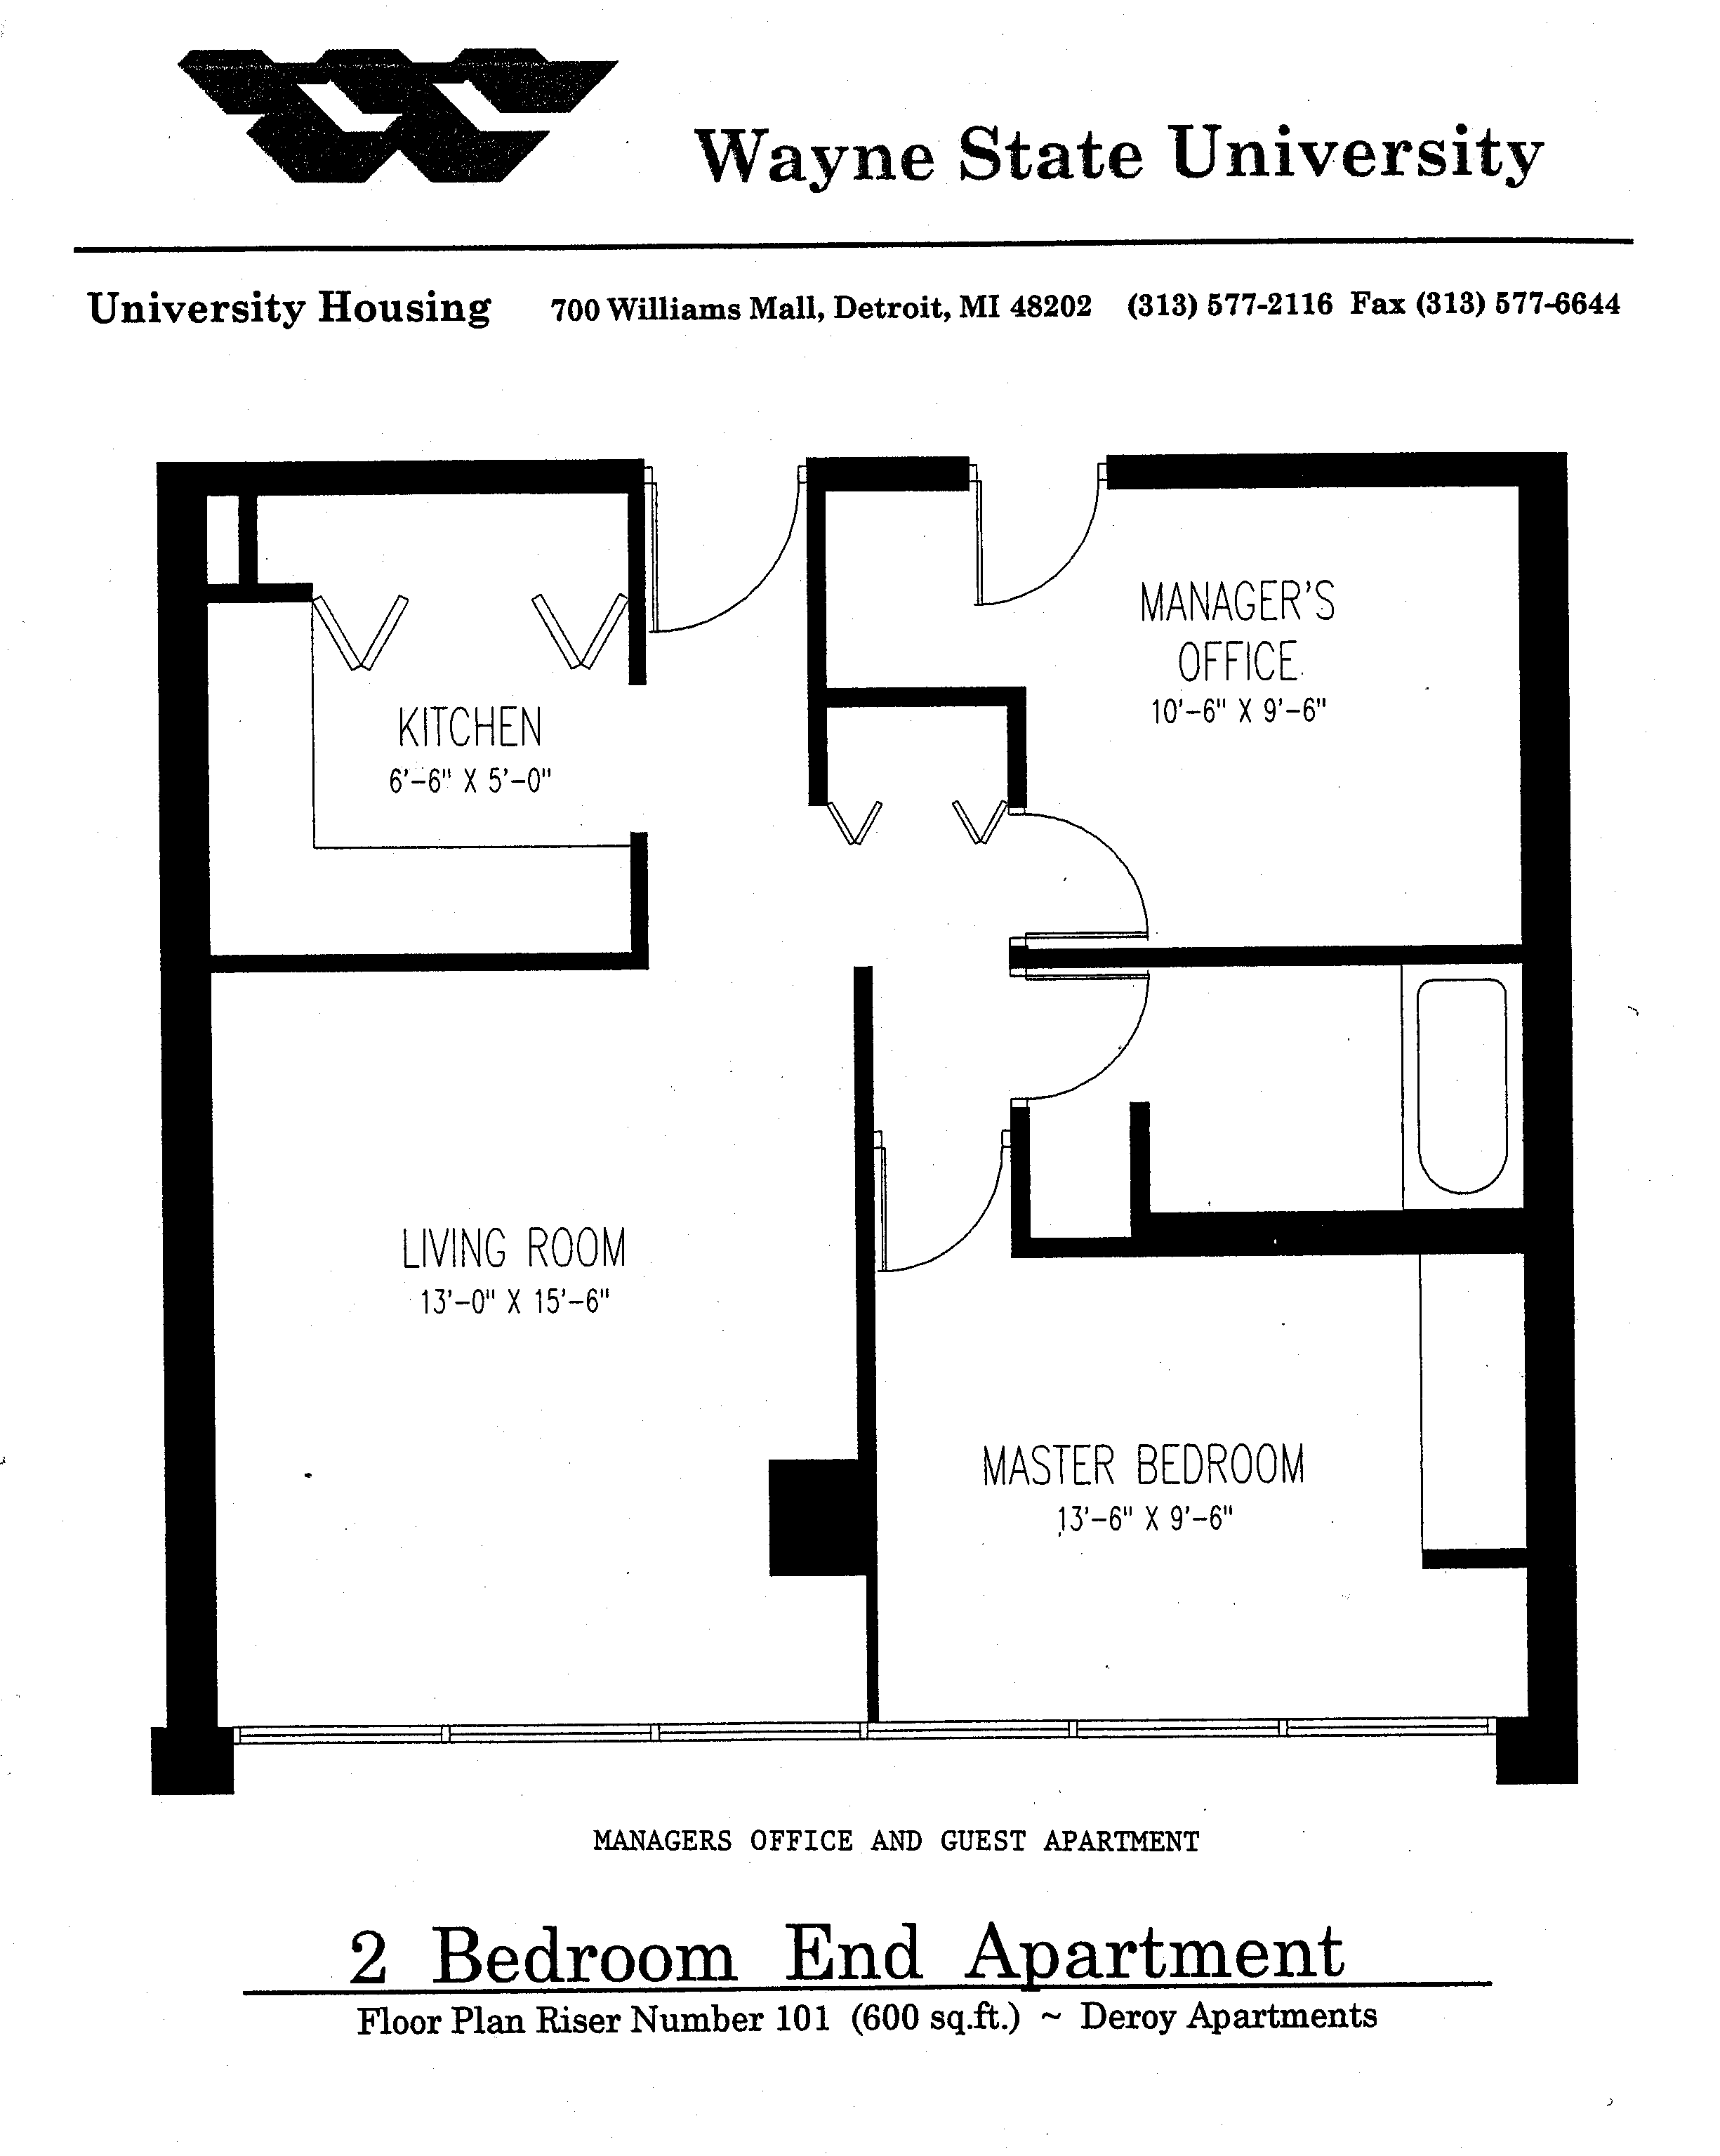
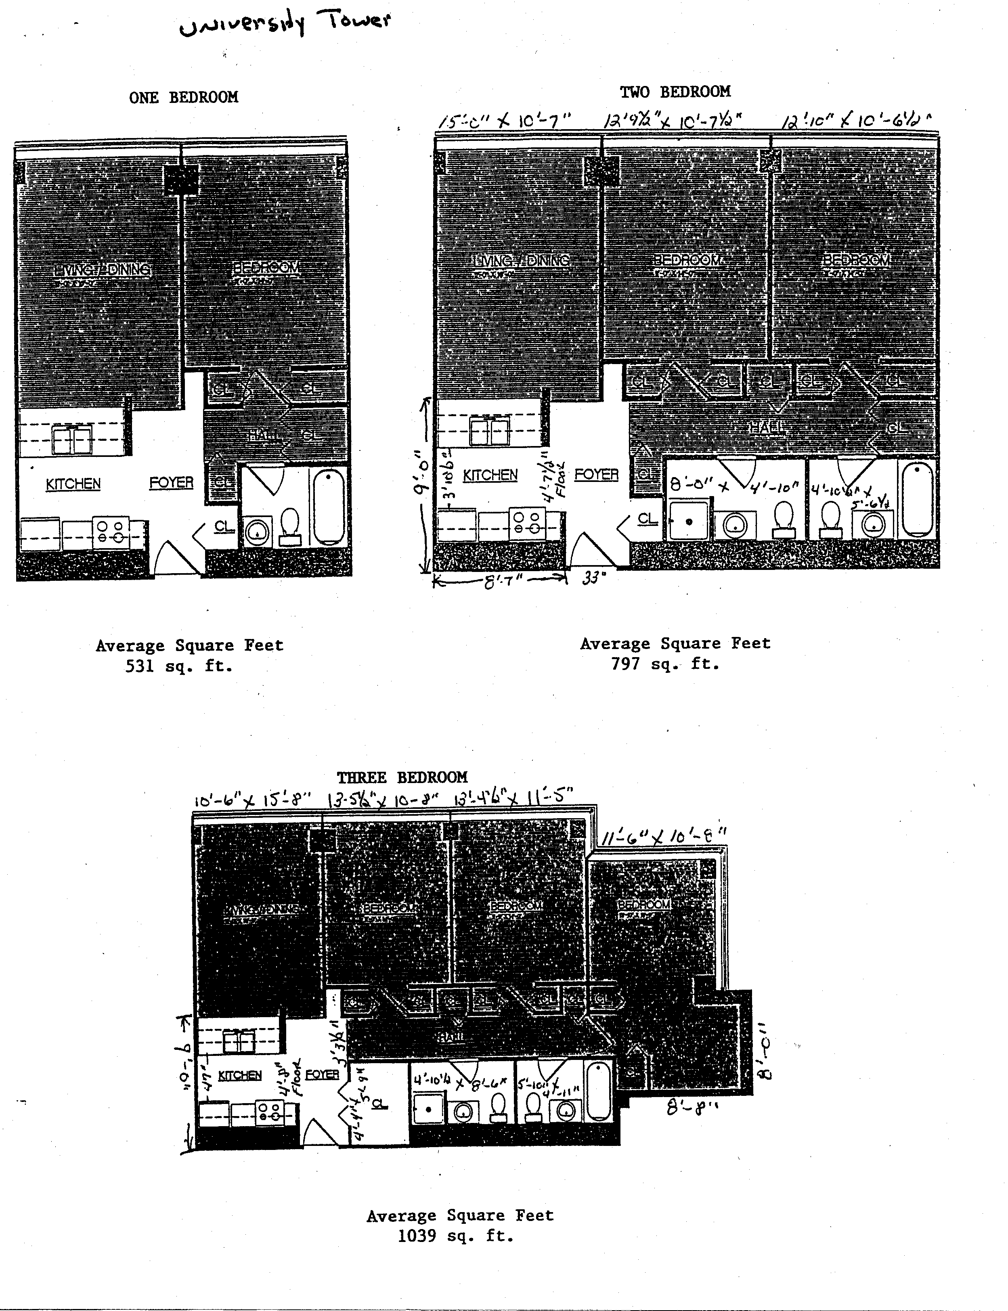
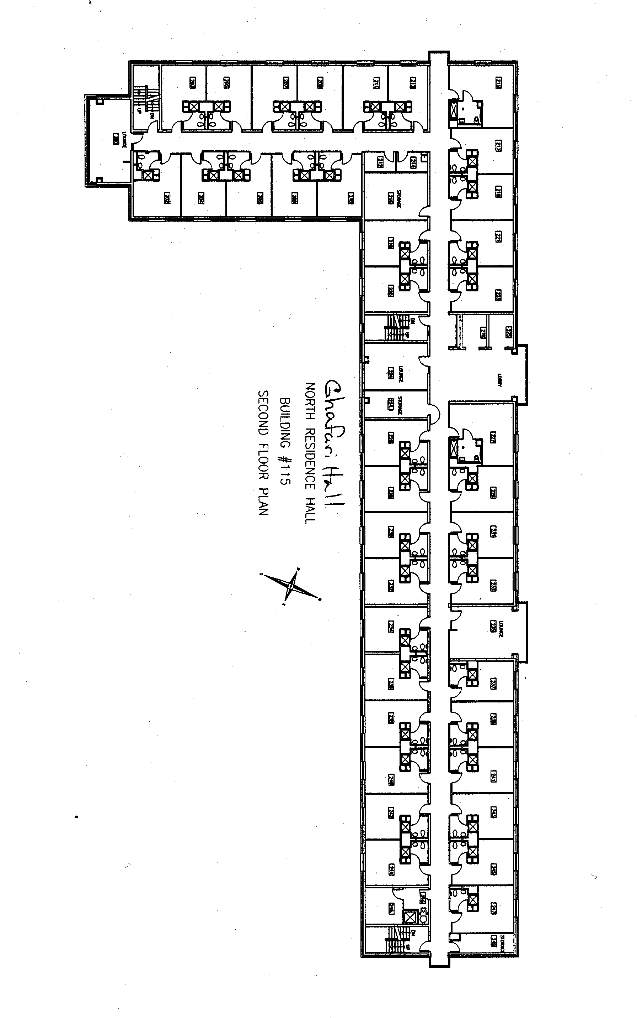
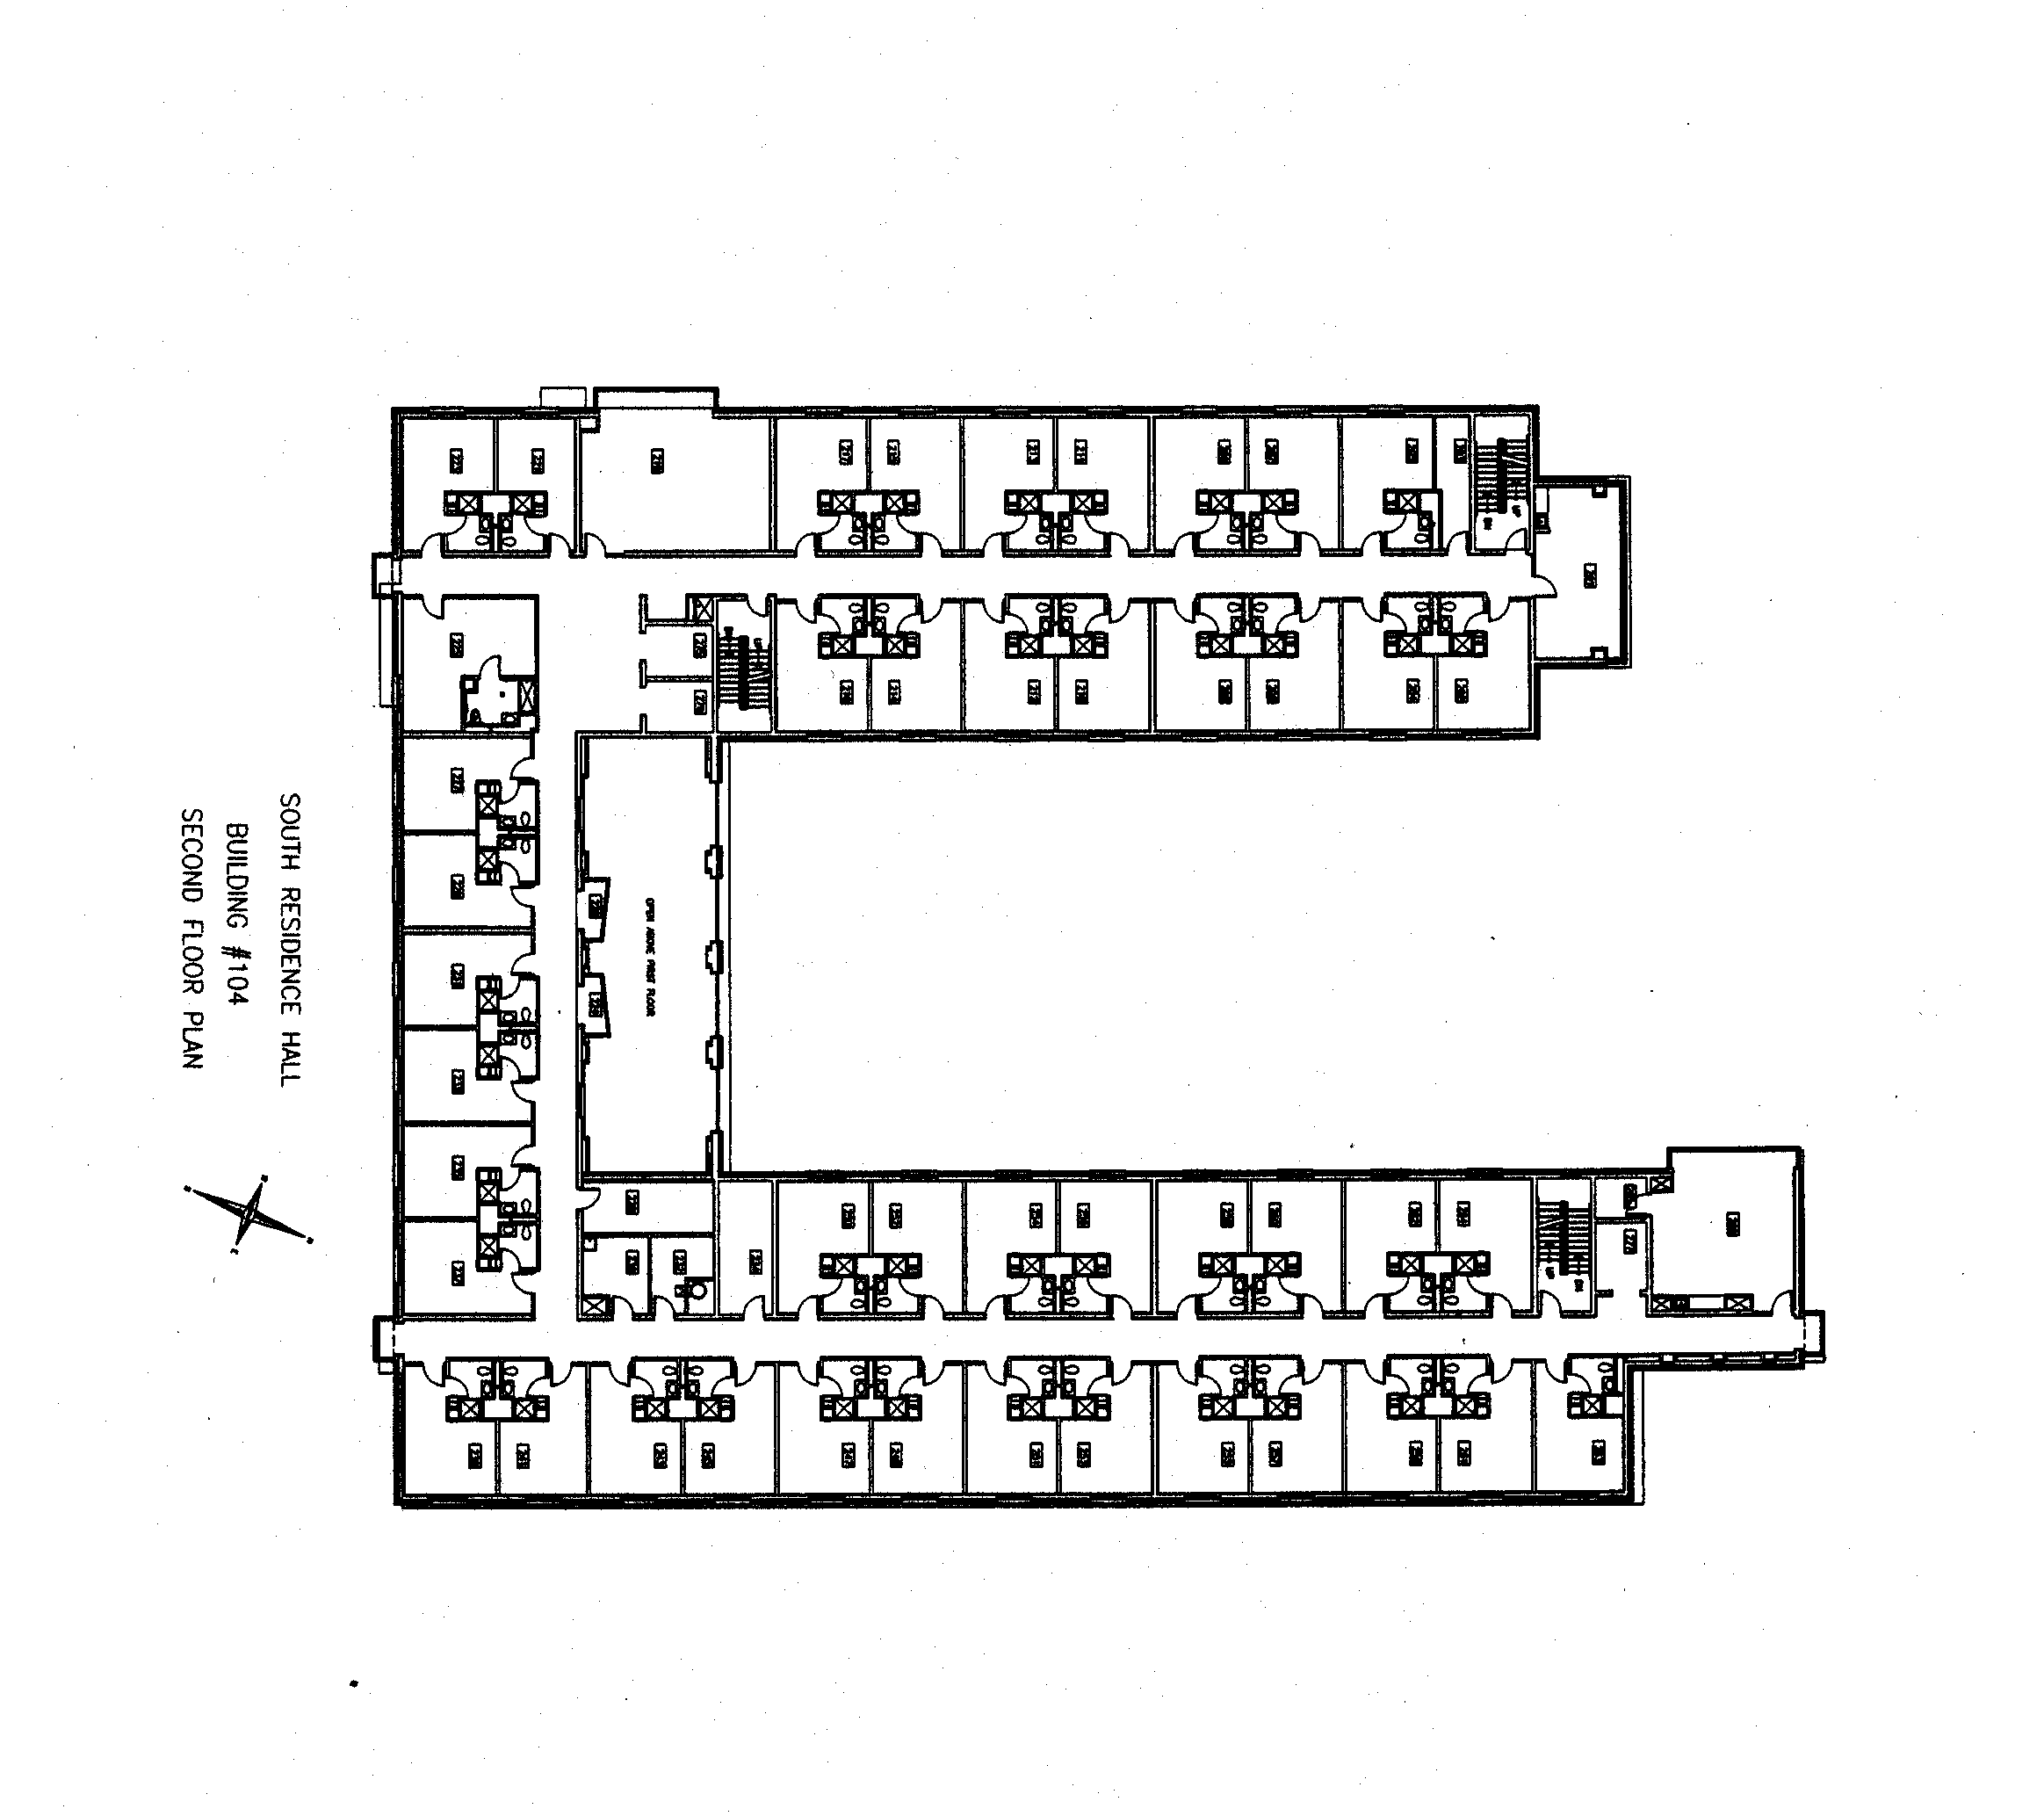

APPENDIX 5

Wayne State University
Standard Service Provider Agreement

Wayne State University
STANDARD SERVICE PROVIDER AGREEMENT

This Agreement is made by and between Wayne State University, 5700 Cass Avenue, suite 4200, Detroit, Michigan 48202, a constitutional body corporate of the State of Michigan ("University") and, (Supplier_Name), (Supplier_Address), (Supplier_City_State_Zip), (“the Supplier”)

For good and valuable consideration, the parties agree as follows:

- General Purpose: The general purpose of this Agreement is to engage the services of the Supplier to provide (Named_Services), per the University Request for Proposal dated (Quote_Date) (the RFP) and the Supplier’s response Proposal dated (Bid_Date) ( ) and the subsequent modifications made to such proposal that are set forth in Exhibit C and reflected in the Price Schedule attached as Exhibit B). The University has assigned (Project_Manager) as the Contract Administrator. Only contract directives from the University’s Procurement and Strategic Sourcing Department or the Contract Administrator shall be accepted by the Supplier.

- General Duties of the Supplier: The Supplier shall provide the University with (Named_Services) of superior quality, at competitive pricing, as described in the Statement of Work section of the RFP, which is incorporated by reference into this Agreement. The Supplier agrees to perform such professional services with the standard of professional care and skill customarily provided in the performance of such services. The supplier agrees to perform these services to the satisfaction of the University during the term of this Agreement.

- Term: The contract period shall be for an initial time period through (Contract_End_Date), with the option to renew for up to one additional one-year period of service, through (Extention_Date). Renewal is contingent upon both parties agreeing in writing to do so, based on satisfaction of the price and the Supplier’s performance.

This Agreement may be terminated by the University or by the Supplier upon thirty (30) days’ written notice to the other party. Either party may designate a different person to whom notices should be sent at any time by notifying the other party in writing in accordance with this Agreement.

- The Roles and Responsibilities (Scope of Work):
The roles and responsibilities of the Supplier are listed in Exhibit A of this agreement.
(Scope_of_Work)

- Customer Support: The Supplier shall have a primary point of contact for the University community. The contact shall be accessible during normal business hours of every business day (8:00 a.m. to 5:00 p.m. (Eastern Time). A toll free number is preferred.

- Business Review Meetings: In order to maintain the partnership between the University and the Preferred Supplier, the University requires regular Business Review meetings. Meetings shall be held on at least an annual basis, or more frequently upon University request. The business review meeting shall include, but not be limited to, the following:
- Review of Preferred Supplier performance as determined by Service Level Agreement metrics
- Review of minimum required reports (see Section IV. xiv - Reporting)
- Review of continuous improvement plans to consolidate number of Core items

- Reports: The Supplier will submit applicable monthly and quarterly usage reports, in the format specified below, to the Procurement and Strategic Sourcing Department, which details the usage during the reporting period.
Reports are to be submitted to (Project_Manager), the commodity manager as listed below:

Monthly and Year-to Date (YTD) reports are required to be received in an excel format, by the 8th of the month following activity, and must include the following information:

Reports & Statistics
- Total value of purchases and total number of orders by Department
- Quantity of all product being sold & installed
- Description of all product being sold & installed
- Total Orders Received including dollar value of purchases and total number of orders
- Total value of purchases and total number of orders by University
- Total value of tier 2 purchases obtained from Diverse Businesses (M/W/DBE)
- Average Time to deliver, install, and turn over to customer, on an individual order basis.
- Weighted Average Discount for each purchase (Standard Educational Pricing vs Wayne State Pricing)
- Overall Order Accuracy Rate = # orders with order accuracy rate of less than 98% vs. # orders with order accuracy rate of more than 98%
- Number of orders returned due to University error
- Total re-stocking charges ($) applied (if any)
- Number of Orders returned due to Supplier error
- Current Back Order Report

Upon request, additional Adhoc reports must be prepared and made available to the University.

- Purchase Orders: Orders will be placed for goods, services or projects as the need arises. Each order will be placed on an individual University Purchase Order generated through our WayneBuy system. All subsequent invoices, packing tickets, and other correspondence related to the individual order are to include the unique PO number.

- Invoicing: Deliveries shall be invoiced on an individual basis. It is the intent of Procurement and Strategic Sourcing to enable the Supplier in WayneBuy, the Supplier should be eInvoice capable. If eInvoicing is not an option at inception of the contract, the invoices must reference the PO number and be submitted to the University’s Accounts Payable department via email address: www.wsuinvoices@wayne.edu.

- ACH Payments: The Supplier is expected to enroll in the University’s ACH program. The ACH payment agreement form can be downloaded at http://fisops.wayne.edu/disbursements/tax-forms.php. The completed form should be signed, scanned, and sent to vendorach@wayne.edu.

- eProcurement Requirements: The University has implemented an eProcurement platform. The Supplier will work in close cooperation with the Procurement Department to adapt to the eProcurement program as required by the University.

- Annual Price Increases: All prices quoted must be firm for the first ______ months (__) of the contract, through September 30, 20__. If a price increase is required at the end of periods two or three, the Supplier must have their request in writing to the Commodity Manager no later than July 31 of each year. Price increases must be justified by citing the appropriate market indices. Price increases will be reviewed and either accepted or rejected in writing.

- Shared Revenue: The Supplier will provide a “shared revenue” commission on all sales to help offset the internal cost for administration of the program through the University. This shared revenue plan is listed below:

Shared Revenue Schedule: payable annually:
Sales up to $250,000 - 1%
Sales above $ 500,000 - 2%

- Confidentiality of Information: The Supplier agrees to keep confidential and not to disclose to third parties any information provided by the University pursuant to this Agreement unless the Supplier has received prior written consent of the University to make such disclosure. This obligation of confidentiality does not extend to any information that:
- Was in the possession of the Supplier at the time of disclosure by the University, directly or indirectly;
- Is or has become, through no fault of the Supplier, available to the general public; or
- Is independently developed and hereafter supplied to the Supplier by a third party without restriction on disclosure. This provision shall survive expiration and termination of this Agreement.

- Confidentiality and Non-Disclosure Agreement: The Supplier is required to sign the University Confidentiality and Non-Disclosure Agreement. A copy of the Agreement can be found in Exhibit C. If the Supplier is not an individual, the Supplier represents and warrants that it has the authority to bind each of its employees, officers, agents, representatives and consultants to the terms of the Agreement. The Supplier shall be responsible for ensuring such personnel are aware of and comply with all obligations imposed by this Confidentiality and Non-Disclosure Agreement.

- Independent Contractor: The parties expressly acknowledge that the Supplier is an independent contractor. The Supplier is not an agent, partner, or employee of the University. The Supplier shall not have the authority to enter into any contract or agreement to bind the University and shall not represent to anyone that the Supplier has such authority. The Supplier represents and warrants to the University that in performing the Services, the Supplier will not be in breach of any agreement with a third party. The Supplier declares that he/she is not a Legislator, elected or appointed officer, or that his/her firm is not owned or controlled by any Legislator, elected or appointed officer, compensated or uncompensated, member of a State board or commission, or other employee of the State of Michigan (including an employee, officer, or official of Wayne State University). The Supplier agrees that he/she is subject to the University’s regulations, laws of the United States and of the State of Michigan, and that, in the event of violation of these, or behavior that is considered to be detrimental to the University or its students, faculty or staff; the University shall have the right to terminate the agreement without prior notice.

- Property Rights and Reports: The Supplier agrees that any computer programs, software, documentation, copyrightable work, discoveries, inventions, improvements, or other products developed by the Supplier solely, or with others, resulting from the performance of this Agreement are the property of the University, and the Supplier agrees to assign all rights therein to the University. The Supplier further agrees to provide the University with any assistance which the University may require to obtain patents or copyright registrations, including the execution of any documents submitted by the University. This provision shall survive expiration and termination of this Agreement.

- Suspension or Termination of Contract: The University reserves the right to suspend or terminate the contract and the performance to be rendered under this Agreement by the Supplier, for any reason upon 30 days’ written notice to the Agency, or immediately pursuant to the Independent Contractor provision, above.

- Indemnification and Hold Harmless: The Supplier agrees that any personal injury to the Supplier or third parties or any property damage incurred in the course of performance of this Agreement shall be the responsibility of the Supplier. The Supplier agrees to indemnify, defend, and hold harmless the University, its governing board, officers, employees, agents, and students from and against any and all costs, losses, damages, liabilities, expenses, demands, and judgments, including court costs and attorneys’ fees, whether for personal injury or property damage or any other claim, which may arise out of the Supplier’s performance of this Agreement whether caused in whole or in part by the Supplier or anyone for whom the Supplier is responsible, regardless of whether or not it is caused in part by the University.

- Notice: Any notice to either party hereunder must be in writing signed by the party giving it and shall be served either personally or by registered or certified mail addressed as follows:

To the University:  Wayne State University  Kenneth Doherty, Assistant VP  Procurement & Strategic Sourcing  5700 Cass Avenue, Suite 4200  Detroit, MI, 48202 |  | To the Supplier:  (Supplier_Name)  (Supplier_Address), (Supplier_City_State_Zip)

or to such other addresses as may be hereafter designated by written notice. All such notices shall be effective only when received by the addressee.

- Entire Agreement; Modification: This Agreement, along with the RFP dated (Quote_Date) and the Supplier’s Proposal dated (Bid_Date) (and its attachments, if any), and subsequent clarifications and addenda, constitute the entire agreement between the parties with respect to the subject matter hereof and may not be amended except by an agreement signed by the Supplier and an authorized representative of the University. Said terms govern and supersede the standard terms and conditions of Purchase of individual Purchase Orders, regardless of whether said Purchase Orders specifically reference back to this Agreement

- Severability: The terms of this Agreement are severable such that if any term or provision is declared by a court of competent jurisdiction to be illegal, void, or unenforceable, the remainder of the provisions shall continue to be valid and enforceable.

- Governing Law and Compliance: This Agreement shall be governed by and construed under the laws of the State of Michigan, without regard to its choice of law rules. Any lawsuits arising from or incident to this Agreement shall be brought in the Michigan Court of Claims. Each party will be individually responsible for compliance with all laws, including anti-discrimination laws, which may be applicable to their respective activities under this Agreement.

- Non-Waiver: The delay or failure of either party to exercise any of its rights under this Agreement for a breach thereof shall not be deemed to be a waiver of such rights, nor shall the same be deemed to be a waiver of any subsequent breach, either of the same provision or otherwise.

- Assignment: The Supplier may not assign the rights or obligations under this Agreement without the University’s prior written consent.

- Authority: The parties warrant that they have the authority to enter into this Agreement and that entering into this Agreement is not restricted or prohibited by any existing agreement to which they are parties.

- Non Exclusivity: This Agreement does not create an exclusive relationship between Wayne State University and the Supplier. The University reserves the right to use other service providers, either through the other Preferred Vendor agreements executed as a result of the RFP, or non-preferred service providers in the event it is determined to be in the best interest of the University, its employees, students, or staff.

- Credit References: From time to time, the University is asked to provide credit and business references to potential new Vendors. Company agrees that it will serve as a Credit Reference for the University with respect to the amount and timeliness of payments.

- Insurance:
INSURANCE REQUIREMENTS (Rev 11-2012)

The Supplier, at its sole expense, shall cause to be issued and maintained in full effect for the term of this Agreement, insurance as set forth hereunder:

General Requirements

Type of Insurance | Minimum Requirement
1. Commercial General Liability (CGL)  CGL insurance should be written on ISO  form CG 00 01 (or equivalent substitute) | $1,000,000 combined single limit  $2,000,000 annual aggregate
2. Commercial Automobile Liability  (including hired and non-owned vehicles) | $1,000,000 combined single limit per accident for bodily injury and property damage, without annual aggregate.
3. Workers' Compensation  (Employers' Liability) | Required by the State of Michigan and Employer’s Liability in the amount of  $500,000 per accident for bodily injury or disease.

Maximum Acceptable Deductibles

Type of Insurance Deductible

Comprehensive General Liability $5,000
Comprehensive Automobile Liability 0
Workers' Compensation 0
Property - All Risk $1,000

Coverage

1. All liability policies must be written on an occurrence form of coverage.
2. Commercial General Liability (CGL) includes, but is not limited to: personal injury, property damage, consumption or use of products, existence of equipment or machines on location, and contractual obligations to customers.
3. The Board of Governors of Wayne State University shall be named as an additional insured, but only with respect to accidents arising out of said contract , on any of Supplier’s or its subcontractors’ insurance policies.
4. The additional insured provision shall contain a cross liability clause as follows: “The insurance afforded applies separately to each insured against whose claim is made or suit is brought, except with respects to the limits of the company’s liability.”
5. The insurance company for each line of insurance coverage will be reviewed and checked per the A.M. Best’s Key Rating Guide. A rating of not less than “A-“ is required.”

Certificates of Insurance

1. Certificates of Insurance naming Wayne State University / Office of Risk Management as the certificate holder and stating the minimum required coverage must be forwarded to the Office of Risk Management to be verified and authenticated with the agent and/or insurance company.
2. Certificates shall contain a statement from the insurer that, for this contract, the care, custody, or control exclusion is waived.
3. Certificates shall be issued on a ACORD form or one containing the equivalent wording, and require giving WSU a thirty (30) day written notice of cancellation or material change prior to the normal expiration of coverage.
4. Revised certificates must be forwarded to the Office of Risk Management thirty (30) days prior to the expiration of any insurance coverage listed on the original certificate, as follows:

Wayne State University
Office of Risk Management
5700 Cass Avenue, Suite 4622 AAB
Detroit, MI 48202

Additional Requirements. The Supplier shall either require each of its subcontractors or suppliers to procure and maintain during the life of the subcontract the same insurance types and in the same amounts as specified in this paragraph, above, or insure the activity of its subcontractors on its own policy.

IN WITNESS WHEREOF, the authorized representatives of the parties have executed this Agreement on (Contract_Date).

Wayne State University |  | (Supplier_Name)
Signature: |  | Signature:
Name: Kenneth Doherty, CPSM |  | Name:
Title: Assistant Vice President – Procurement |  | Title:
Date: |  | Date:
Phone: 313-577-3756 |  | Phone:
email: ac0578@wayne.edu |  | email:

Wayne State University

Signature:
Name: William Decatur
Title: Vice President, Treasurer, and Chief Financial Officer
Date:
Phone: 313-577-5580
email: er9278@wayne.edu


Wayne State University

EXHIBIT A
Roles & Responsibilities.

The roles and responsibilities of the Supplier are listed below.
(Scope_of_Work)

.

Wayne State University

EXHIBIT B
Price or Rate Structure
.
Wayne State University

EXHIBIT C

Confidentiality and
Non-Disclosure Agreement

Wayne State University, hereafter referred to as “University”, has contracted with (Supplier_Name), hereafter referred to as “The Supplier” to supply (Named_Services) and related services to the University under a Service Provider Agreement. As part of this Agreement, the undersigned agrees to the terms of this Confidentiality and Non-Disclosure Agreement (the “NDA”) as follows:

1) Confidential Information

For the purposes of this NDA the term “Confidential Information” shall include any information received by the Supplier, from the University, in the course of providing services as described above, including but not limited to: (i) any and all technical and business information of the University and (ii) information from third parties related to health care services and research.

2) Use of Information

The undersigned hereby agrees not to use Confidential Information for any purpose except in the performance of services as described above.

3) Reproduction of Materials

The undersigned will not retain or transfer any programming, documentation, or any other University controlled or provided software or other materials. No such materials may be copied or reproduced without the University’s express prior written consent, and any copies made shall become the property of the University.

4) Confidentiality

The undersigned agrees to maintain the confidentiality of the Confidential Information, programs, documentation, and any related materials. The undersigned will not share any information regarding the Confidential Information, programs, documentation, and any related materials with any third party, subcontractor, or independent vendor unless expressly given permission in writing by an authorized University official.

5) No Waiver

Nothing in this NDA shall be construed to limit or otherwise reduce the University’s rights to enforce its terms. No delay or forbearance by the University in enforcing any rights set forth in this NDA shall be construed to operate as a waiver of such rights.

6) Vendor Employees and Agents

If the Supplier is not an individual, the Supplier represents and warrants that it has the authority to bind each of its employees, officers, agents, representatives and consultants to the terms of the Agreement. The Supplier shall be responsible for ensuring such personnel are aware of and comply with all obligations imposed by this NDA.

7) Breach of Contract
Any breach of this NDA by the Supplier and/or any of its officers, agents, employees, representatives and/or consultants shall be considered a material breach of the Service Provider Agreement or individual Purchase Order. The Supplier and each of its officers, agents, employees, representatives and/or consultants shall be both jointly and individually liable to the University for damages as a result of any breach of this NDA.

The Supplier acknowledges and agrees that a breach of this NDA may cause continuing and irreparable injury to the University as a direct result of any such violation, for which the remedies at law may be inadequate, and that the University shall therefore be entitled, in the event of any actual or threatened violation of the NDA by the Supplier, and in addition to any other remedies available to it, to a temporary restraining order and to injunctive relief against the Supplier or the undersigned to prevent any violations thereof, and to any other appropriate equitable relief.

8) Governing Law, Modification

This NDA shall be governed by and construed under the laws (other than the choice or conflict of law provisions) of the State of Michigan. Any legal action arising out of or relating to this NDA shall be brought in the Michigan Court of Claims. The provisions of this NDA may not be amended except in a writing signed on behalf of each party.

The undersigned agrees to the specific terms expressed in this NDA.

( )
Name Telephone

(Supplier_Name)
Title Company

Signature Date

