

**Division of Finance and Business Operations**

**Request for Proposal  
  
and Specifications for**

**Preferred Construction Vendors for**

**Time and Materials Work**

No part of this publication may be reproduced, transmitted, transcribed, stored in a retrieval system, or translated into any language in any form by any means without the written permission of Wayne State University

**Wayne State University**

**Procurement & Strategic Sourcing**

**April 2, 2024**

Table of Contents

1. RFP Overview and Schedule 3

2. Scope of Work 4

3. Cost of the Work 5

4. Proposal Requirements 10

5. Evaluation Criteria 12

**Schedules**

Schedule A – Proposal Certification, Acknowledgements, and Non-Collusion Affidavit

Schedule B – Insurance Requirements

Schedule C – Fee Schedule

Schedule D – Summary Questionnaire

**Appendices**

Appendix A – Campus map

Appendix B – Sample Contract

Appendix C - Reserved

Appendix D - Vendor Performance Scorecard

Appendix E – Contractor’s Time & Material Daily Work Summary Template

Appendix F – Time & Material Contractor Invoice Template and Payment Provisions

**Preferred Construction Vendors for Time and Materials Work**

# About Wayne State

**Wayne State University**, founded in 1868, is committed to preparing its students to excel in a fast-paced and interconnected global society. It combines the academic excellence of a major research university with the practical experiences of an institution whose history, location and diversity make it a microcosm of the world students will enter when they graduate. The University holds the Highest Carnegie Foundation classification for research activity. It has 13 colleges and schools and offers more than 350 academic programs including bachelor’s, master’s and doctoral degrees; post-baccalaureate, graduate and specialist certificates; and three professional programs (<http://wayne.edu/about/facts/>).

# RFP Overview and Schedule

Wayne State University (WSU) requests proposals from skilled trade and specialty contractors to support small University renovation projects across campus. It is the University’s intent to award contracts to multiple contractors for multiple construction trades. These contractors must self-perform and manage their work to support the construction. Overall project coordination will be done by University staff. Upon execution of the contracts, the University will issue blanket purchase orders to each selected firm. Work will be distributed to the contractors by the University. Work performed by the contractors will be paid on a time and material basis, as further described within the RFP, unless lump sum bids are requested for specific work scope.

|  |  |
| --- | --- |
| **RFP Schedule** | |
| Bid Date: | April 2, 2024 |
| Optional Pre-Bid Meeting: | Optional  Date: April 11, 2024  Time: 9:00 am  Location: Microsoft TEAMS  TEAMS LINK: [**Join the meeting now**](https://teams.microsoft.com/l/meetup-join/19%3ameeting_OWVmZjUzNjktMmVmYS00MTBkLWE0MDQtZGNjYTA0NDA3Yzgx%40thread.v2/0?context=%7b%22Tid%22%3a%22e51cdec9-811d-471d-bbe6-dd3d8d54c28b%22%2c%22Oid%22%3a%2277cc5d84-79dd-4386-bb9a-6aae17743ee7%22%7d)  230 651 307 663 |
| Questions: | Due: April 18, 2024  Submit to: Valerie Kreher at [rfpteam2@wayne.edu](mailto:rfpteam1@wayne.edu) |
| Bid Due Date: | April 25, 2024  Electronic Submittal via link posted on the website |
| Contractor Interviews: | Week of May 6, 2024 |
| Final Selection: | Week of May 20, 2024 |
| Start of Services: | Week of June 1, 2024 |
| **Note:** | These dates may be adjusted, at the discretion of the University. |
| Contract Term: | 3 years from date of Award ending September 30, 2027 with 2 optional 1 year extensions ending September 30, 2029 |

1. **Registration**

Please use our online registration form at <https://forms.wayne.edu/65fb43322f6cf/> to indicate your attendance at the optional pre-bid meeting to be held on April 11, 2024 at 9:00 am and your intent to submit a proposal for the services listed.

1. **Questions and Addenda**

All questions must be directed to Valerie Kreher at [rfpteam2@wayne.edu](mailto:rfpteam1@wayne.edu) prior to the question deadline. It is the contractor’s responsibility to check for any additional addenda. Only written addenda shall be revisions to this solicitation.

1. **Submission**

Proposals will be received by electronic submission until April 25, 2024, at 2:00 p.m. (local time – Detroit Michigan). The link for bid submission will be posted with the bid details at <http://go.wayne.edu/bids> beginning April 2, 2024, and can be accessed direct at <https://forms.wayne.edu/65fb440548755/>. Schedule C must be provided in Excel format. Vendors are required to combine any other documents into one PDF for the ease of distribution within the University, and to ensure no portion of your response is inadvertently omitted in transmission to the University or internally to the end user department.

**Please Note, the submission form has approximately 40 fields. Allow at least 15 minutes to complete this, when approaching the bid submission deadline. For any discrepancy between the submission form and the actual proposal, the responses in the proposal will prevail.**

1. **Withdrawal**

After the submission deadline has passed, no modification of any proposal will be accepted. All proposals become the property of the University.

1. **Contractor Interviews**

The proposals will be used to develop a short-list of qualified firms to attend contractor interviews with the project selection committee. The selection of contractors will be based on the contractor’s response to this RFP and interviews.

# Scope of Work

1. **Background**

The University’s Design and Construction Services (D&CS) Department is responsible for managing all stages of construction on campus. The department has a small capital construction project team that provides general improvement construction project management. Projects managed by this group are typically customer funded and could range from $500 up to approximately $50,000 worth of work for a single trade contractor. This RFP is intended to enter into agreements with trade contractors to support these projects.

1. **Scope**

The contractors will provide construction services and will be responsible for coordinating work amongst their tradespeople. Trades included in this RFP are listed below. Responding firms may respond to any of these trades and are not obligated to respond to all of them.

1. Electrical
2. Low Voltage Electrical
3. Security
4. HVAC – Sheet Metal
5. HVAC – Pipefitter
6. Plumbing
7. Fire Suppression
8. Carpentry
9. Painting
10. Concrete
11. Abatement
12. Masonry
13. Flooring; Epoxy and Concrete Polishing
14. Flooring; Carpet, VCT, LVT, Ceramic
15. Glazing

Typical tasks may include any combination of the above trades and may be simple or involved. Services will be requested on an as-needed basis and work will be assigned on a discretionary basis. The existence of a contract does not obligate the University in any way relative to the quantity of work assigned to each contractor. The University intends to select from 1 to 3 contractors per trade as a result of this RFP. Successful contractors will be issued a blanket Purchase Order with specified value and individual work tasks will be assigned via additional project specific Purchase Orders (POs), depending on the size of the tasks. In other cases, the University may issue PO’s on a project by project basis.

The awarded contractors will be required to provide adequate personnel in a timely fashion to perform assigned projects. Additionally, the contractor will be required to provide timely daily reports and detailed project invoices, as further detailed in the contract and within this RFP. Services provided by this contract shall include all meetings and correspondence to support the construction activities. The University expects the contractors to assist the University in many aspects of the work, including, but not limited to: optimization of project scope, project duration and project cost.

All work order assignments should be treated as if the space is occupied. It is expected that each trade will have and use a shop vacuum, dust protection, and/or temporary partitions as necessary to contain and clean project sites. Each contractor is expected to maintain the worksite free of any debris, resulting from their scope of work. Daily cleaning of the site is expected. University dumpsters may not be used for construction debris. If a site-specific dumpster is necessary, placement will be coordinated with the assigned WSU Project Manager.

1. **Subcontractors**

Each contractor is required to self-perform all work and not use any subcontractors unless approved in advance by the University’s project manager.

1. **Vendor Performance**

The University reserves the right to adjust the amount of work assigned to contractors based on past performance by the vendors under this contract. The University plans to hold annual performance reviews on each vendor to document vendor performance. The form in Appendix D will be used for the evaluation. The evaluation will be conducted by University project management staff.

# Cost of the Work

1. **Payment to Contractor**

Payment to the contractors for work performed will be based on the actual cost of time and materials, unless otherwise approved as noted below under lump sum pricing. All costs reimbursed to the contractor for time and material work will be based on actual costs, as detailed below.

Labor – The labor rates that will be paid under this contract will be included as an attachment to the contract. All labor must be paid Prevailing Wages as outlined in item 3 B. below. The Vendor shall fill out Schedule C with their proposed labor rates. Include the base rate, the rate including fringes, the overhead and profit (as a percentage of the rate with fringes), and the all-inclusive hourly billing rate. Only provide rates for trades for which you wish to be considered. You may add labor categories to Schedule C, as necessary. Also, include the cost for apprentice hours (as a percentage of the all-inclusive billing rates). Annual escalation of the labor rates will be allowed at 2.5% each October 1, starting on October 1, 2025. Each invoice shall include certified payroll showing the job classification codes and rates for each invoiced position.

Materials/Consumables – The cost of materials and consumables required to construct assigned projects will be reimbursed based on actual costs to the trade contractor. Only the actual quantities used on the project will be reimbursed. Material and consumables may be marked up no more than 5% of the actual costs.

Equipment – Any equipment that will be charged to an assignment must be approved in advance by the University project manager. If it is approved, then the equipment will be reimbursed based on the agreed upon rates. Include in Schedule C any equipment you may charge and the proposed rates. For all approved equipment, the most cost efficient monthly, weekly, or daily rate will be applied. No markups beyond what is included in the rate will be reimbursed.

Disposal and dump fees – With proper supporting documentation, these fees are reimbursable (must include manifest/receipts). In the event of hazardous waste, contaminated spoils, or remediation, it will be necessary to coordinate with the project manager and the WSU Office of Environmental Health and Safety (OEHS) to obtain the appropriate shipping manifest and disposal procedures. Vendors shall not use University dumpsters.

Regulatory and permit fees – These fees are reimbursable, with proper documentation.

Freight charges – Freight charges for material delivery to the contractor for material used on this project may be reimbursable, pending approval from the University project manager.

Restocking fees – These are not allowed, unless approved by the University project manager.

Inventory carrying costs, travel time, travel costs, delivery fees, and contractor vehicle costs will not be reimbursable and should be included in the markup. Small tools, overhead and profit, and non-working supervision are included in the labor markups and are not separately allowed as billable items. The table below summarizes allowable and non-allowable reimbursables.

Employee parking –Parking of employee vehicle shall only be permitted in designated lots or structures, and **NOT** on University sidewalks or malls. Employee parking is not reimbursable and should be included in the markup. Fines for parking ticket or towing costs shall be the responsibility of the vehicle owner and is not a reimbursable expense. Employee vehicles should be marked with the company logo. A parking permit must be obtained for each contractor vehicle that will be used on malls, loading docks, and approved designated parking locations. Permits will be charged on a quarterly bases by Parking Department. It is the responsibility of the contractor to obtain and maintain parking permit as part of contracted overhead. Company vehicles not displaying permit hang tags are subject to ticketing.

Identification - Contractors’ mechanics who routinely work on the WSU Campus must have the workers obtain a photo WSU Contract Staff Card though the WSU One Card Office. The costs of the cards are to be included as a part of the contracted overhead. All required documentation and programming of identification cards must be coordinated through the WSU Director of Design and Construction Services.

|  |  |  |
| --- | --- | --- |
| Cost Category | Allowed? | Cost Basis |
| Construction Labor | Yes | Hourly Rates (includes markup) |
| Materials/Consumables | Yes | Actual costs + 5% markup, based on receipts |
| Equipment | Yes | Agreed upon rental rates |
| Disposal and dump fees | Yes | Actual cost, Must include manifest/receipts |
| Regulatory and permit fees | Yes | Must include appropriate documentation |
| Freight charges | Yes | If approved by the PM with documentation |
| Restocking fees | No | Unless approved by University PM |
| Inventory carrying costs | No | Not allowed |
| Employee parking costs | No | Included in markup above |
| Travel costs | No | Not allowed |
| Delivery fees | No | Not allowed |
| Vehicle costs | No | Not allowed |
| Small Tools | No | Included in mark up above |
| Overhead and Profit | No | Included in markup above |
| Non-working supervision or management | No | Included in markup above |
| Clerical, office staff, admin | No | Included in markup above |

Vendor must fill out Schedule C with labor rates for appropriate categories including but not limited to installation, fabrication, design etc.

Lump Sum Pricing – For projects where scope is clearly defined, and are of value less than $ 50,000 but more than $10,000 per trade, the University may solicit lump sum bids from contractors that are under contract with the University. Such assignments will require the execution of separate contracts for Construction that specifically define the contract sum and schedule as being based on a proposed lump-sum. The successful contractor will be paid on a percent complete basis for this work and will be required to submit a detailed invoice on AIA G702/G703 forms. Daily work sheets are not required to be submitted for lump sum bids when accepted. The agreed upon lump sum price will be the full payment for the work, unless a negotiated and approved change order is issued to modify the contract amount.

Daily Work Summary – Appendix E includes the form to use for the daily work summary. Each contractor must fill out the form and get the signature of the University’s project manager or other designated University personnel each day they are working under this contract.

Invoicing – Appendix F includes the format to be used for invoicing Time and Material work under this contract as well as additional invoicing requirements. Fill out each portion of the invoice form and attach certified payroll, sworn statements, lien waivers, signed daily reports, and supporting receipts with each invoice. If material used on a project is from the vendor’s warehouse, backup documentation is required to support the original cost of the material for reimbursement. For lump sum work, invoices will be required to be submitted on AIA G702/G703 forms. Invoices must be to be specific to individual Purchase Orders or Field Orders that assigned the work and may not combine multiple projects. Invoices must be submitted within 30 days of completion of the work.

1. **Wayne State University Wage Rate Schedule**

**POLICY**

Wayne State University requires all project contractors, including subcontractors, who provide labor on University projects to compensate at a rate no less than WSU wage rates.

The rates of wages and fringe benefits to be paid to each class of laborers and mechanics by each VENDOR and subcontractor(s) (if any) shall be not less than the wage and fringe benefit rates prevailing in Wayne County, Michigan, as determined by the United States Secretary of Labor. Individually contracted labor commonly referred to as “1099 Workers” and subcontractors using 1099 workers are not acceptable for work on any of Wayne State’s properties. Rates for all counties are available at https://wdolhome.sam.gov/, and Procurement will post the schedules quarterly that pertain to Wayne County on its website at https://procurement.wayne.edu/vendors/wage-rates.

Certified Payroll must be provided for each of the contractor’s or subcontractor’s payroll periods for work performed on any University project. Certified Payroll must accompany Pay Applications, and be fully reconciled with the final Pay Application. Failure to provide certified payroll will constitute a material breach of contract, and pay applications will be returned unpaid, and remain unpaid until satisfactory supporting documents are provided.

Additional information can be found on the University Procurement & Strategic Sourcing’s web site at the following URL address: [**https://procurement.wayne.edu/vendors/wage-rates**](https://procurement.wayne.edu/vendors/wage-rates)

**PROCEDURE**

Construction Bids and other Bids or Proposals for work that includes construction shall contain a WSU Wage Rate clause outlining a contractor’s responsibilities under University policy. Each bid solicitation shall include reference to the most current wage determination schedule that contractors can use when preparing their bids.

When compensation will be paid under WSU Wage Rate requirements, the University shall require the following:

The contractor shall obtain and keep an accurate record showing the name and occupation of and the actual wages and benefits paid to each laborer and mechanic employed in connection with this contract.

The contractor shall submit a completed certified payroll document [U.S. Department of Labor Form WH 347] verifying and confirming the WSU Wage and benefits rates for all employees and subcontractors for each payroll period for work performed on this project. The certified payroll form can be downloaded from the Department of Labor website at [**http://www.dol.gov/whd/forms/wh347.pdf**](http://www.dol.gov/whd/forms/wh347.pdf).

A properly executed sworn statement is required from all tiers of contractors, sub-contractors and suppliers which provide services or product of $10,000.00 or greater. Sworn statements must accompany applications for payment. All listed parties on a sworn statement as a subcontractor must submit Partial or Full Conditional Waivers for the amounts invoiced on the payment application. A copy of the acceptable WSU Sworn Statement and Waiver will be provided to the awarded contractor.

If the VENDOR or subcontractor fails to pay the WSU rates of wages and fringe benefits and does not cure such failure within 10 days after notice to do so by the UNIVERSITY, the UNIVERSITY shall have the right, at its option, to do any or all of the following:

Withhold a portion of payments due the VENDOR as may be considered necessary by the UNIVERSITY to pay laborers and mechanics the difference between the rates of wages and fringe benefits required by this contract and the actual wages and fringe benefits paid.

Terminate the contract and proceed to complete the contract by separate agreement with another vendor or otherwise, in which case the VENDOR and its sureties shall be liable to the UNIVERSITY for any excess costs incurred by the UNIVERSITY.

Propose to the Associate Vice President for Business Services / Procurement that the Vendor be considered for Debarment in accordance with the University’s Debarment Policy, found on our website at [**https://policies.wayne.edu/appm/2-8-debarment-policy-on-non-responsible-vendor-in-procurement-transactions**](https://policies.wayne.edu/appm/2-8-debarment-policy-on-non-responsible-vendor-in-procurement-transactions)

Terms identical or substantially similar to this section of this RFP shall be included in any contract or subcontract pertaining to this project.

Prior to award of the project, the apparent low bidder will be required to produce a schedule of values which will include the proposed subcontractors for each division of work and whether the subcontractor is signatory or non-signatory. A letter of intent or contract will not be issued to the apparent low bidder until this document is provided. The apparent low bidder will have one week to produce this document. If the required document is not received within this time, the bidder will be disqualified, and the next low bidder will be required to provide this schedule of values.

1. **State Sales Tax**

The contractor is responsible for the tax attributed with the procurement of materials. Sales tax for goods purchased by the contractor may not be separately charged to the University. Refer to State of Michigan Revenue Bulletin RAB 2016-18 for further information:

(<https://www.michigan.gov/documents/treasury/RAB_2016-18_Sales_and_Use_Tax_in_Construction_Industry_534977_7.pdf> ).

1. **Insurance**

Each contractor must be able to meet the insurance requirements further detailed in the contract and in Schedule B.

1. **Substantial Completion and Warranty**

All labor and materials for work completed under this contract will have a minimum one-year full warranty regardless of a Certificate of Substantial Completion document having been generated. As deemed necessary, installations requiring a full seasonal cycle to pass for project observation and performance reviews will have extended warranties for cost beyond the first year. All manufacturer’s warranty shall be extended to the University without limitations.

1. **Contract**

Beyond the information included in this RFP, each contractor is responsible to fully meet all the requirements in the contract. The contractors are responsible for meeting regulatory and code requirements. Contractors must comply with the University’s current [**Construction Design Standards**](http://www.forms.procurement.wayne.edu/Adv_bid/DC-Standards-Nov-2018.pdf) and [**Computing and Information Technology Department (C&IT) Standards**](https://tech.wayne.edu/docs/wsu-communications-standards.pdf) for the work.

1. **Construction Permits and Inspections**

The University is not subject to the jurisdiction of the City of Detroit and is not required to apply or pay for construction permits with the City, except for elevator scope or public sidewalk site work or within City property where the University has an easement. Work to be performed within a classroom building or dormitory does fall within the jurisdiction of the State Fire Marshal and requires permits and inspections by the State of Michigan Bureau of Fire Services. All electrical, fire protection, and fire alarm trades are required to obtain permits for work in these buildings. The cost of such requirements will be reimbursed during invoicing as applicable. Further, the University reserves the right to employ the services of independent inspectors and testing agents, at its expense, to confirm compliance with applicable codes and specifications. The contractor shall cooperate with and participate in any such independent inspections.

# Proposal Requirements

All contractors responding to this RFP must submit complete information requested in this section and clearly note any exceptions to any information contained in the RFP. For each trade submission, responses are limited to 20 pages total, one-sided, with 11-point font. This is inclusive of all required documents and attachments, as well as any optional material included at the discretion of the respondent. Tab sheets and the cover pages do not count. Responses will be evaluated based upon selection criteria as outlined within the RFP. Each proposal shall include the following items:

1. **Executive Summary**

Provide a summary describing your understanding of the RFP requirements and what unique qualities differentiate your company from others responding to this RFP.

1. **Company Contact Information and Company Overview**

Clearly identify the contact information of the company representative designated to receive all RFP information, addenda, or any other official correspondence relating to the project. Provide a profile of the local office presence and capabilities of the local office to support the University.

1. **Similar Experience**

Provide detailed information on previous similar skilled trades experience as it may relate to the scope, size, and complexity of University work. Provide a detailed list of projects of similar size and nature. References should be available, upon request.

1. **Project Team**

Identify your company’s proposed project team. Include staff qualifications, resumes, roles, an organizational chart, and responsibilities. Provide the name and contact information of the point person for the work. Personnel identified in the proposal shall not be replaced without approval from the University.

1. **Approach**

Describe your team’s approach to delivering the skilled trades work, providing cost and duration opinions, interacting with the customers, and the challenges anticipated in performing the services. What makes your team best qualified to perform projects for the University? How will you ensure you meet our staffing requirements and schedule to perform the assigned projects in a timely fashion?

1. **Safety**

Explain your company’s safety plan, approach, and historical EMR.

1. **Communication Plan**

Open and clear channels of communication with the University and other vendors is important. Please outline your communication plan. How quickly can you respond to requests for new work, rework, and warranty work? How will you ensure that the University is an important priority?

1. **Estimating**

There may be some occasions where the University would like the vendors to estimate the cost of each project. Please detail your company’s estimating approach and experience.

1. **Innovation**

What innovations does your company bring, if hired? Any and all ideas of how to optimize the work will be encouraged.

1. **Construction Contract**

Sample contract documents are attached to this RFP. The terms are non-negotiable. Please confirm your willingness to accept these terms.

1. **Cost of Proposal Preparation**

Expenses for developing and presenting proposals are marketing expenses and shall be the responsibility of the contractors. They will not be reimbursed by the University. All supporting documentation submitted with this proposal will become the property of the University and may be subject to Freedom of Information Act disclosures.

1. **Schedules to Return with the Proposal**

Complete the schedules and include them with your proposal. Include Schedule C both in your proposal and as a separate Excel file.

1. **Evaluation Criteria**

The selection committee will consider all aspects of the RFP responses. We may short list the firms and then hold interviews of the shortlisted firms. The final award will be based on the following criteria:

|  |  |
| --- | --- |
| Evaluation Criteria | Weight |
| Relevant Project Team Experience and Qualifications | 20% |
| Interview | 20% |
| Relevant Company Experience and Qualifications | 15% |
| Cost Proposal | 15% |
| Quality of Proposal | 10% |
| Communication Plan | 5% |
| Estimating Capabilities | 5% |
| Safety Plan and History | 5% |
| Innovation | 5% |

1. **W/MBE participation**

The University is committed to the development and utilization of WBE and MBE enterprises. Implicit in this RFP is a desire to receive proposals from WBE and MBE enterprises. WBE and MBE participation may factor in the selection of contractors and all contractors are expected to support the University’s WBE and MBE initiatives.

Schedule A

**Response to Wayne State University**

**Request for Proposal**

**RFP: Preferred Construction Vendors for**

**Time and Materials Work**

**DATED: April 2, 2024**

**PROPOSAL CERTIFICATION, ACKNOWLEDGEMENTS,  
and NON-COLLUSION AFFIDAVIT**

VENDOR is to certify its proposal as to its compliance with the Request for Proposal specifications using the language as stated hereon.

**ACKNOWLEDGEMENTS**

By virtue of submittal of a Proposal, VENDOR acknowledges and agrees that:

* All of the requirements in the Scope of Work of this RFP have been read, understood and accepted.
* The University’s General Requirements and Guidelines have been read, understood and accepted.
* Compliance with the Requirements and/or Specifications, General Requirements and Guidelines, and any applicable Supplemental Terms and Conditions will be assumed acceptable to the VENDOR if not otherwise noted in the submittal in an Exhibit I, Restricted Services.
* The Supplier is presently not debarred, suspended, proposed for debarment, declared ineligible, nor voluntarily excluded from covered transactions by any Federal or State of Michigan department or agency.
* Wayne State University is a constitutionally autonomous public university within Michigan's system of public colleges and universities, and as such, is subject to the State of Michigan Freedom of Information Act 442 of 1976. Any Responses Proposals, materials, correspondence, or documents provided to the University are subject to the State of Michigan Freedom of Information Act, and may be released to third parties in compliance with that Act, regardless of notations in the VENDOR's Proposal to the contrary.
* All of the Terms and Conditions of this RFP and Vendor’s Response Proposal become part of any ensuing agreement.
* The individual signing below has authority to make these commitments on behalf of Supplier.
* This proposal remains in effect for **[120]** days.

VENDOR, through the signature of its agent below, hereby offers to provide the requested products/services at the prices specified, and under the terms and conditions stated and incorporated into this RFP.

**PROPOSAL CERTIFICATION**

The undersigned, duly authorized to represent the persons, firms and corporations joining and participating in the submission of this Proposal states that the Proposal contained herein is complete and is in strict compliance with the requirements of the subject Request for Proposal***,*** except as noted in Exhibit 1, the "**Restricted Services/Exceptions to RFP**" section of the Proposal. If there are no modifications, deviations or exceptions, indicate “None” in the box below:

|  |  |
| --- | --- |
|  | **NONE** – There are no exceptions to the University’s requirements or terms |

|  |  |
| --- | --- |
|  | **YES** – Exceptions exist as shown in Exhibit 1, Restricted Services. |

**NON-COLLUSION AFFIDAVIT**

The undersigned, duly authorized to represent the persons, firms and corporations joining and participating in the submission of the foregoing Proposal, states that to the best of his or her belief and knowledge no person, firm or corporation, nor any person duly representing the same joining and participating in the submission of the foregoing

Proposal, has directly or indirectly entered into any agreement or arrangement with any other VENDORS, or with any official of the UNIVERSITY or any employee thereof, or any person, firm or corporation under contract with the UNIVERSITY whereby the VENDOR, in order to induce acceptance of the foregoing Proposal by said UNIVERSITY, has paid or given or is to pay or give to any other VENDOR or to any of the aforementioned persons anything of value whatever, and that the VENDOR has not, directly or indirectly entered into any arrangement or agreement with any other VENDOR or VENDORS which tends to or does lessen or destroy free competition in the letting of the contract sought for by the foregoing Proposal.

The VENDOR hereby certifies that neither it, its officers, partners, owners, providers, representatives, employees and parties in interest, including the affiant, have in any way colluded, conspired, connived or agreed, directly or indirectly, with any other proposer, potential proposer, firm or person, in connection with this solicitation, to submit a collusive or sham bid, to refrain from bidding, to manipulate or ascertain the price(s) of other proposers or potential proposers, or to obtain through any unlawful act an advantage over other proposers or the college.

The prices submitted herein have been arrived at in an entirely independent and lawful manner by the proposer without consultation with other proposers or potential proposers or foreknowledge of the prices to be submitted in response to this solicitation by other proposers or potential proposers on the part of the proposer, its officers, partners, owners, providers, representatives, employees or parties in interest, including the affiant.

**CONFLICT OF INTEREST**

The undersigned proposer and each person signing on behalf of the proposer certifies, and in the case of a sole proprietorship, partnership or corporation, each party thereto certifies as to its own organization, under penalty of perjury, that to the best of their knowledge and belief, no member of the UNIVERSITY, nor any employee, or person, whose salary is payable in whole or in part by the UNIVERSITY, has a direct or indirect financial interest in the award of this Proposal, or in the services to which this Proposal relates, or in any of the profits, real or potential, thereof, except as noted otherwise herein.

Any notice required under the Agreement shall be personally delivered or mailed by first class or certified mail, with proper postage, prepaid, to the Subject VENDOR at the following address:

Company Name: _________________________________________________________

Address: _________________________________________________________

_________________________________________________________

Telephone: (________________)_______________________________________

Fax: (________________)_______________________________________

Tax Payer ID: _________________________________________________________

Signature _________________________________________________________

Typed Name _________________________________________________________

____________________________________ ___________________

(Title) (Date)

The Internal Revenue Code requires recipients of payments which must be reported on Form 1099 to provide their taxpayer identification number (TIN).

T.I.N. (Taxpayer Identification Number, Federal Identification Number, or Social Security Number)*.*

**Schedule B - INSURANCE REQUIREMENTS**

____________________________________________, at its sole expense, shall cause to be issued and maintained in full effect for the term of this agreement, insurance as set forth hereunder:

|  |  |  |  |  |  |  |  |  |  |  |  |  |  |  |  |  |  |  |  |  |  |  |  |  |
| --- | --- | --- | --- | --- | --- | --- | --- | --- | --- | --- | --- | --- | --- | --- | --- | --- | --- | --- | --- | --- | --- | --- | --- | --- |
| |  |  |  | | --- | --- | --- | | **General Contractors/Construction Managers** |  | | | **Projects < $5,000,000** | Workers' Compensation with Employers' Liability & Alternate Employers Endorsement | Statutory Limits & EL $1,000,000 | |  | Commercial General Liability | $1,000,000 per occurrence & $2,000,000 aggregate | |  | Contractors' Pollution Liability with E&O | $5,000,000 per claim | |  | Professional Liability | $2,000,000 per claim & $4,000,000 aggregate * | |  | Auto Liability with Pollution & Legal Liability | $1,000,000 | |  | Excess Liability (umbrella) | $2,000,000 | |  | University Added as Additional Insured on CGL & Auto | * If we require them to have higher PL limits and we PAY for them, then the limits need to be part of an endorsement that says they're for the University | |

**General WSU Requirements, When Not in Conflict with the Above**

**Type of Insurance Minimum Requirement**

1. Comprehensive General Liability $1,000,000 per occurrence

or

$2,000,000 Aggregate

2. Comprehensive Automobile Liability $1,000,000 Combined Single Limit (CSL)

3. Workers' Compensation Statutory-Michigan $ 100,000

(Employers' Liability)

**Maximum Acceptable Deductibles**

**Type of Insurance** **Deductible**

Comprehensive General Liability $ 100,000

Comprehensive Automobile Liability 0

Workers' Compensation 0

**Coverage**

1. All liability policies must be written on an occurrence form of coverage.

2. Commercial General Liability (CGL) includes, but is not limited to: consumption or use of products, existence of equipment or machines on location, and contractual obligations to customers.

3. The Board of Governors of Wayne State University shall be named as an additional insured for CGL and Auto Liability, but only with respect to accidents arising out of said contract.

4. The additional insured provision shall contain a cross liability clause as follows: “The insurance afforded applies separately to each insured against whose claim is made or suit is brought, except with respects to the limits of the company’s liability.”

5. The insurance company for each line of insurance coverage will be reviewed and checked per the A.M. Best’s Key Rating Guide. **A rating of not less than “A-” is required**

**Certificates of Insurance**

1. Certificates of Insurance naming Wayne State University / Office of Enterprise Risk Management & Insurance Programs (ERM) as the certificate holder and stating the minimum required coverage must be forwarded to the Office of Risk Management to be verified and authenticated with the agent and/or insurance company.

2. Certificates shall contain a statement from the insurer that, for this contract, the care, and custody or control exclusion is waived.

3. Certificates shall be issued on a ACORD form or one containing the equivalent wording, and require giving WSU a thirty (30) day written notice of cancellation or material change prior to the normal expiration of coverage.

4. Revised certificates must be forwarded to the Office of ERM thirty (30) days prior to the expiration of any insurance coverage listed on the original certificate, as follows:

Wayne State University

Office of Enterprise Risk Management & Insurance Programs (ERM)

5700 Cass Avenue, Suite 4622 AAB

Detroit, MI 48202

**Specific Requirements-** Individual contracts may require coverage in addition to the minimum general requirement such as, business interruption, higher limits and or blanket fidelity insurance.

**Exception to the insurance requirements** is to be approved, in writing, by the Office of Enterprise Risk Management & Insurance Programs (ERM). Exceptions are determined by the type and nature of the contract and the individual contractor

|  |
| --- |
|  |

**Schedule C**

**Fee Schedule**

(download separately from the Website)

[**http://go.wayne.edu/bids**](http://go.wayne.edu/bids)

**Schedule D - Summary Questionnaire**

|  |  |  |  |
| --- | --- | --- | --- |
| 1. Can your company **commence on or before June 1, 2024**? |  | **YES**  _______ | **ALTERNATIVE**  **__________________** |
| 1. Did you attend **the Optional Pre-Proposal** meeting **on April 18, 2024?** |  | _______ | **__________________** |
| 1. If the meeting was **Optional**, what was the Attendance “secret word” provided to confirm attendance? |  |  | **__________________** |
| 1. Did your company provide the required Proposal Certification, Non- Collusion Affidavit and Vendor Acknowledgement**, Schedule A**? |  | _______ | **__________________** |
| 1. If awarded a contract, will your company provide a certificate of insurance to meet or exceed all our minimum requirements as outlined in **Schedule B** |  | _______ | **Required** |
| 1. Did your company complete and provide the Summary **Price Schedule C**, and submit it electronically**?** ***(Zip Files are not acceptable)*** |  | _______ | **__________________** |
| 1. Did your company complete and submit Vendor Set-Up Documents as listed in **Appendix 2?** |  | _______ | **__________________** |
| 1. Please complete the following:   Total number of employees in your company  Total years in business under this company name |  | _______  _______ |  |
| 1. Are you or any Officer, Owner or Partner in this company an employee of Wayne State University, or have you been an employee within the past 24 months? If Yes, explain in Exhibit 1. |  | **___ Yes**  **___ No** |  |
| 1. Are any family members of any Officer, Owner or Partner in this company employees of Wayne State University? If Yes, explain in Exhibit 1. |  | **___ Yes**  **___ No** |  |
| 1. Did your company provide a “Restricted Services” exhibit, Exhibit 1? |  | **___ Yes**  **___ No** |  |
| 1. Does your company agree to provide a minimum of 3 references to the University upon request, with specific contact names and phone numbers? |  | _______ | **__________________** |
| 1. Does your company agree to provide a list of lost accounts in excess of $25,000, if any? |  | _______ | **__________________** |
| 1. For any construction or installation work, did your company quote services at WSU Wage Rates and clearly indicate such in your proposal? |  | _______ | **__________________** |
| 1. If awarded an agreement as a result of this RFP, is your company willing to serve as a future credit reference for the University? |  | _______ | **__________________** |
| 1. Does your company agree to comply with the University Smoke and Tobacco Free Policies? |  | _______ | **__________________** |

1. ADDENDA:

The undersigned affirms that the cost of all work covered by the following Addenda are taken into consideration when providing price and other elements of the vendor’s proposal.

Addendum No. Date Addendum No. Date

Addendum No. Date Addendum No. Date

Addendum No. Date Addendum No. Date

Addendum No. Date Addendum No. Date

Addendum No. Date Addendum No. Date

Company Name:

Address:

Telephone: (________________)

Email address:

Submitted by:

Signature

(Title) (Date)

**APPENDIX A**

**(Wayne State University Campus Map)**

**See web site:**

[**http://campusmap.wayne.edu/**](http://campusmap.wayne.edu/)

**A detailed list of Paid Parking Options can be viewed at**

[**https://parking.wayne.edu/news/approved-2023-24-parking-rates-and-fall-permit-sales-46614**](https://parking.wayne.edu/news/approved-2023-24-parking-rates-and-fall-permit-sales-46614)

**Appendix C – (Reserved)**

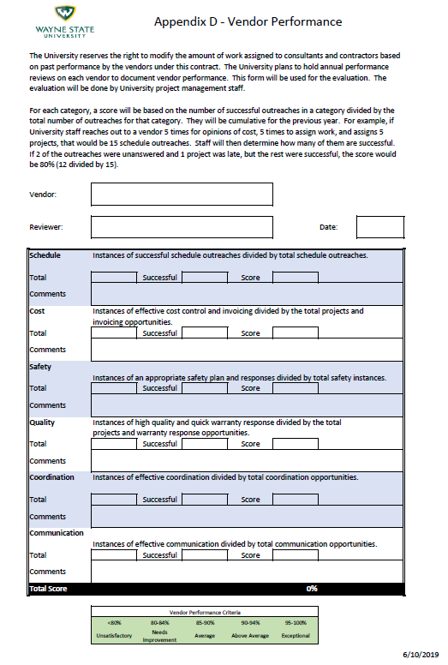

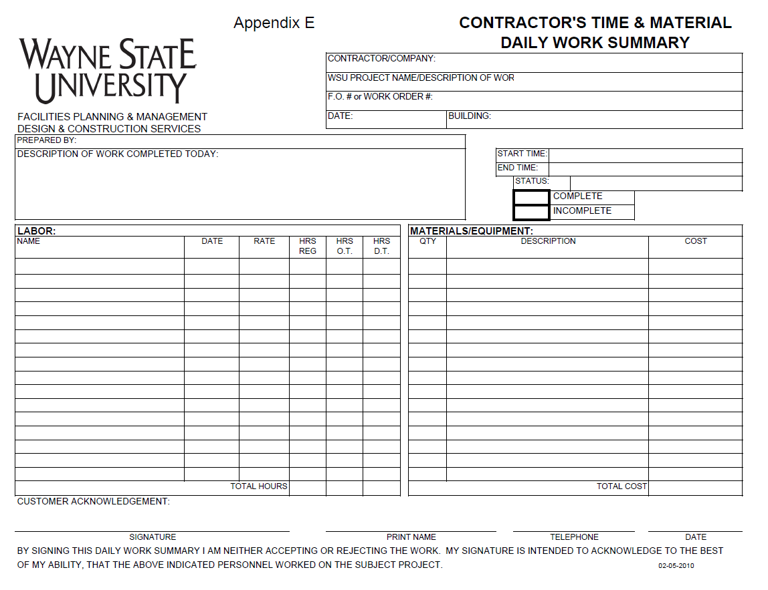

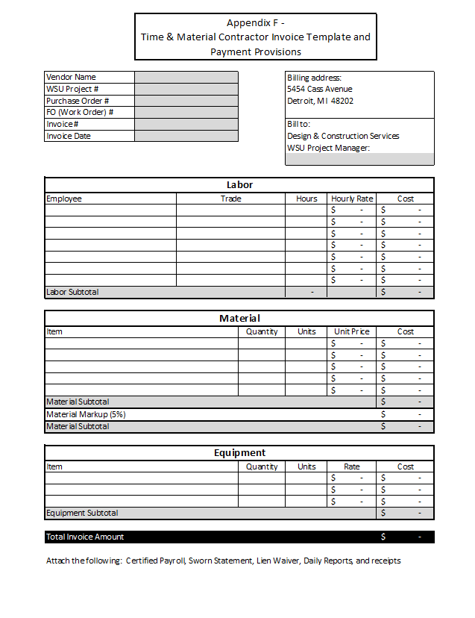fd

**Appendix F – Time & Material Contractor Invoice Template and Payment Provisions**

**WAYNE STATE UNIVERSITY**

**PAYMENT PACKAGE DOCUMENT REQUIREMENTS (Revised 7-23-2015)**

Below is a list of the invoice requirements. Changes may be made to this based on input from the University project manager.

INVOICE

* Use the form that precedes this information as the basis for the invoices.
* Include supporting documents.

SWORN STATEMENT – Checklist:

* List all contractors, sub-contractors, suppliers… ≥ $1000.00
* A sworn statement is required from every Sub Contractor on the job with a material purchase or sub-contract of $10,000 or more. (All tiers.)
* Purchase Order Number
* Dates – Back dating not accepted.
* Signed and Notarized.

CERTIFIED PAYROLL - Dept. of Labor Form WH-347 – Checklist: (Union and Non-Union)

* For every contractor & sub-contractors work, for each week within the application reporting period.
* Correct Project Number
* List ALL workers on-site.
* Make sure their addresses are listed.
* Social Security Numbers MUST be blackened out or listed in XXX-XX-1234 format.
* Work classifications based on the job specific Prevailing Wage Schedule descriptions.
* For any workers paid at the Apprenticeship rates - proof of enrolled program and current completion required.
* Rate of Pay verified against the Prevailing Wage Schedule with an hourly cost breakdown of fringes paid.
* Authorized signatures on affidavit.
* Dates – must represent the weeks within the application period.

APPLICATION PACKAGE SUPPORTING DOCUMENTATION

* Copies of Pay Stubs for each Certified Payroll period reported may be required– (Social Security Numbers MUST be blackened out or listed in XXX-XX-1234 format. Pay stubs need to reflect claimed participation of fringes like Medical, Dental, Retirement or 1099 classification.)
* Proof of Ownership for any ‘Owner Operator’ contractors not wishing to claim their time on prevailing wage. – (Must list their hours and dates worked on the WH-347 Form and enter EXEMPT on the income brackets.) The Owner must provide copies of “DBA” registration form confirming status as exempt from prevailing wage requirements.
* Proof of Stored Materials – Bill of Lading, Delivery Receipts, Pictures, Certificate of Insurance or endorsement pate specifically insuring stored material at location, and pictures with materials clearly separated and labeled for WSU. The University reserves the right to on site verification of stored materials.
* Partial Conditional Waivers – The contractor shall provide covering the entire amount of the application. For non-bonded projects all sub-contractors must provide for all applications which they have a draw.
* Partial Unconditional Waivers – Must release amount paid for work and be delivered starting with application #2 and in no case after payment application #3, through all sequential applications for contractors, sub-contractors, and suppliers listed on the Sworn Statements.
* Full Unconditional Waivers – Must be delivered with final payment application, releasing all contractors, sub-contractors, suppliers listed on the sworn statements and any legitimate notice of furnishings reconciled.

FINAL PAYMENT APPLICATION – Checklist (if applicable):

* Clear and concise As-Built drawings.
* Operation and Maintenance Manuals
* Process and training directions (if applicable).
* Warranty of work in accordance with project documents.
* Submittals log and samples installed on the job.
* Certificate of Substantial Completion
* Full Unconditional Waiver