  Division of Finance and Business Operations |  | Procurement & Strategic Sourcing  5700 Cass Avenue, Suite 4200  Detroit, Michigan 48202  (313) 577-3734  FAX (313) 577-3747

March 04, 2024

Addendum 2 - Clarifications

RFQ for liquid nitrogen (99.998% grade) to the Chemistry Department purchase
for Chemistry Department

Dated February 22, 2024

Since the time of the release of the Request for Quotation (RFQ) for liquid nitrogen (99.998% grade) to the Chemistry Department purchase for the Chemistry Department, questions regarding the specifications have been submitted. Those questions and the University response appear below.

- Where wouldwe have enough room for a temporary portable nitrogen trailer, if one is needed during a transition?

When we did this the last time the temporary tank was located by the generator. Please see the attached photo and we outlined the area in yellow

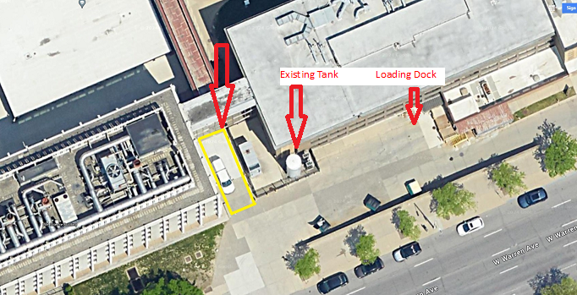

Proposals with supporting documentation shall be submitted by electronic submission. The link for bid submission will be posted with the bid details at http://go.wayne.edu/bids beginning February 22, 2024. Remember, your bids must be in the format provided and be received in the Procurement & Strategic Sourcing by March 7, 2024 by 2:00 p.m.

All questions concerning this project must be emailed to: Valerie Kreher@wayne.edu, Procurement & Strategic Sourcing at rfpteam2 by 12:00 p.m., March 7, 2024.

Do not contact the Chemistry Department, or other University Units, directly as this may result in disqualification of your quotation.

Thank you

Valerie Kreher,
Senior Buyer, Purchasing
313-577-3720

cc: Gregory Kish, Participant list.

