  Division of Finance and Business Operations |  | Procurement & Strategic Sourcing  5700 Cass Avenue, Suite 4200  Detroit, Michigan 48202  (313) 577-3734  FAX (313) 577-3747

February 22, 2024

Addendum 1 - Clarifications

RFQ for liquid nitrogen (99.998% grade) to the Chemistry Department purchase
for Chemistry Department

Dated February 22, 2024

Since the time of the release of the Request for Quotation (RFQ) for liquid nitrogen (99.998% grade) to the Chemistry Department purchase for the Chemistry Department, questions regarding the specifications have been submitted. Those questions and the University response appear below.

- Is Wayne State University part of E & I? Airgas is the only gas supplier on the E & I if that helps. All the terms and conditions have been figured out already so we would just add a bulk nitrogen rider and tag it to the main E & I agreement.
Yes, Wayne State University is a member of E&I

- Does Wayne State own the tank or does the new supplier need to supply the tank?
The current tank is owned by Messer, and would need to be replaced if we changed suppliers.

- You would need the new supplier to begin supplying nitrogen on April 1st? This can be a challenge in such a short period of time especially if you do not own the tank. A bulk tank and related equipment typically have a few months lead time after both parties sign the agreement. A one day turnaround time from the contract being awarded to needing product on site is very challenging as there is paperwork that would need to be completed.
We would be able to arrange a 30 – 60 day transition.

- Do we have to put an agreement solely on Wayne State University paper?
We often have the supplier’s agreement as an Appendix to the Strategic Supplier Agreement.

- Is it possible to get me a picture of the sticker on the side of the nitrogen bulk tank that shows the pressure settings on the tank? Or do you know what pressure requirement is for the chemistry building?
Below are the pictures requested.

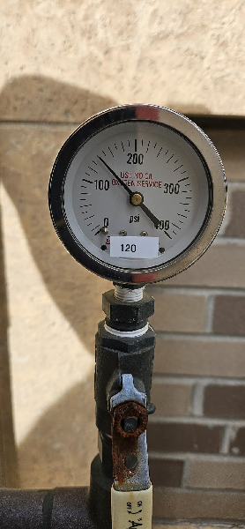 | 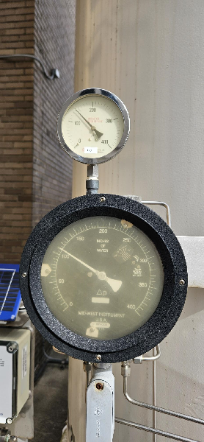
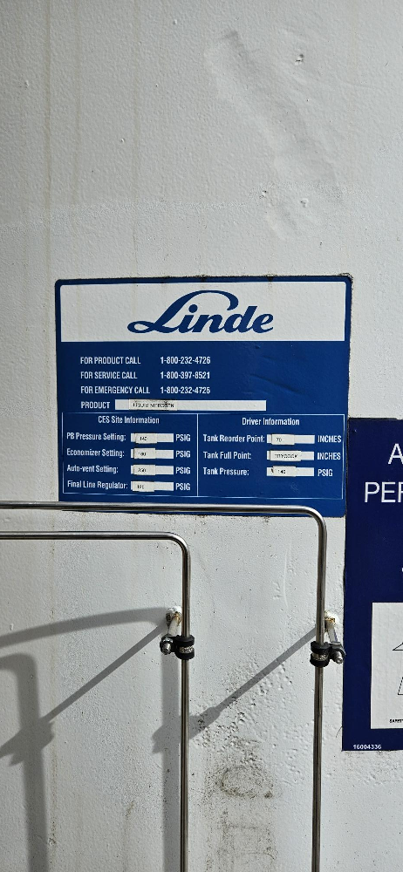

Proposals with supporting documentation shall be submitted by electronic submission. The link for bid submission will be posted with the bid details at http://go.wayne.edu/bids beginning February 22, 2024. Remember, your bids must be in the format provided and be received in the Procurement & Strategic Sourcing by March 7, 2024 by 2:00 p.m.

All questions concerning this project must be emailed to: Valerie Kreher@wayne.edu, Procurement & Strategic Sourcing at rfpteam2 by 12:00 p.m., March 7, 2024.

Do not contact the Chemistry Department, or other University Units, directly as this may result in disqualification of your quotation.

Thank you

Valerie Kreher,
Senior Buyer, Purchasing
313-577-3720

cc: Gregory Kish, Participant list.

