  Division of Finance and Business Operations |  | Procurement & Strategic Sourcing  5700 Cass Avenue, suite 4200  Detroit, Michigan 48202  (313) 577-3734  FAX (313) 577-3747

September 26, 2018

Addendum #4 To
Request for Proposal

For iBio Landscaping Update: Project 211-312745

Dated September 13, 2018

The Addendum must be acknowledged on your lump sum bid.

As a result of mandatory pre-bid ,meeting for the release of our RFP FPM iBio Landscapinig Update, the following question was submitted. The questions and the University’s response is as follows:

- Looking through the documents I see that addendum #1 states that there is an updated bid form, I only see the ‘Turf & Grass’ spec in Add #1. Please provide updated form?
Response: That was written in error. The Form of Proposal, Section 300 has not been revised.

- Can you please advise where I can find the Prequalification matrix/questioner that needs to be submitted as part of our proposal?
Response: The Prequalification matrix/ questionnaire is located in Section 300.

- Please review counts for NA1 when adding up quantities given on the drawing NA1 comes to 750.
Response:
Contactor is responsible for correct plant count per the drawings.

- Please specify what planting medium is to be installed in the Bioswale.:
Response:
Detail 6/L8.0 indicates 4” depth topsoil. Additional soil augmentation to meet any specific plant needs will be completed by WSU.

- Demo plan shows construction fence on the legend, but does show on the drawing, is there protection fence that is required, if so please indicate where?
Response:
Protection fencing should not be required. Please follow OSHA standards.

- Please specify what edging is to be used between plant beds and lawn?
Response:
Edging should not be required as all the beds are existing. If edging needs to be replaced, it should match existing.

- Looking at the drawing I see some discrepancies between the plant list and the drawings. My biggest concern is that the landscape plan shows 65 daylilies to be transplanted, but when comparing the existing drawing with the daylilies that are to be transplanted there are actually only 39 available for transplanting. See below: 78 existing and 39 to remain, which leaves 39 to be transplanted, and the landscape plan calls out 65 to be transplanted.
Response:
The idea is to reuse all the plants to be transplanted. If that number is less than what is actually needed, then they will have to be bought new.

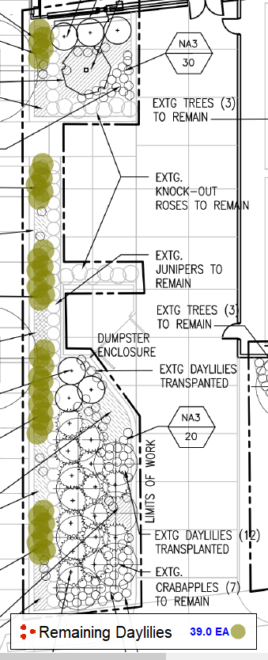
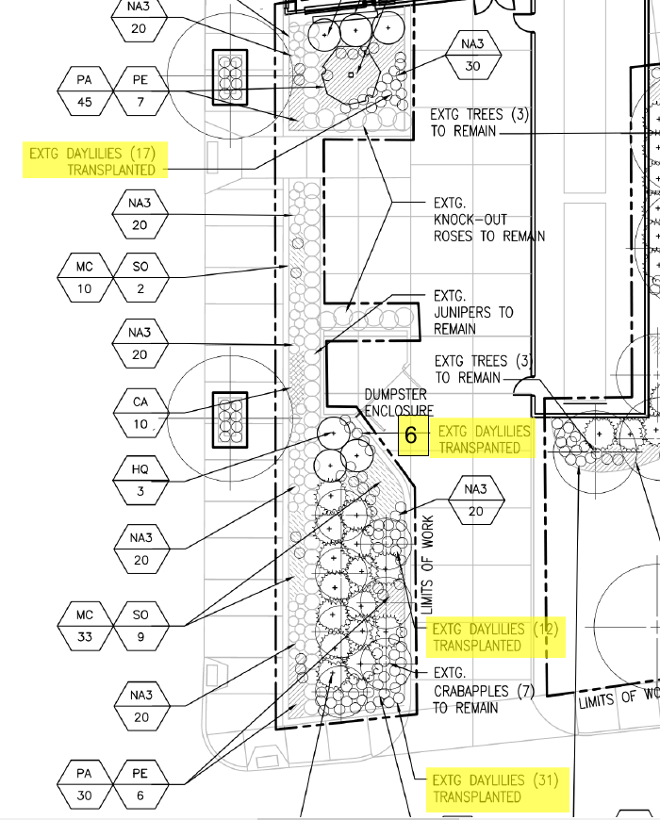
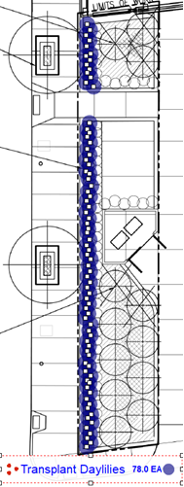

- Please clarify if we are also to remove the existing Ivy on the west side of the site by the existing Crabapples.
Response: The documents state all ivy shall be removed on site.

- There are also quite a few mislabeled or unlabeled plants. Can you have the LA update the plant tags?
Response:

- Looking at the drawing I see some discrepancies between the plant list and the drawings. My biggest concern is that the landscape plan shows 65 daylilies to be transplanted, but when comparing the existing drawing with the daylilies that are to be transplanted there are actually only 39 available for transplanting. See below: 78 existing and 39 to remain, which leaves 39 to be transplanted, and the landscape plan calls out 65 to be transplanted.
Response: See question 7.

NOTE: You must have attended a pre-bid conference in order to be eligible to bid on a particular project. Receipt of minutes or addenda without being at a pre-bid conference does not qualify your company to bid.

A copy of this Addendum will be posted to the Purchasing web site at http://go.wayne.edu/bids.

All questions concerning this project must be emailed to: Kimberly Tomaszewski, Procurement & Strategic Sourcing. Email: ac9934@wayne.edu, and copy Leiann Day, Associate Director, at Leiann.day@wayne.edu.

Bids are due by electronic submission on no later than 2:00 p.m., October 1, 2018. The link for bid submission has been posted with the bid details at http://go.wayne.edu/bids beginning September 13, 2018.
Thank you,
Kimberly Tomaszewski,
Senior Buyer

