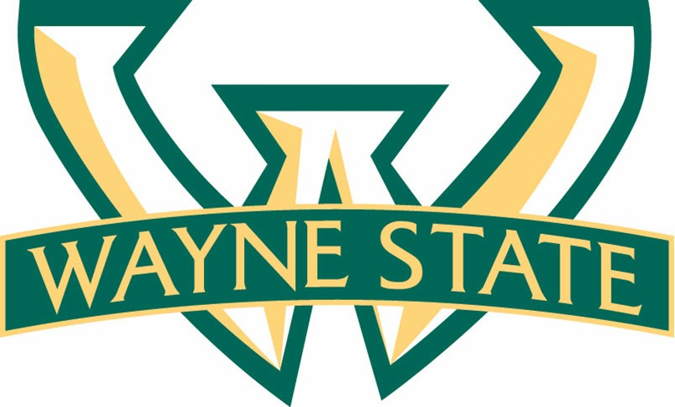  Division of Finance and Business Operations |  | Procurement and Strategic Sourcing  5700 Cass Avenue, suite 4200  Detroit, Michigan 48202  (313) 577-3734  FAX (313) 577-3747

December 23, 2014

Announcement
Engineering Student Innovation Center
999-253057

PURCHASING AGENT: Kimberly Tomaszewski
WSU Procurement and Strategic Sourcing
5700 Cass Avenue, Suite 4200
Detroit Michigan 48202
(313) 577-3757

Thank you to all of the firms that submitted a response to our RFP for Design Services for the Engineering Student Innovation Center for Wayne State University.

The Wayne State University Evaluation Team has completed its review and evaluation of proposals.

As a result, a final recommendation has been made to go forward with NORR.

We sincerely appreciate the time, effort, and patience all the participants and their teams have invested to participate in our Request for Proposal process, and hope all participants will participate in any future opportunities that the University may have.

Thank you for your continued interest in doing business with Wayne State University.

Sincerely,

Kimberly Tomaszewski
Senior Buyer

