Division of Finance and Business Operations |  | Procurement & Strategic Sourcing  5700 Cass Avenue, suite 4200  Detroit, Michigan 48202  (313) 577-3734

October 13, 2023

Addendum #4 To
Request for Proposal

For UGL-W360 Academic Student Engagement: Project 096-353617

Dated September 20, 2023

The Addendum must be acknowledged on your lump sum bid.

Question:
Where is the existing closet the cabling should run to? Is it the space labeled storage on E210?

Answer:
A Majority of the cables run to IDF 1230 or IDF 1696 locations, they are adjacent the peripheral walls of the office space.
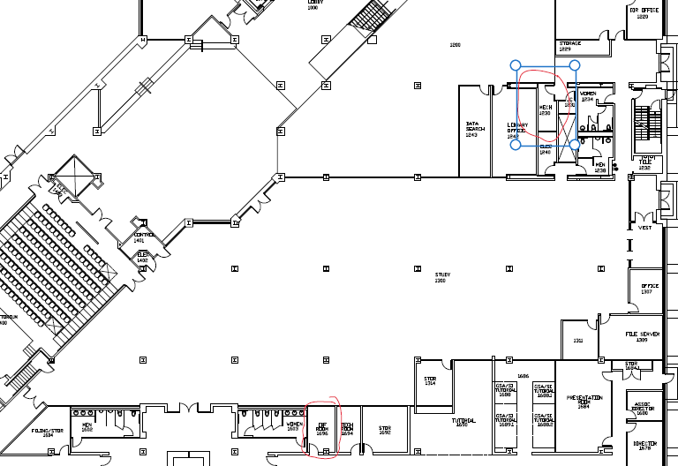

A copy of this Addendum will be posted to the Purchasing web site at
http://go.wayne.edu/bids.

All questions concerning this project must be emailed to: Valerie Kreher, Procurement & Strategic Sourcing. Email: rfpteam2@wayne.edu.

Bids are due by electronic submission on no later than 2:00 p.m., October 18, 2023. The link for bid submission will be posted with the bid details at http://go.wayne.edu/bids beginning September 20, 2023.
Thank you,

Valerie Kreher,
Senior Buyer

